**August 18, 2016**

**Booster’s 2-nd Harmonic Tunable Cavity meeting**

1. **Magnet Current Shape**

**Inputs:**

1. Timing curve by Tan (May 31, 2016):

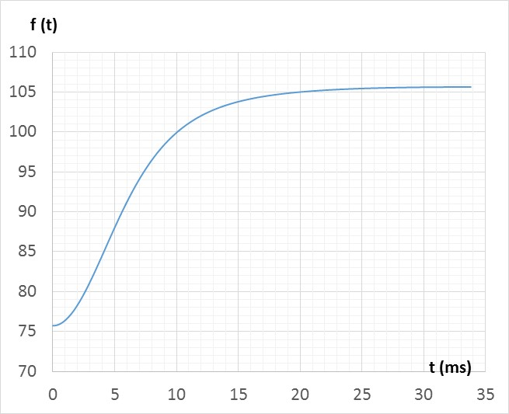

1. Tuning curve by Gennady (July 12, 2016)

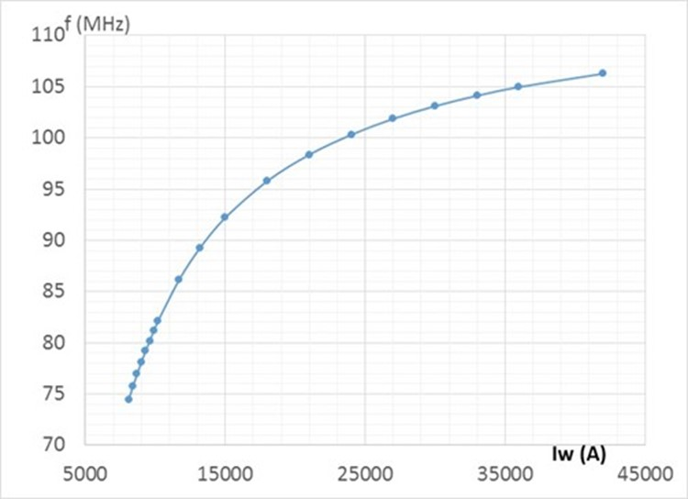 

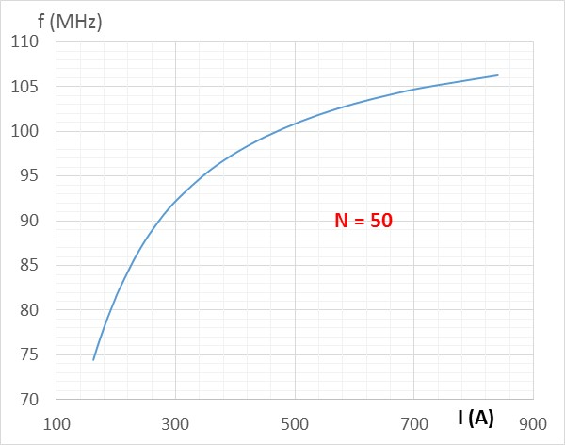

**Current Shape at injection (0 ≤ t ≤ 3 ms)**

**I [A] = 167.855 + 3.36*t2** where t is in ms

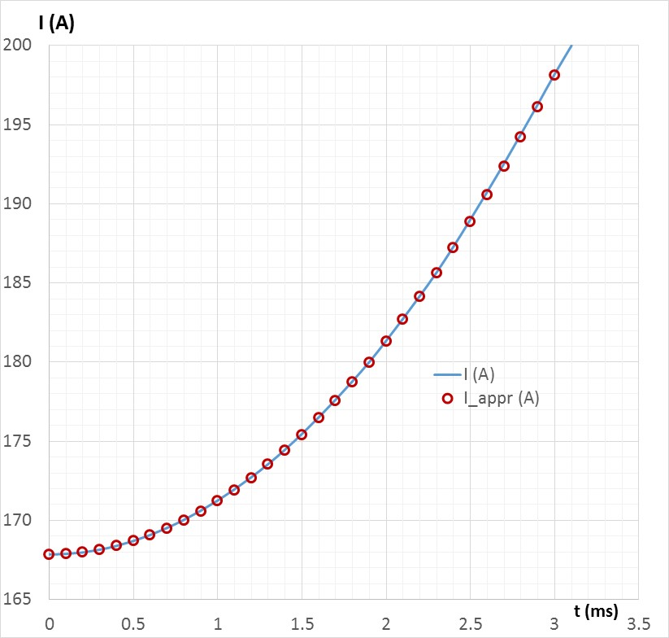 

**Current shape at transition (16 ms ≤ t ≤ 19 ms)**



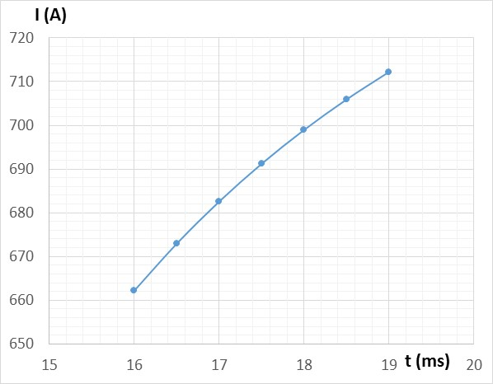 

**Current shape at extraction (32 ms ≤ t < 34 ms)**

 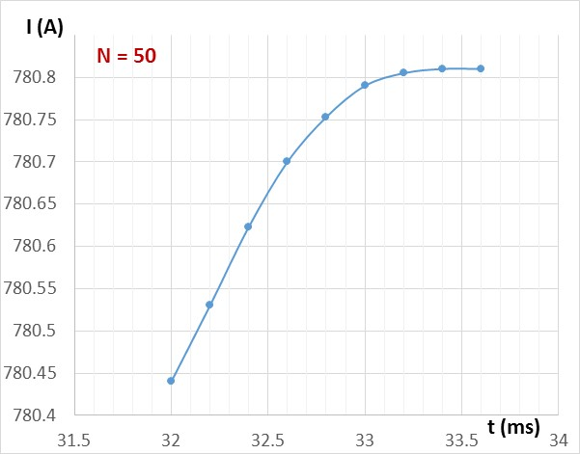



**Combined data:**