Analysis of the measurements made by John K.

**Dec. 22, 2016**:

Iteration #1

1. Magnetization

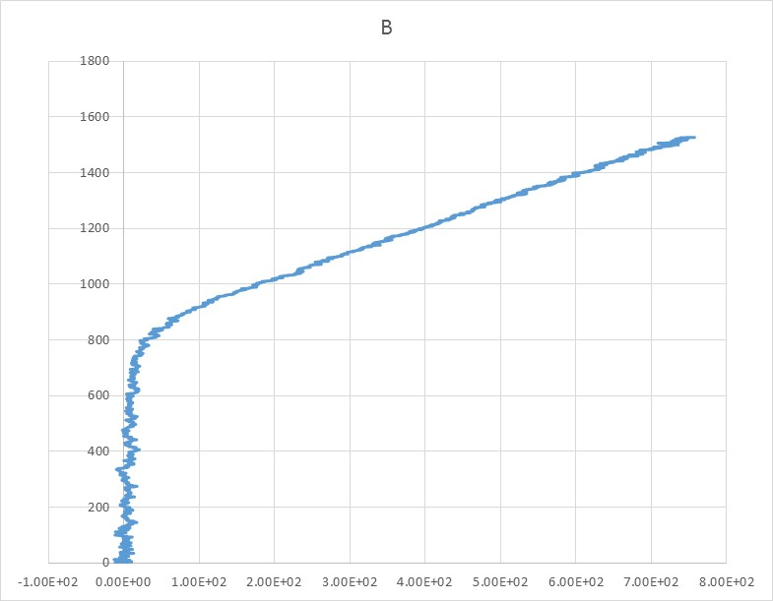

2. Permeability

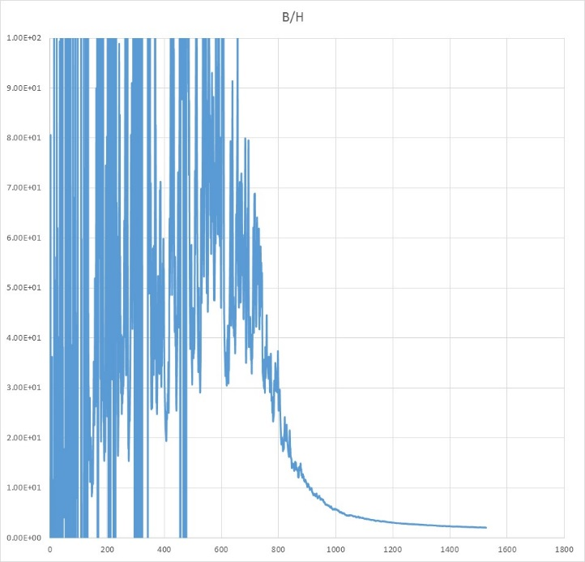

|  |  |  |  |  |  |  |
| --- | --- | --- | --- | --- | --- | --- |
| B (G) | 1200 | 1100 | 1000 | 900 | 800 | 700 |
| Mu_measur | 3 | 4 | 5.8 | 11 | ~25 | ~55 |
| Mu_ref | 2.75 | 3.2 | 4.2 | 6.2 | 13 | 40 |

Data from the note TD-15-004



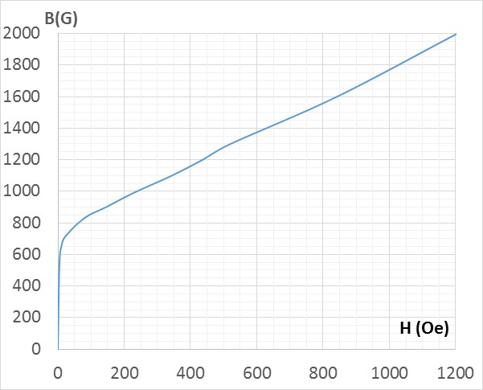 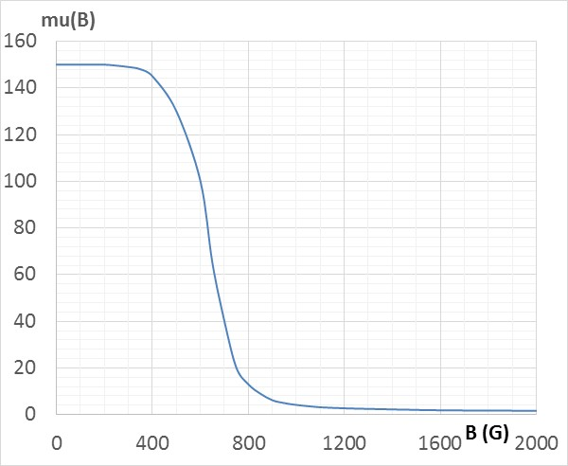

**Dec. 28, 2016**

**Iteration #2**

S_sign = 248 mm2

N_dr = 183

N_sign = 80

V_sign = S_sign*dB/dt*N_sign 🡪 dB/dt = V_sign / (S_sign*N_sign)

H*L = I_dr*N_dr 🡪 H = I_dr*N_dr/L

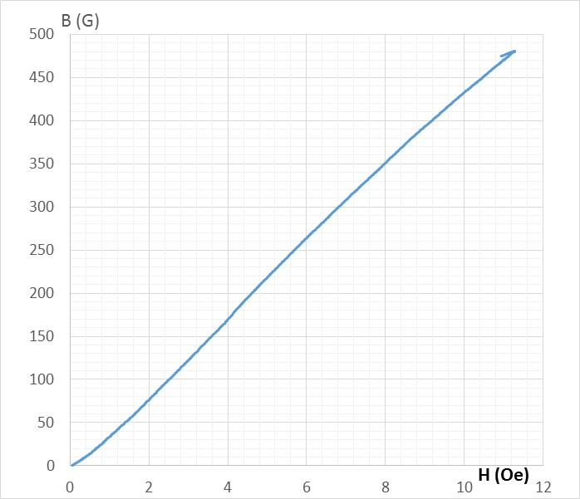 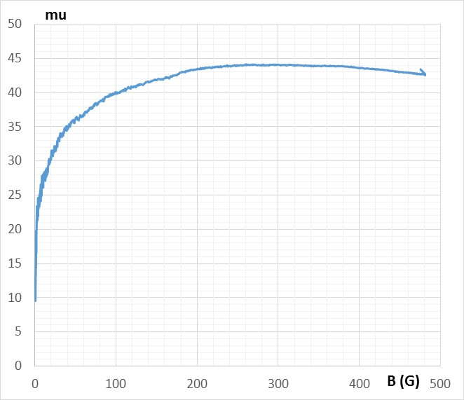

**Dec. 29, 2016**

**Iteration #3**

S_sign = 248 mm2

N_dr = 183

N_sign = 80

V_sign = S_sign*dB/dt*N_sign 🡪 dB/dt = V_sign / (S_sign*N_sign)

H*L = I_dr*N_dr 🡪 H = I_dr*N_dr/L

**Version B:**

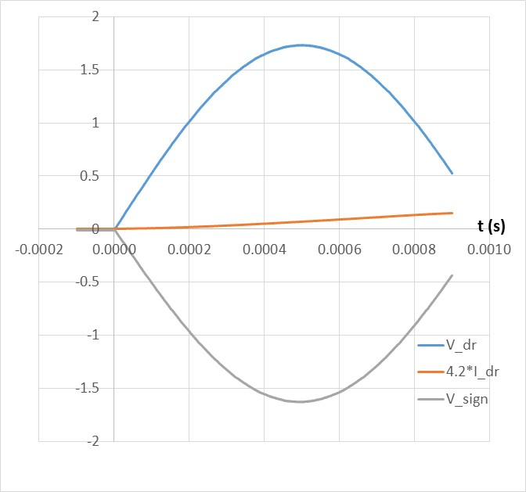

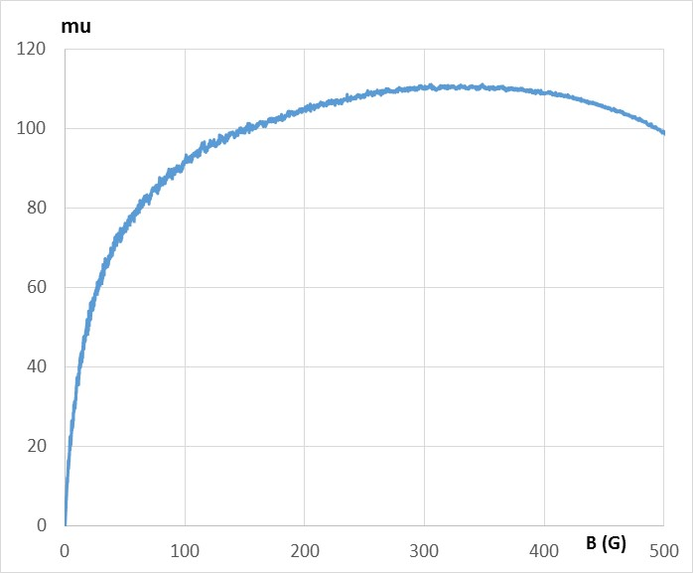

**Version A:**

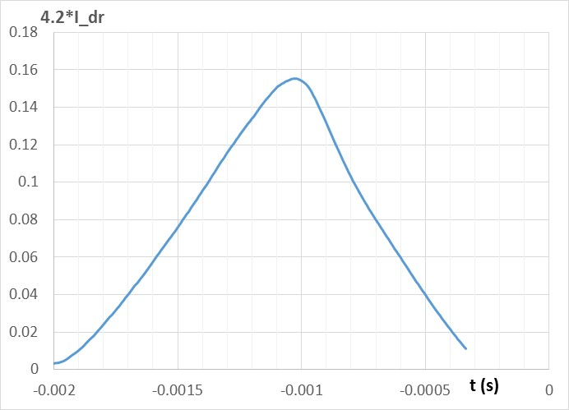

1. The permeability changes dramatically as the current returns back to zero.

Technically, the reason of this behavior is that the current crosses zero at t = -0.00025 s. At this moment the field is less than 100 G.

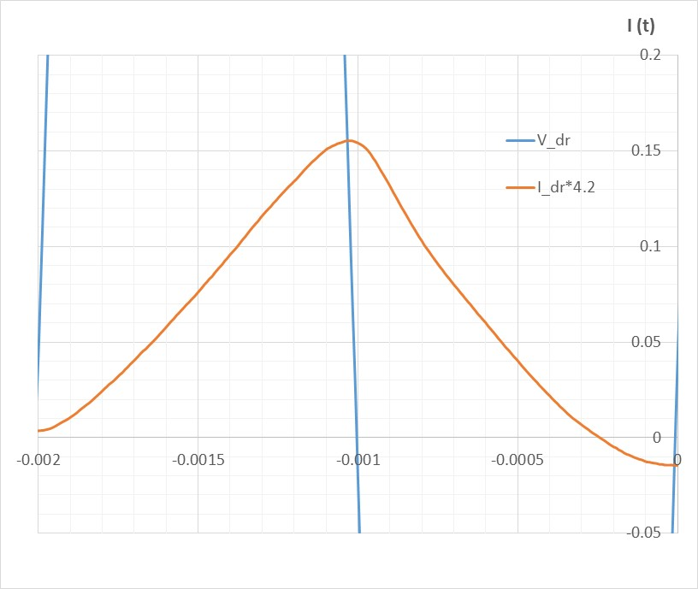

Physically, this is hysteresis that is responsible for this behavior:

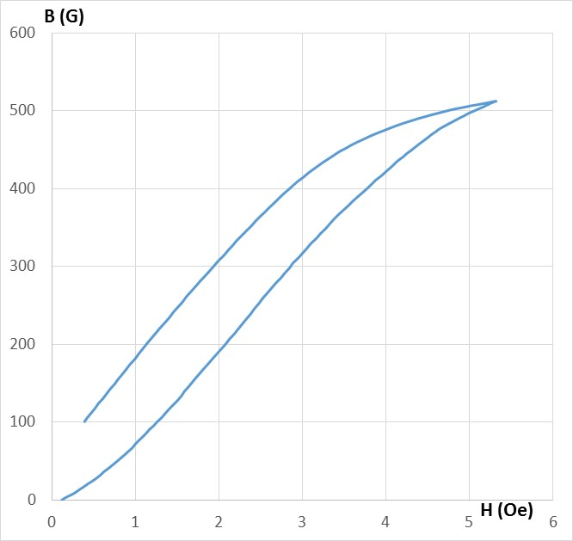

1. Obviously, the gaps in the flux return gives a lot of uncertainty, and we need to find a way to offset this.

**Suggested initial plan**:

1. Demagnetize before measuring and measure during only the rising part of the current pulse
2. Use version B as this may give better accuracy. Check this approach using one half of a period (that is current coming back to zero)
3. Make different clamping (vertical clamping) to get consistent results
4. Try to use a magnetic paste (ferrite nanoparticles in oil ?) to fill the gaps between the poles and the top plate of the flux return

<http://www.inframat.com/products/26FO3-08N3.htm> nanopower 50 g - $50

