PIP
BOOSTER UPGRADE
STATION 21 AND 22 STATUS
26, April, 2017

- Plumbing: All the pieces are cut and Drew has been brazing them in his shop. Though he is working by himself, he believes he will be done by Friday 26 of April 2017.

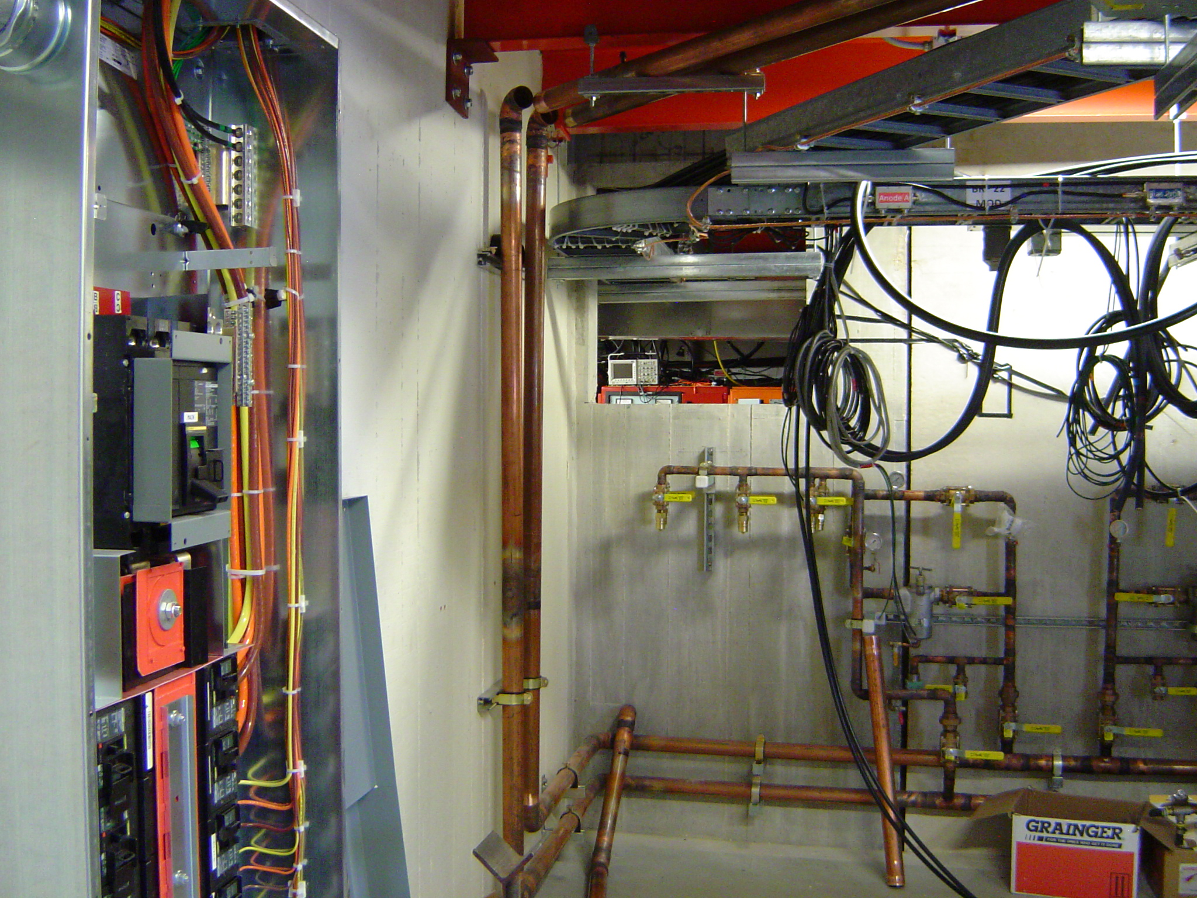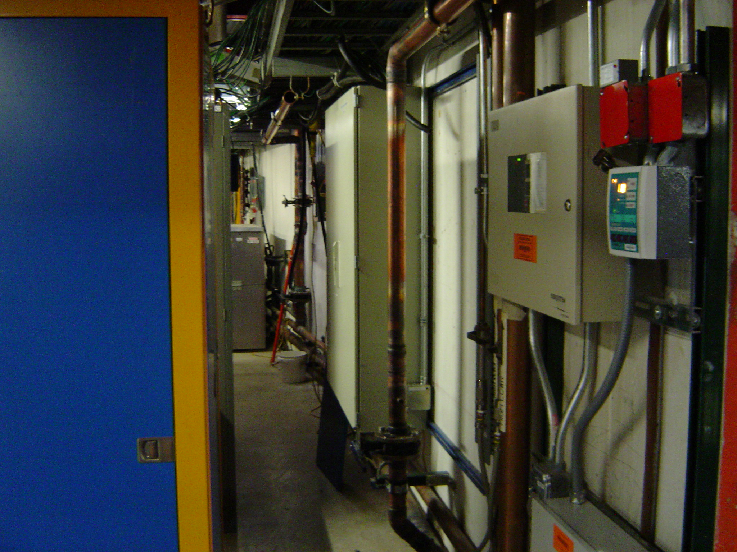

- Electrical: The room is all wired up. All we need is the 480 VAC coming into the room. Surveyors came to check the walls where the hole for the pipes were laid out and found rebar behind one of the marked holes. A new location was designated and just waiting for money to do the job.

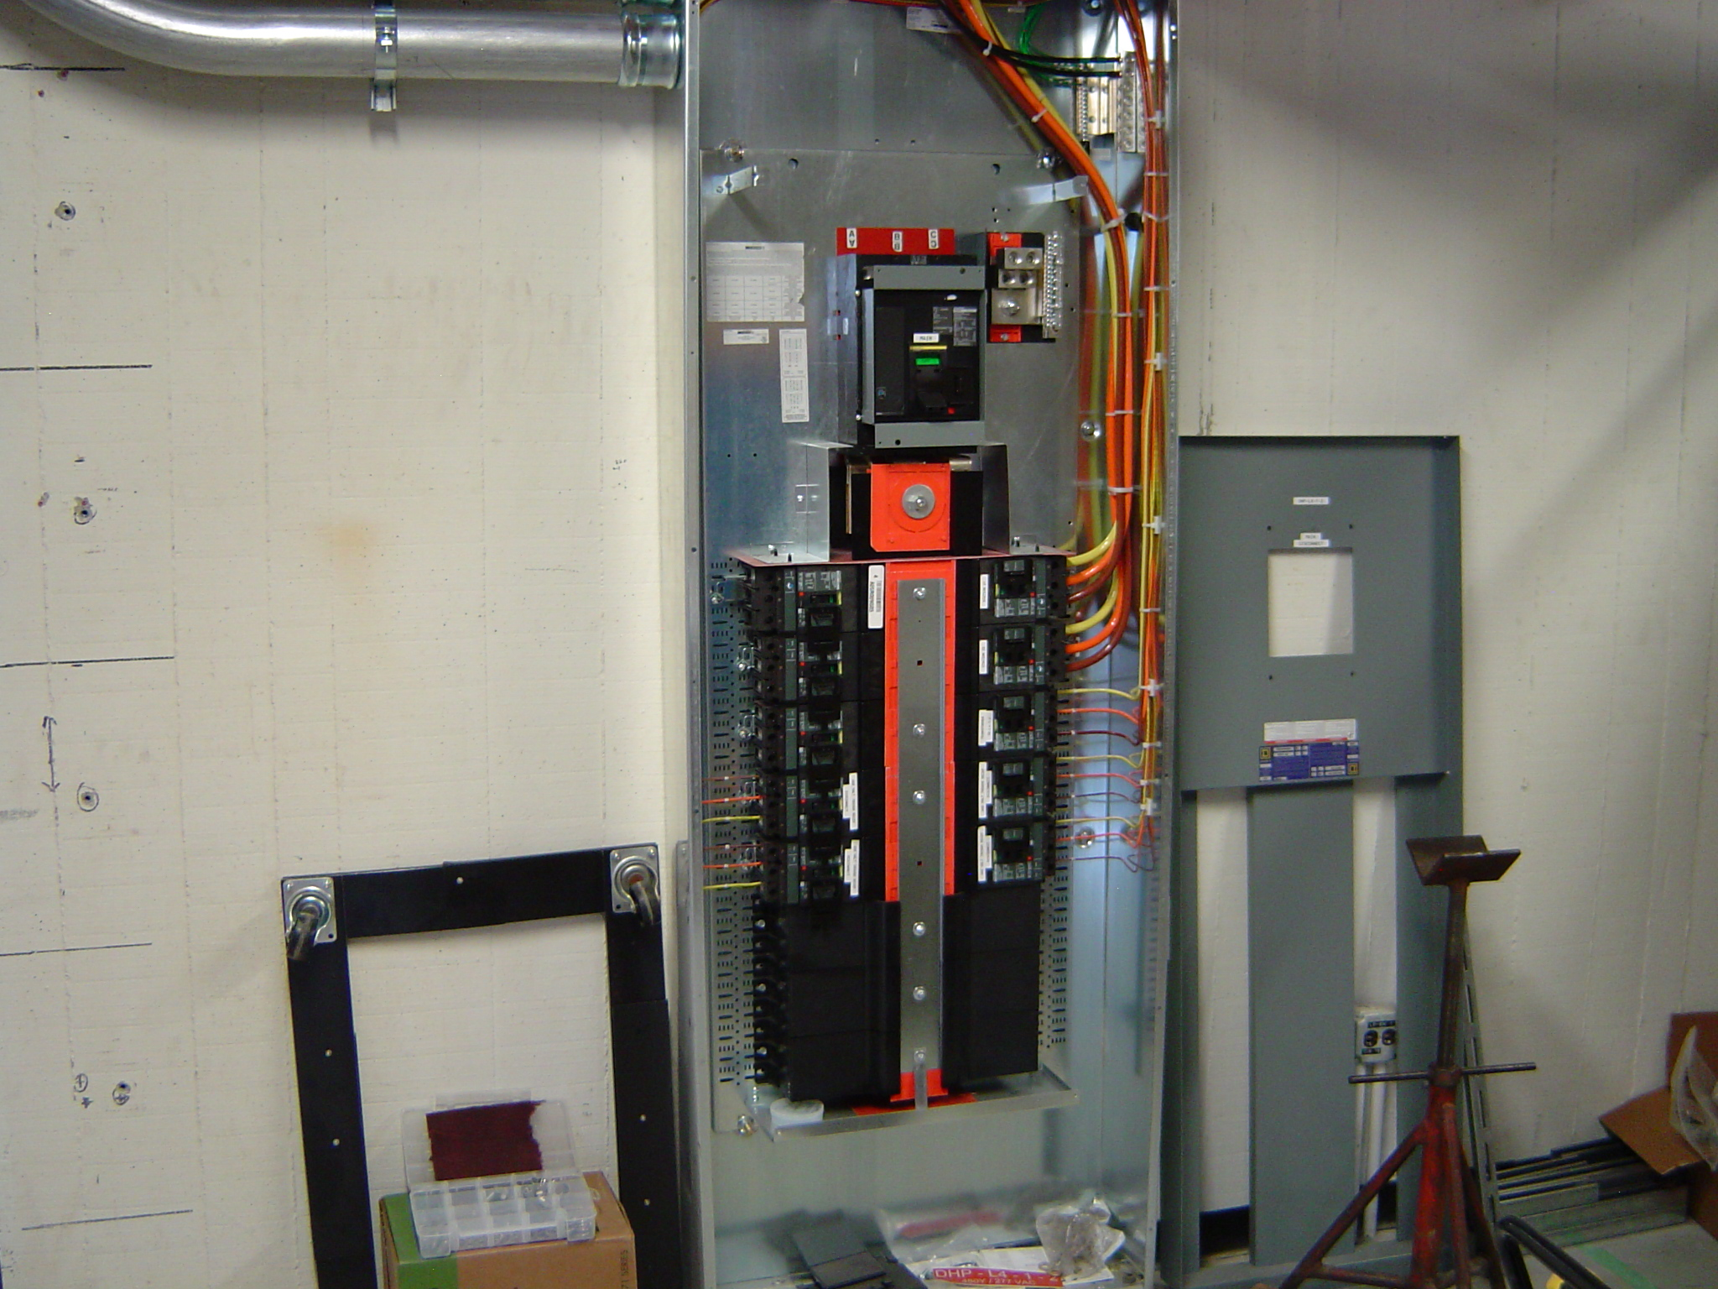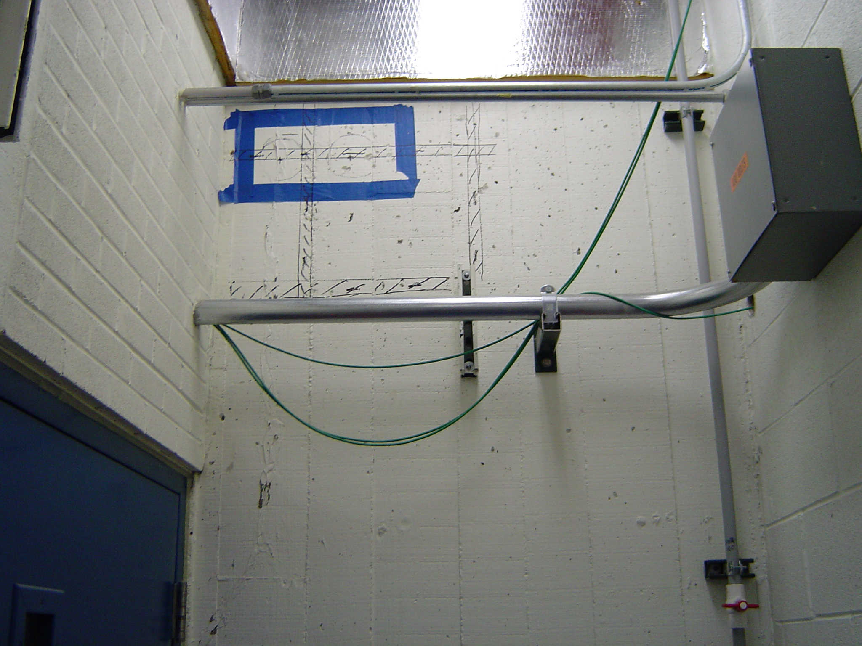

- Relay Racks: The Solid State Driver Racks are done and tested. The two RMU Racks still need the MEICU which Matt will finish as soon as we get the front panels which will be in this week. We are also waiting for the top panel of the RMU Rack to finish the A to D chassis. These panel should be in by next week.

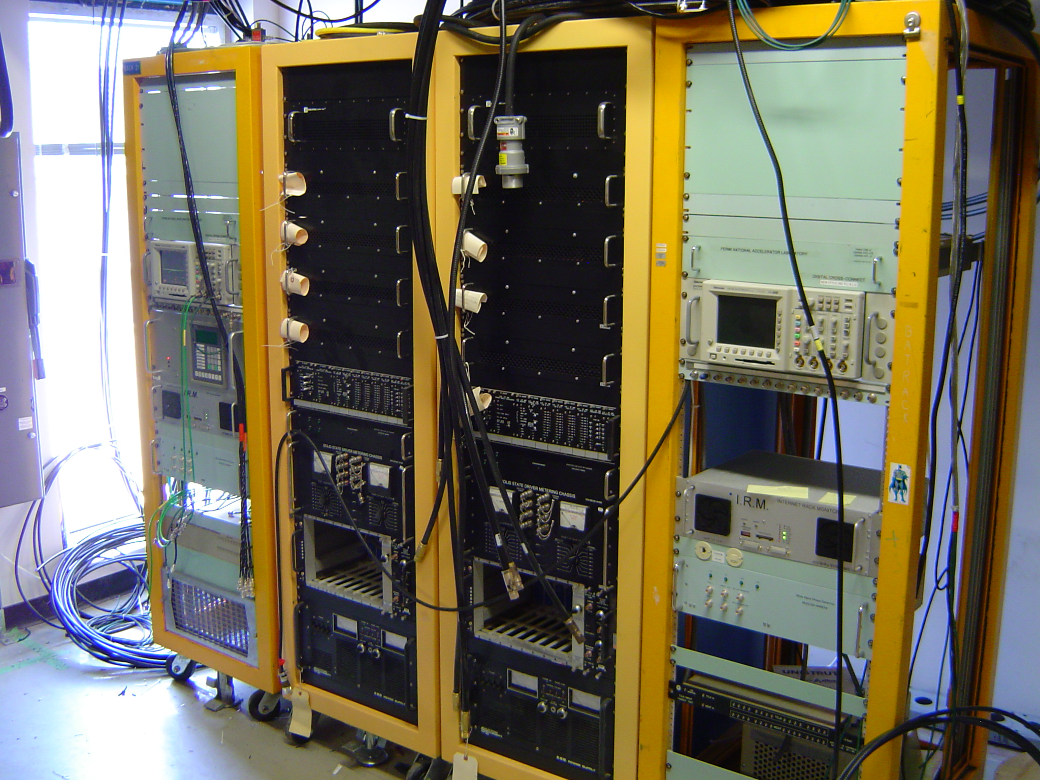

- Cables: All the cables are in place and being terminated. Still need to determine electrical length of RF cables and start phase matching them.

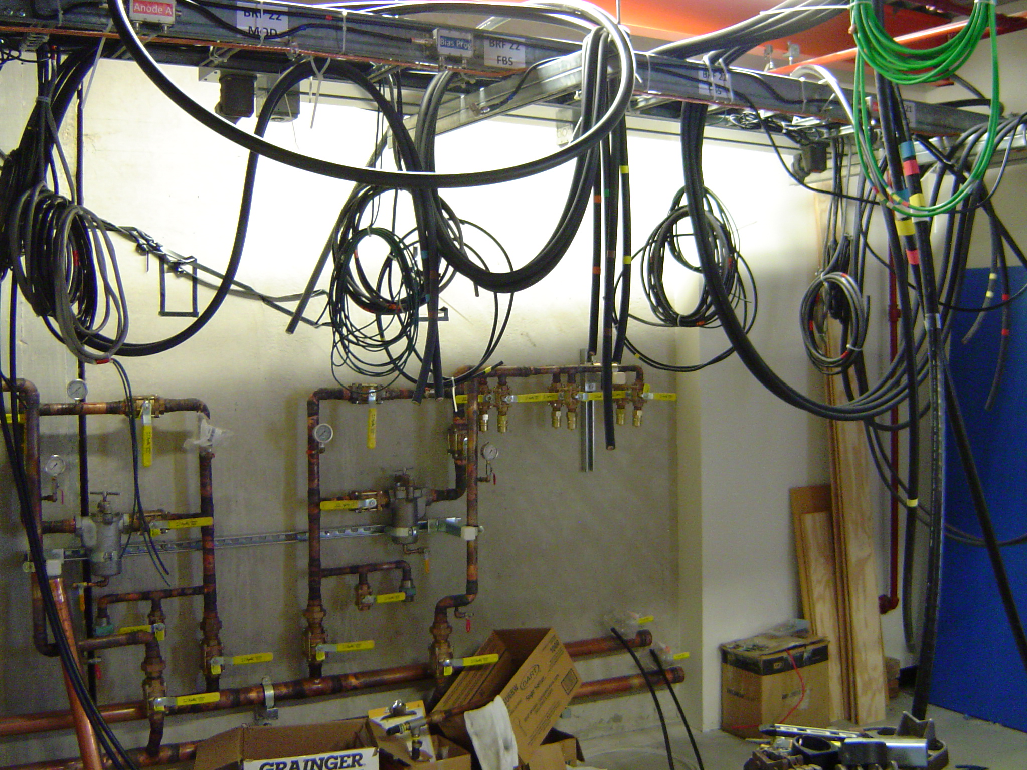

- Modulator: We have two Modulators. One of them is being brought to room BWG-124 today so Bob can start hooking up the cable to it.

- Bias Supply: We are making progress. About 80% of major components are in.

