Booster Beam Position Monitor System Requirements
Draft for Review
December 11, 2014
Revision 2.0

Table of Contents
1.0 Scope of Work 1
2.0 Functional and Technical Requirements 1
2.1 Number of BPM’s to be Instrumented 1
2.2 Booster System Parameters Effecting BPM System Design 1
2.3 Basic BPM Measurement and Data Acquisition Requirements 3
2.4 Applications Using BPM Data for Booster Operations and Studies 5
2.5 Position Sampling Logic 5
3.0 Planning The Booster Gallery Installation 7
4.0 Final Acceptance Testing 7
5.0 Documentation to be Archived 8
Appendix A: Pre-Upgrade BPM Electronics Installation Details 9
Period 1 Racks 9
Period 21 Racks 10
Period 18 Rack (BGW-North Corner) 11
Period 17 Racks 12
Period 14 Racks 13
Period 11 Racks 14
Appendix B: Pre-Upgrade Rack Layouts 15
Appendix C: Requirement and Specifications Review 20
Appendix D: Engineering Design Review 20

Tables and Figures
Table 2.2.1 Booster System Parameters 2
Table 2.3.1 Position Data Acquisition Requirements 3
Table 2.3.2 Typical sampling intervals through the Booster cycle 4
Table 2.4.1 List of ACNET Applications 5
Figure 2.5.1 Simplified block diagram of the Daughter Trigger Generator chassis. 7

Scope of Work

The scope of the Booster BPM upgrade includes the development and installation of the electronics that measures the BPM pickup RF signals and computes beam position and information. This requires the development of new electronic modules and front-end software for collecting and delivering measurement data to the operations control system. This project does not involve changing the BPM detectors or the cabling that comes up from the Booster Accelerator enclosure.
The upgrade is required to improve the stability of the Turn-by Turn measurement of the beam position used for basic machine tuning, aperture scan measurements and accelerator tune measurements. The new upgrade will eliminate issues with obsolescence of replacement parts used in the current BPM system. Using more modern digital methods, there is an opportunity for the new system to measure beam position around the entire Booster between the first turn of injected beam and the time when the beam is captured at the Booster LLRF frequency. The current system cannot determine beam position during this interval.
A total of 96 BPM measurements will be upgraded. Specific Booster operating parameters that the new BPM system must accommodate are listed in Section 4.0.
Requirements for the new BPM system include, on one side, an interface to the Booster Facility that includes details regarding rack space, power and environmental factors, and timing, gating and RF reference signals. On the other side there are the requirements of the applications for ACNET control and Booster operator diagnostics and tuning.

Functional and Technical Requirements

Number of BPM’s to be Instrumented
There are 51 BPM detectors, providing 102 position measurements that need to be instrumented. Appendix A lists the measured BPM positions according to the location in the Booster gallery where the electronics is expected to reside. Appendix B shows pre-upgrade rack layouts for the BPM electronics to indicate the space available for the new electronics.

Booster System Parameters Effecting BPM System Design
Table 2.1.1 lists Booster system parameters for both the present Booster, as well as the future Booster that will work with a new Linac proposed in the PIP II project.

Table 2.2.1 Booster System Parameters
Booster System Parameter | Present Value | Future PIP II Value
Beam Frequency | 37 to 53 MHz | 45 to 53 MHz
Cycle Duration | 33.3 ms (½15 Hz) | 33.3 ms (½ 15 Hz)  25.0 ms (½ 20 Hz)
Cycle Repetition Rate | 15 Hz | 15 Hz or 20 Hz
Batch Intensity | 2E11 to 7E12 protons per batch | same
Harmonic # | 84 | same
Capture | Multi-Turn Adiabatic Process  (1 – 18 turns)  201 MHz bunch structure at injection | Multi- Turn Bucket to Bucket  162.5 MHz Bunch structure  Injection Time – 600 ms
Extraction Notch  (Note 1) | 2 to 3 bucket notch created after beam bunching.  Time of notch creation changes every cycle. It is not set to particular turn or bucket. See Note 1  Work in progress to create the notch in the Linac . This would be synced to the Booster. | The notch will be created in the Linac and synced to the Booster.
Pinger System | Used to create a step in the position of a portion of the beam for the sake of measuring the tune of the accelerator.  Horizontal Pings and Vertical Pings may impact a variable number of bunches per turn.  The Pinger system must be synchronized to the BPM position sampling. | same
Note 1: Sampling the BPM position in the vicinity of the notch can result in measurement errors.

Basic BPM Measurement and Data Acquisition Requirements
The basic requirements for the measurement and data acquisition for the new BPM system are listed in Table 2.3.1.
Table 2.3.1 Position Data Acquisition Requirements
Parameter | Specification | Description
Position Horiz./Vert. Range | +/- 50.8 mm  (+/-2.0 inches)
Position Resolution | 0.2 mm
Position Accuracy | +/- 0.5 mm rms
Position Measurement Rise Time | 58 nano sec | Target Performance. See Note 1
 | 116 nano sec | Minimum Performance. See Note 1
Position Signal Bandwidth | 6.0 MHz | Target Performance. See Note 2
 | 3.0 MHz | Minimum Performance. See Note 2
Turn by Turn Sampling |  | See position sampling requirements in Section 2.5.
Time Between Position Samples | 2.22us to 1.59us | Turn-by-turn sampling interval is the revolution time which changes through the cycle. See Table 4.2.2
Data Points per Position per Cycle | 20,000 pts. | For each position every 15 Hz (66.6ms)
Ping Measurement Performance | Accurate positions for  5 bunch ping | This is the Target Performance
 | Accurate positions for 10 bunch ping | This is the Minimum Performance cutoff.
Position Measurements on 200MHz Injected Beam | Range, Resolution, Accuracy as above. | Target Performance: Beam positions at every BPM measured for the first turn of injected beam
Note 1: . Rise time is defined as the time required for the position measurement to rise from 10% to 90% of its steady state value in response to a step change in beam position.
Note 2: The bandwidth specifications are based on the required rise time of the position measurement. The bandwidth is estimated according to BW = 0.35/T_rise, which assumes a signal time constant transfer function

Table 2.3.2 Typical sampling intervals through the Booster cycle
Time in Cycle, ms | Rev. Time, sec | Bunch Spacing, sec
0 | 2.218E-06 | 26.4E-09
1 | 2.199E-06 | 26.2E-09
2 | 2.145E-06 | 25.5E-09
3 | 2.072E-06 | 24.7E-09
4 | 1.989E-06 | 23.7E-09
5 | 1.912E-06 | 22.8E-09
6 | 1.843E-06 | 21.9E-09
7 | 1.787E-06 | 21.3E-09
8 | 1.743E-06 | 20.8E-09
9 | 1.709E-06 | 20.3E-09
10 | 1.683E-06 | 20.0E-09
11 | 1.663E-06 | 19.8E-09
12 | 1.647E-06 | 19.6E-09
13 | 1.635E-06 | 19.5E-09
14 | 1.626E-06 | 19.4E-09
15 | 1.619E-06 | 19.3E-09
16 | 1.613E-06 | 19.2E-09
17 | 1.609E-06 | 19.2E-09
18 | 1.605E-06 | 19.1E-09
19 | 1.602E-06 | 19.1E-09
20 | 1.600E-06 | 19.0E-09
21 | 1.598E-06 | 19.0E-09
22 | 1.597E-06 | 19.0E-09
23 | 1.595E-06 | 19.0E-09
24 | 1.594E-06 | 19.0E-09
25 | 1.593E-06 | 19.0E-09
26 | 1.593E-06 | 19.0E-09
27 | 1.592E-06 | 19.0E-09
28 | 1.592E-06 | 18.9E-09
29 | 1.591E-06 | 18.9E-09
30 | 1.591E-06 | 18.9E-09
31 | 1.591E-06 | 18.9E-09
32 | 1.591E-06 | 18.9E-09
33 | 1.591E-06 | 18.9E-09

Applications Using BPM Data for Booster Operations and Studies
The ACNET applications listed in Table 2.4.1 use data from the current Booster BPM data acquisition system. They are all required and expected to remain and be supported by a new BPM data acquisition system. The AD/Controls Group writes and maintains these applications and is expected to continue to do so. Specifications for the data acquisition necessary to support these applications will be made by them to the AD/Instrumentation Group.
Table 2.4.1 List of ACNET Applications
Current ACNET Application | Booster Function
B38  Turn by Turn BPM | A variety of methods for analyzing Turn by Turn data from one or multiple BPM’s. This includes analysis of the ping/tune data, plotting on one BPM versus another in an XY plot, and analyzing the orbit using Fourier Transforms of the data.
B40  Booster Orbit | This beam orbit display utility provides methods for plotting the beam position at each BPM for a specific point in time for specific types of cycles. Orbit data is derived by averaging a number of position measurements at each BPM to determine the mean beam orbit.
B80  Booster Orbit Correction | Currently 7 “break points” or times points in the cycle, are defined for the corrector dipole current ramps. This orbit correction program will determine a best dipole ramp using BPM positions at these break points.
Snapshot Plotting (setup from a parameter page of the Utilities menu) | From an ACNET console one can plot BPM traces on Snapshot plots, but currently this is limited to plotting data for only the Booster TClk/Reset Event setup in the B40 application. It is desired to be able to plot Orbit Data, derived from an average of a fixed number of turn by turn position measurements, for the reset event chosen for the other data plotted on the Snapshot plot.
B75  Aperture Scanning | The aperture scan application manipulates corrector dipoles using a 3-bump or 5-bump method while monitoring BPM positions and beam intensity. The data acquisition settings for the BPM data acquisition are setup in the B40 page.
B40  Booster Orbit Archiver | Records the Booster orbit several times a day. This is a slot 7 sa (sa4007) application which runs constantly on console 9. Management, plot, and retrieval functions are under the archive menu of B40.

Position Sampling Logic
There are two general requirements in acquiring the BPM position measurements. First, it is desired to record a position from each vertical and horizontal BPM on each revolution of the beam, each turn. The second objective is for every BPM around the Booster to measure the position of the same portion of the circulating beam. These objectives are achieved with the individual timing of the sampling for each BPM. A description of the current (pre-upgrade) method for managing the sampling triggers is given in the document “Installation, Timing and Gating Details for the BPM’s in the Booster”, April 16, 2014, Beams-doc-3696-v2.
Turn by turn sampling implies a sample each revolution period. The Booster revolution frequency is the Booster Low Level RF divided by the harmonic number, 84. The Booster LLRF frequency increases through the cycle according to the sum of a predefined curve and a real time phase error between the LLRF reference signal and the bunched beam wall monitor pickup signal. The phase error feedback to the LLRF reference keeps it phase locked to the bunched Booster Beam.
The LLRF reference is distributed to all the BPM electronics racks around the Booster. This RF signal converted to a logic clock and divided by 84 using digital logic provides a position sampling reference.
In order for each BPM distributed around the Booster to sample the same portion of beam, the sampling reference needs to be delayed in two ways. The first delay provides compensation for the beam transport delay. The beam transport delay changes in proportion to the revolution frequency, which is proportional to the LLRF frequency, and can hence be compensated by delaying the sampling by a number of LLRF periods. Typically this delay will be between 0 and 7 periods for the particular BPM’s cabled to a specific rack location. The second delay that needs to be compensated for is the signal propagation delay coming up the Heliax cables from the detectors to the position measuring electronics. It is the differential between the varying cable lengths for each BPM that needs to be compensated for, and the delay added to all but the BPM(s) with the longest cable runs is considered a fixed delay. That is it does not vary through the cycle.
In order to provide a reference for all the individual sampling delays to start from, an “Injection Sync” signal is distributed around to all of the BPM electronics racks around the Booster. This sync signal is also provided to other processes that need to run synchronously with the beam position sampling. One such process is the beam pinger which is used for the accelerator tune measurement. Note that the cable delay incurred with the distribution of the Injection Sync and LLRF signals becomes part of the delay compensation.
A block diagram of the logic currently used for managing the delays and producing individual sampling triggers is illustrated in Figure 2.5.1.

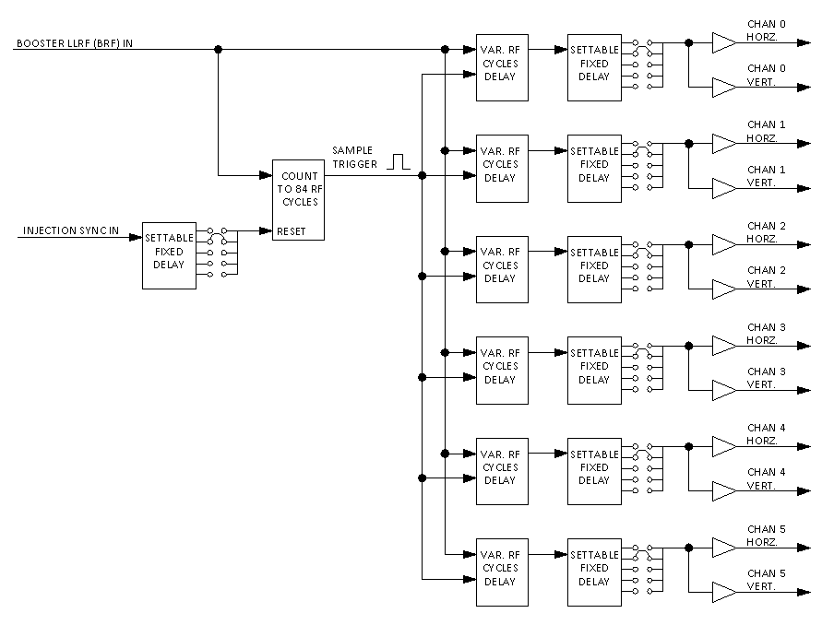
Figure 2.5.1 Simplified block diagram of the Daughter Trigger Generator chassis.

Planning The Booster Gallery Installation
Installation plans including rack layouts, AC power strip usage, additional airflow equipment, addition cable routing in the gallery and rack usage beyond what is made available by the removal of the old BPM electronics is to be reviewed by the Booster and possibly the AD/RF support department. This is to be reviewed before final production of the equipment to be installed.

Final Acceptance Testing
Final acceptance will be given and the project complete milestone will be reached once all of the BPM measurements have been brought online and tested using the ACNET application listed in Table 2.4.1 and found to provide correct results. Additional application, or modified versions of existing ones, may be required to measure position accuracy and resolution more directly.
???

Documentation to be Archived

???
Schematics, Bill of Materials, Mechanical Assembly Drawings, Fabrication and Assembly Instructions
List of programming tools and software versions, FPGA Code, Testing and Development Code
Front-End and ACNET application project files, compiler and linker tools and their version.
BPM calibration data and calculations for BPM position and intensity scaling.
BPM position sampling time delay calculations and settings.

Revision History
Revision 1.0: Removed the Figure 2.3.1 Illustrating the Ping Analysis and was more explicit in specifying a minimum position measurement rise time.
Revision 2.0: Made minor grammatical corrections. Made wording changes to the introduction and description of the interval after injection in which the current system (pre-upgrade) cannot make position measurements.

Appendix A: Pre-Upgrade BPM Electronics Installation Details

Period 1 Racks
BPM Positions: 26
Rack Numbers: G01-RR6-1, G01-RR6-2, G01-RR6-3.
BPM’s Serviced Here:
VME Crate: BBPM21
Name | Period | Demod Rack # | VME alias | VME MOD | VME CHAN
HL24 | 24 | G01-RR6-1 | HP24L | 0 | 0
VL24 | 24 | G01-RR6-1 | VP24L | 0 | 1
HS24 | 24 | G01-RR6-1 | HP24S | 0 | 2
VS24 | 24 | G01-RR6-1 | VP24S | 0 | 3
HL1 | 1 | G01-RR6-1 | HP01L | 1 | 0
VL1 | 1 | G01-RR6-1 | VP01L | 1 | 1
HS1 | 1 | G01-RR6-1 | HP01S | 1 | 2
VS1 | 1 | G01-RR6-1 | VP01S | 1 | 3
HL2 | 2 | G01-RR6-1 | HP02L | 2 | 0
VL2 | 2 | G01-RR6-1 | VP02L | 2 | 1
HS2 | 2 | G01-RR6-1 | HP02S | 2 | 2
VS2 | 2 | G01-RR6-1 | VP02S | 2 | 3
HL3 | 3 | G01-RR6-2 | HP03L | 3 | 0
VL3 | 3 | G01-RR6-2 | VP03L | 3 | 1
HS3 | 3 | G01-RR6-2 | HP03S | 3 | 2
VS3 | 3 | G01-RR6-2 | VP03S | 3 | 3
HL4 | 4 | G01-RR6-2 | HP04L | 4 | 0
VL4 | 4 | G01-RR6-2 | VP04L | 4 | 1
HS4 | 4 | G01-RR6-2 | HP04S | 4 | 2
VS4 | 4 | G01-RR6-2 | VP04S | 4 | 3
HL5 | 5 | G01-RR6-2 | HP05L | 5 | 0
VL5 | 5 | G01-RR6-2 | VP05L | 5 | 1
HS5 | 5 | G01-RR6-2 | HP05S | 5 | 2
VS5 | 5 | G01-RR6-2 | VP05S | 5 | 3
HP03LU | 3 | G01-RR6-3 | HP03LU | 7 | 2
VP03LU | 3 | G01-RR6-3 | VP03LU | 7 | 3

Period 21 Racks
BPM Positions: 12
Rack Numbers: G21-RR5-1, G21-RR5-2, G21-RR5-3.
BPM’s Serviced Here:
VME Crate: BBPM21
Name | Period | Demod Rack # | VME alias | VME MOD | VME CHAN
HL21 | 21 | G21-RR5-2 | HP21L | 0 | 0
VL21 | 21 | G21-RR5-2 | VP21L | 0 | 1
HS21 | 21 | G21-RR5-2 | HP21S | 0 | 2
VS21 | 21 | G21-RR5-2 | VP21S | 0 | 3
HL22 | 21 | G21-RR5-2 | HP22L | 1 | 0
VL22 | 21 | G21-RR5-2 | VP22L | 1 | 1
HS22 | 21 | G21-RR5-2 | HP22S | 1 | 2
VS22 | 21 | G21-RR5-2 | VP22S | 1 | 3
HL23 | 21 | G21-RR5-2 | HP23L | 2 | 0
VL23 | 21 | G21-RR5-2 | VP23L | 2 | 1
HS23 | 21 | G21-RR5-2 | HP23S | 2 | 2
VS23 | 21 | G21-RR5-2 | VP23S | 2 | 3

Period 18 Rack (BGW-North Corner)
BPM Positions: 12
Rack Numbers: Period 18 - 20.
BPM’s Serviced Here:
VME Crate: BBPM18
Name | Period | Demod Rack # | VME alias | VME MOD | VME CHAN
HL18 | 18 | P. 18-20 (BGW-North) | HP18L | 0 | 0
VL18 | 18 | P. 18-20 (BGW-North) | VP18L | 0 | 1
HS18 | 18 | P. 18-20 (BGW-North) | HP18S | 0 | 2
VS18 | 18 | P. 18-20 (BGW-North) | VP18S | 0 | 3
HL19 | 18 | P. 18-20 (BGW-North) | HP19L | 1 | 0
VL19 | 18 | P. 18-20 (BGW-North) | VP19L | 1 | 1
HS19 | 18 | P. 18-20 (BGW-North) | HP19S | 1 | 2
VS19 | 18 | P. 18-20 (BGW-North) | VP19S | 1 | 3
HL20 | 18 | P. 18-20 (BGW-North) | HP20L | 2 | 0
VL20 | 18 | P. 18-20 (BGW-North) | VP20L | 2 | 1
HS20 | 18 | P. 18-20 (BGW-North) | HP20S | 2 | 2
VS20 | 18 | P. 18-20 (BGW-North) | VP20S | 2 | 3

Period 17 Racks
BPM Positions: 12
Rack Numbers: G17-RR2, G17-RR1-3.
BPM’s Serviced Here:
VME Crate: BBPM15
Name | Period | Demod Rack # | VME alias | VME MOD | VME CHAN
HL15 | 17 | G17-RR2 | HP15L | 0 | 0
VL15 | 17 | G17-RR2 | VP15L | 0 | 1
HS15 | 17 | G17-RR2 | HP15S | 0 | 2
VS15 | 17 | G17-RR2 | VP15S | 0 | 3
HL16 | 17 | G17-RR2 | HP16L | 1 | 0
VL16 | 17 | G17-RR2 | VP16L | 1 | 1
HS16 | 17 | G17-RR2 | HP16S | 1 | 2
VS16 | 17 | G17-RR2 | VP16S | 1 | 3
HL17 | 17 | G17-RR2 | HP17L | 2 | 0
VL17 | 17 | G17-RR2 | VP17L | 2 | 1
HS17 | 17 | G17-RR2 | HP17S | 2 | 2
VS17 | 17 | G17-RR2 | VP17S | 2 | 3

Period 14 Racks
BPM Positions: 12
Rack Numbers: G14-RR1.
BPM’s Serviced Here:
VME Crate: BBPM12
Name | Period | Demod Rack # | VME alias | VME MOD | VME CHAN
HL12 | 14 | G14-RR1 | HP12L | 0 | 0
VL12 | 14 | G14-RR1 | VP12L | 0 | 1
HS12 | 14 | G14-RR1 | HP12S | 0 | 2
VS12 | 14 | G14-RR1 | VP12S | 0 | 3
HL13 | 14 | G14-RR1 | HP13L | 1 | 0
VL13 | 14 | G14-RR1 | VP13L | 1 | 1
HS13 | 14 | G14-RR1 | HP13S | 1 | 2
VS13 | 14 | G14-RR1 | VP13S | 1 | 3
HL14 | 14 | G14-RR1 | HP14L | 2 | 0
VL14 | 14 | G14-RR1 | VP14L | 2 | 1
HS14 | 14 | G14-RR1 | HP14S | 2 | 2
VS14 | 14 | G14-RR1 | VP14S | 2 | 3

Period 11 Racks
BPM Positions: 28
Rack Numbers: G11-RR6-1, G11-RR6-2, G11-RR6-3.
BPM’s Serviced Here:
VME Crate: BBPM06
Name | Period | Demod Rack # | VME alias | VME MOD | VME CHAN
HL6 | 11 | G11-RR6-2 | HP06L | 0 |  | 0
VL6 | 11 | G11-RR6-2 | VP06L | 0 |  | 1
HS6 | 11 | G11-RR6-2 | HP06S | 0 |  | 2
VS6 | 11 | G11-RR6-2 | VP06S | 0 |  | 3
HL7 | 11 | G11-RR6-2 | HP07L | 1 |  | 0
VL7 | 11 | G11-RR6-2 | VP07L | 1 |  | 1
HS7 | 11 | G11-RR6-2 | HP07S | 1 |  | 2
VS7 | 11 | G11-RR6-2 | VP07S | 1 |  | 3
HL8 | 11 | G11-RR6-2 | HP08L | 2 |  | 0
VL8 | 11 | G11-RR6-2 | VP08L | 2 |  | 1
HS8 | 11 | G11-RR6-2 | HP08S | 2 |  | 2
VS8 | 11 | G11-RR6-2 | VP08S | 2 |  | 3
HL9 | 11 | G11-RR6-1 | HP09L | 3 |  | 0
VL9 | 11 | G11-RR6-1 | VP09L | 3 |  | 1
HS9 | 11 | G11-RR6-1 | HP09S | 3 |  | 2
VS9 | 11 | G11-RR6-1 | VP09S | 3 |  | 3
HL10 | 11 | G11-RR6-1 | HP10L | 4 |  | 0
VL10 | 11 | G11-RR6-1 | VP10L | 4 |  | 1
HS10 | 11 | G11-RR6-1 | HP10S | 4 |  | 2
VS10 | 11 | G11-RR6-1 | VP10S | 4 |  | 3
HL11 | 11 | G11-RR6-1 | HP11L | 5 |  | 0
VL11 | 11 | G11-RR6-1 | VP11L | 5 |  | 1
HS11 | 11 | G11-RR6-1 | HP11S | 5 |  | 2
VS11 | 11 | G11-RR6-1 | VP11S | 5 |  | 3
HUL6 | 11 | G11-RR6-3 | HP06LU | 7 |  | 0
VUL6 | 11 | G11-RR6-3 | VP06LU | 7 |  | 1
HUL7 | 11 | G11-RR6-3 | HP07LU | 7 |  | 2
VUL7 | 11 | G11-RR6-3 | VP07LU | 7 |  | 3

Appendix B: Pre-Upgrade Rack Layouts

These drawings show how the BPM racks in the Booster Gallery were populated before the upgrade. This is a starting point for planning the space usage for the new system. The areas outlined in red are the spaces occupied by the current BPM electronics that could be used for the new BPM electronics.

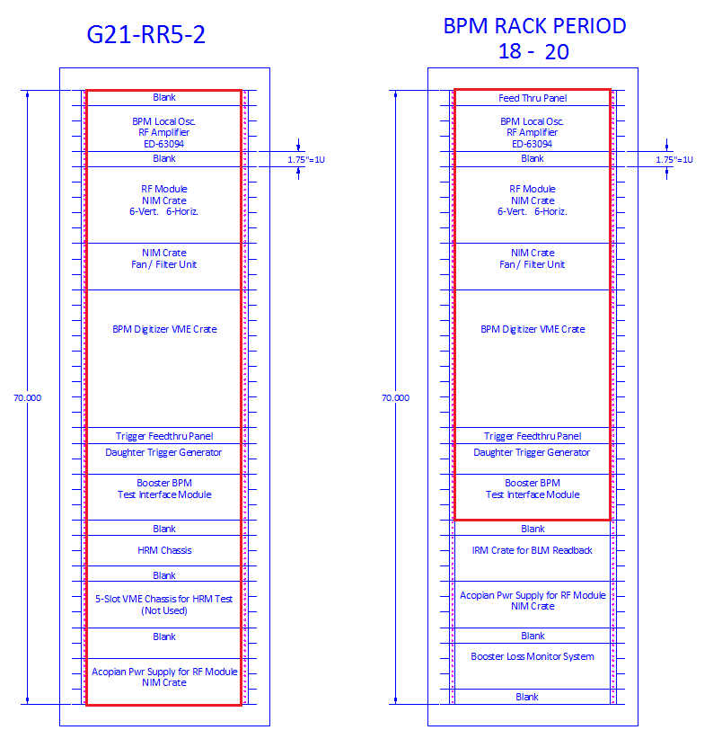

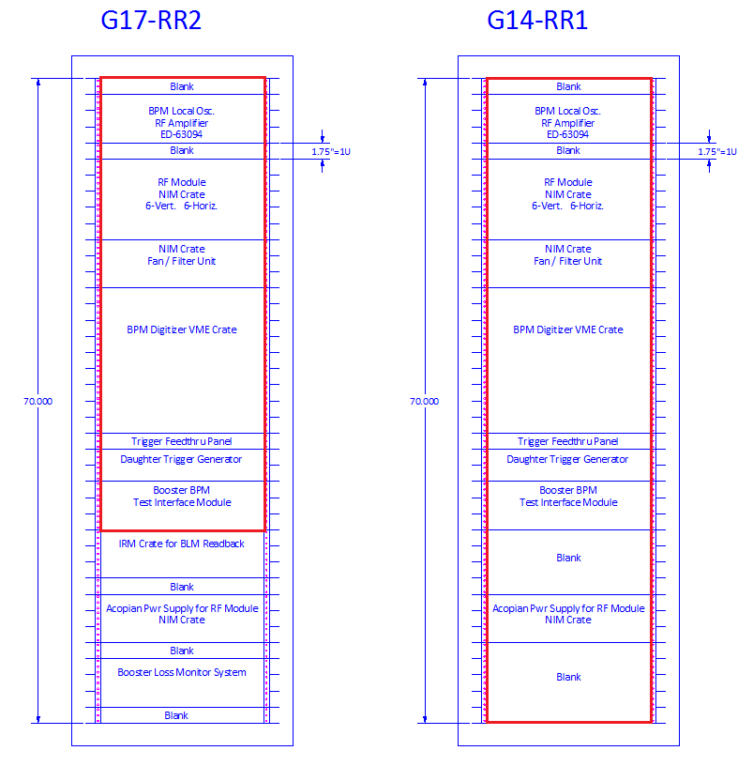

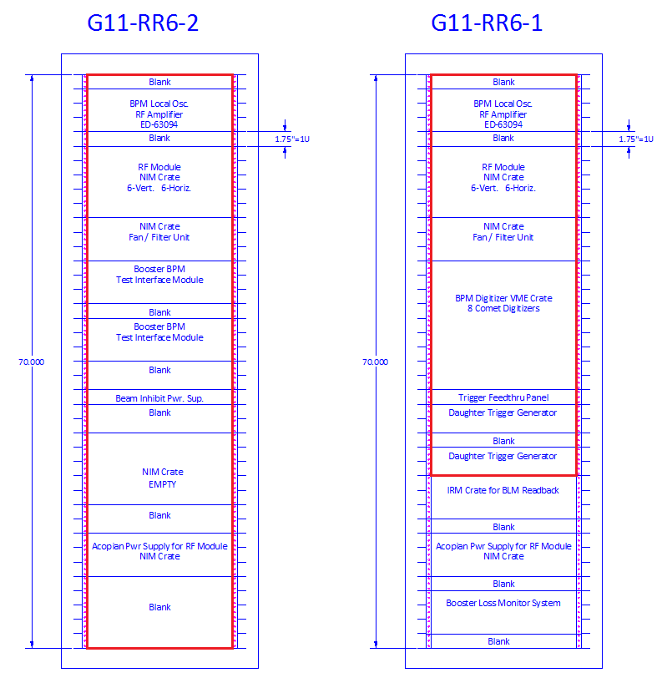

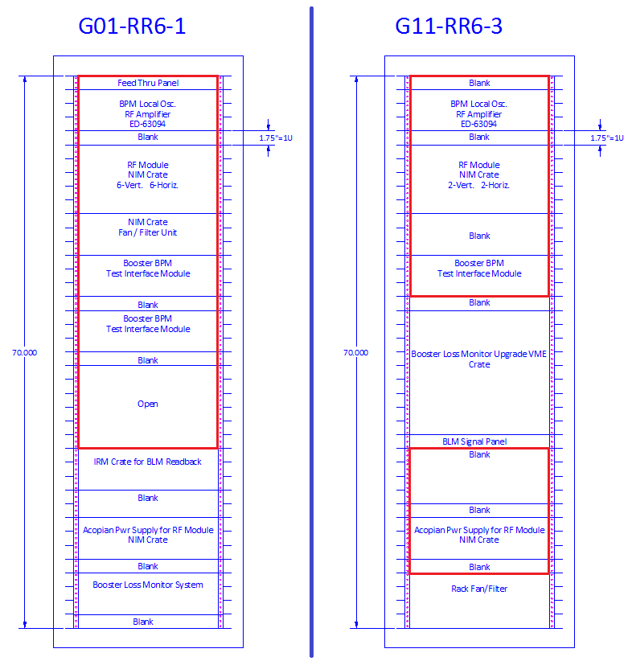

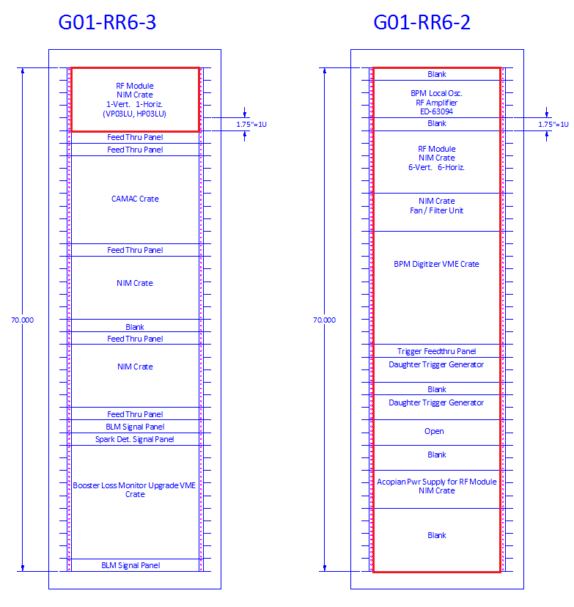

Appendix C: Requirement and Specifications Review

???
Schedule, hold and document the following
- 1st meeting with Peter to discuss the available hardware proposed for use in the Booster.
- Draft and send out the Requirements and Specifications document for comment and review.
- 2nd meeting to discuss the draft Requirements and Specifications document.
- 3rd meeting to accept and finalize Requirements and Specification document.
Produce Requirements and Specifications Review Document
Include:
Project Description
Those in attendance (Presenters and Reviewers)
Review Date
Reference the Specifications document
Review findings and decision to go ahead with production and installation
Any recommendations and action items

Appendix D: Engineering Design Review

???
Review the following items
- Initial Field Test Results
- BPM position calibrations
- ACNET application performance
- Installation plans and operations impact.
Document the results in a report listing any action items.
Discuss any impact or changes the original Requirements and Specifications.

