Installation Planning for Booster BPM DAQ Upgrade

Craig Drennan
April 18, 2014

Contents
Installation Planning for BPM-HRM Booster DAQ Extension 1
Figures 3
I. Introduction 4
Adapter Cable Assembly Specification 6
Length Table for Individual Lemo to 37 Pin DSub Cable Assembly 6
II. Period 1 Racks 7
Period 1 -- TODO 10
III. Period 21 Racks 11
Period 21 -- TODO 13
IV. Period 18 Rack (BGW-North Corner) 14
Period 18 -- TODO 18
V. Period 17 Racks 19
Period 17 -- TODO 23
VI. Period 14 Racks 24
Period 14 -- TODO 27
VII. Period 11 Racks 28
Period 11 -- TODO 31
VIII. BPM Listing 32

Figures

Figure I.1 Cabling modification for the BPM Position signals. 5
Figure II.1 G01-RR5 racks (front, top). 9
Figure II.2 G01-RR5 racks (front, bottom). 10
Figure II.3 G01-RR5 Digitizer VME crate (rear). 10
Figure III.1 G21-RR5 racks (front). 12
Figure III.2 G21-RR5-2 Digitizer VME crate (rear). 13
Figure III.3 G21-RR5-2 Digitizer VME crate close-up. 13
Figure IV.1. Period 18 rack (front) with modification proposal. 15
Figure IV.2 Period 18 rack rear views. 16
Figure IV.3 Period 18 Digitizer VME crate close-up. 17
Figure V.1 G17-RR2 rack front views. 20
Figure V.2 G17-RR2 Digitizer VME crate close-up. 21
Figure V.3 G17-RR1-1 rack. Possible location of the HRM and VME Crate 21
Figure V.4 G17-RR1-3 rack front views. 22
Figure VI.1 G14-RR2 rack (front). 25
Figure VI.2 G14-RR1 rack (top, front). 25
Figure VI.3 G14-RR1 rack (mid, front). 26
Figure VI.4 G14-RR1 rack (bottom, front). 26
Figure VII.1 G11-RR5 racks (top, front). 30

Introduction
This document is written to provide detail for planning the installation of new data acquisition electronics for the Beam Position Monitors (BPM’s) in the Booster. The original system includes several chassis. are digitized using Omnibyte 2 MHz “Comet” VME modules. The data from these modules is processed to provide turn by turn beam position plots for operations. It is desired to also be able to plot the BPM data in “Snap Shot” plots and “Fast Time” plots alongside other data such as beam losses, corrector magnet currents, etc..
We intend to accomplish this by teeing the BPM signals at the VME crates and additionally digitizing them using the HRM electronics. A proposal for this new cabling arrangement is shown in Figure 1. We are planning to mock-up the new cabling arrangement and test to see if there is any negative impact on the position signal or its digitized values.
The 64 channel HRM digitizer data is transmitted over a high speed serial link to a VME PMC carrier module with associated PMC Hotlink data link module and a VME power PC processor module. Both the HRM chassis and VME crates/power supplies will need to be installed.
We are also considering putting in new electronics for the Beam Loss Monitors (BLM’s). In a few of the locations, we are going to be adding full size VME crates to accommodate this in addition to the BPM-HRM readouts.
The following pages provide information on the physical location and installation of the current BPM position demodulation and position data acquisition electronics.

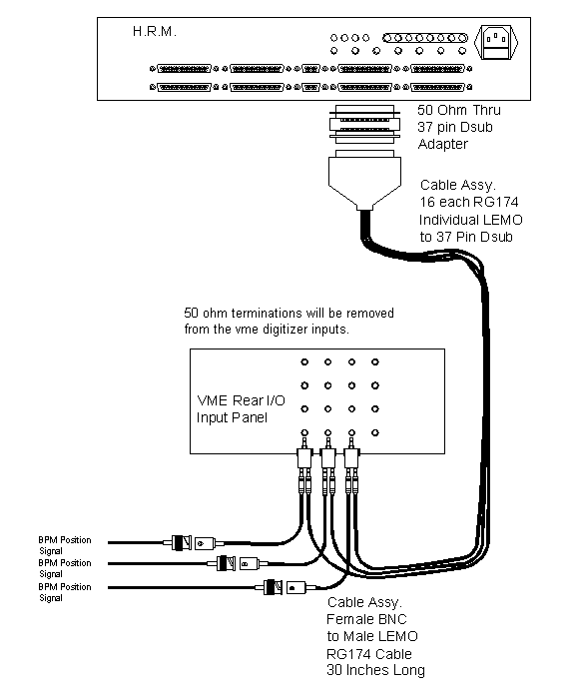
Figure I.1 Cabling modification for the BPM Position signals.

Adapter Cable Assembly Specification

Cable ================================
RG-174
Length = 30" +/- 0.5"

Connector 1 ==========================
LEMO - FFA.00.250.CTAC29Z - RF/Coaxial Connector or equivalent.
Manufacturer: LEMO
Newark Part Number: 70C8241
Manufacturer Part No: FFA.00.250.CTAC29Z

Connector 2 ==========================
AMPHENOL CONNEX - 112160 - RF/Coaxial Connector or equivalent.
Manufacturer: AMPHENOL CONNEX
Newark Part Number: 99H4294
Manufacturer Part No: 112160

Length Table for Individual Lemo to 37 Pin DSub Cable Assembly

Location | Length | Comment
G01-RR6-2 | 6 feet | This applies whether the HRM is in G01-RR6-2 or G01-RR6-1.
G21-RR5-2 | 6 feet | HRM in G21-RR5-2.
Period 18 | 6 feet
G17-RR2 | 20 feet | Cable runs from VME crate in G17-RR2 to HRM in the bottom of G17-RR1-3.
G14-RR1 | 6 feet
G11-RR6-1 | 8 feet | Cable runs from VME crate in G11-RR6-1 to HRM in G11-RR6-2.

Period 1 Racks
Status: Space Available
A 21-slot VME crate is installed in rack G01-RR6-3 that can be used for housing the VME processor for reading back the HRM data and for housing future Beam Loss Monitor Integrators. There appears to be plenty of space in rack G01-RR6-1 for mounting an HRM chassis.
Rack Numbers: G01-RR6-1, G01-RR6-2, G01-RR6-3.
BPM’s Serviced Here:
VME Crate: BBPM24
Name | Period | Demod Rack # | VME alias | VME MOD | VME CHAN | HRM alias | HRM CHAN | HRM PIN
HL24 | 24 | G01-RR6-1 | HP24L | 0 | 0 | HL24P | 0 | 1,20
VL24 | 24 | G01-RR6-1 | VP24L | 0 | 1 | VL24P | 1 | 2,21
HS24 | 24 | G01-RR6-1 | HP24S | 0 | 2 | HS24P | 2 | 3,22
VS24 | 24 | G01-RR6-1 | VP24S | 0 | 3 | VS24P | 3 | 4,23
HL1 | 1 | G01-RR6-1 | HP01L | 1 | 0 | HL01P | 4 | 5,24
VL1 | 1 | G01-RR6-1 | VP01L | 1 | 1 | VL01P | 5 | 6,25
HS1 | 1 | G01-RR6-1 | HP01S | 1 | 2 | HS01P | 6 | 7,26
VS1 | 1 | G01-RR6-1 | VP01S | 1 | 3 | VS01P | 7 | 8,27
HL2 | 2 | G01-RR6-1 | HP02L | 2 | 0 | HL02P | 8 | 9,28
VL2 | 2 | G01-RR6-1 | VP02L | 2 | 1 | VL02P | 9 | 10,29
HS2 | 2 | G01-RR6-1 | HP02S | 2 | 2 | HS02P | 10 | 11,30
VS2 | 2 | G01-RR6-1 | VP02S | 2 | 3 | VS02P | 11 | 12,31
HL3 | 3 | G01-RR6-2 | HP03L | 3 | 0 | HL03P | 12 | 13,32
VL3 | 3 | G01-RR6-2 | VP03L | 3 | 1 | VL03P | 13 | 14,33
HS3 | 3 | G01-RR6-2 | HP03S | 3 | 2 | HS03P | 14 | 15,34
VS3 | 3 | G01-RR6-2 | VP03S | 3 | 3 | VS03P | 15 | 16,35
HL4 | 4 | G01-RR6-2 | HP04L | 4 | 0 | HL04P | 16 | 1,20
VL4 | 4 | G01-RR6-2 | VP04L | 4 | 1 | VL04P | 17 | 2,21
HS4 | 4 | G01-RR6-2 | HP04S | 4 | 2 | HS04P | 18 | 3,22
VS4 | 4 | G01-RR6-2 | VP04S | 4 | 3 | VS04P | 19 | 4,23
HL5 | 5 | G01-RR6-2 | HP05L | 5 | 0 | HL05P | 20 | 5,24
VL5 | 5 | G01-RR6-2 | VP05L | 5 | 1 | VL05P | 21 | 6,25
HS5 | 5 | G01-RR6-2 | HP05S | 5 | 2 | HS05P | 22 | 7,26
VS5 | 5 | G01-RR6-2 | VP05S | 5 | 3 | VS05P | 23 | 8,27
HP03LU | 3 | G01-RR6-3 | HP03LU | 7 | 2 | HL03UP | 24 | 9,28
VP03LU | 3 | G01-RR6-3 | VP03LU | 7 | 3 | VL03UP | 25 | 10,29
HRM Patch Panel Connections
 |  | G01-RR6-1 |  |  |  | Input 26 | 26 | 11,30
 |  | G01-RR6-1 |  |  |  | Input 27 | 27 | 12,31
 |  | G01-RR6-1 |  |  |  | Input 28 | 28 | 13,32
 |  | G01-RR6-1 |  |  |  | Input 29 | 29 | 14,33
 |  | G01-RR6-1 |  |  |  | Input 30 | 30 | 15,34
 |  | G01-RR6-1 |  |  |  | Input 31 | 31 | 16,35

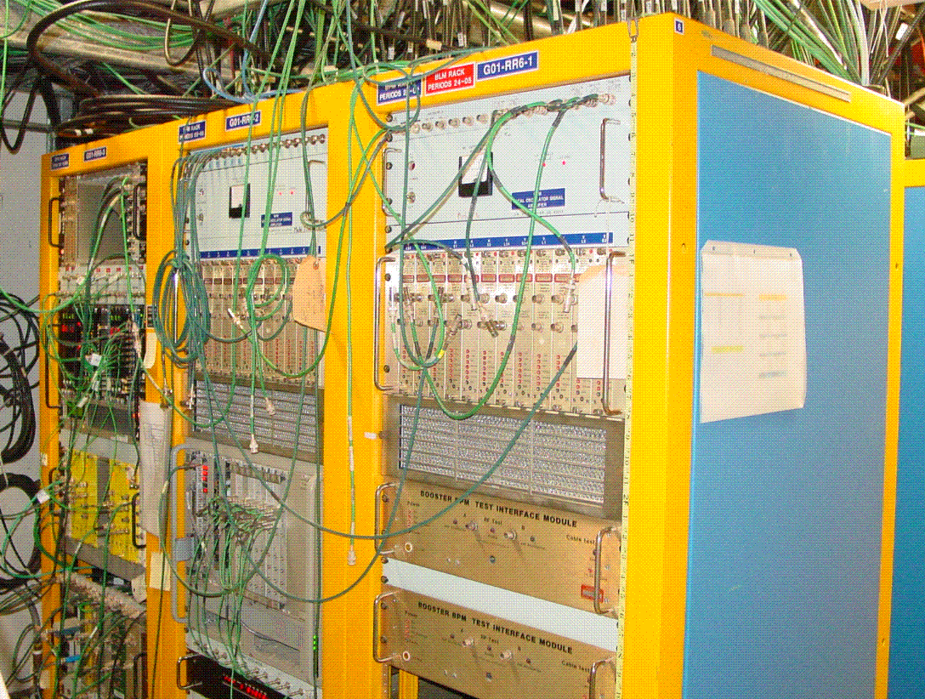
Figure II.1 G01-RR5 racks (front, top).
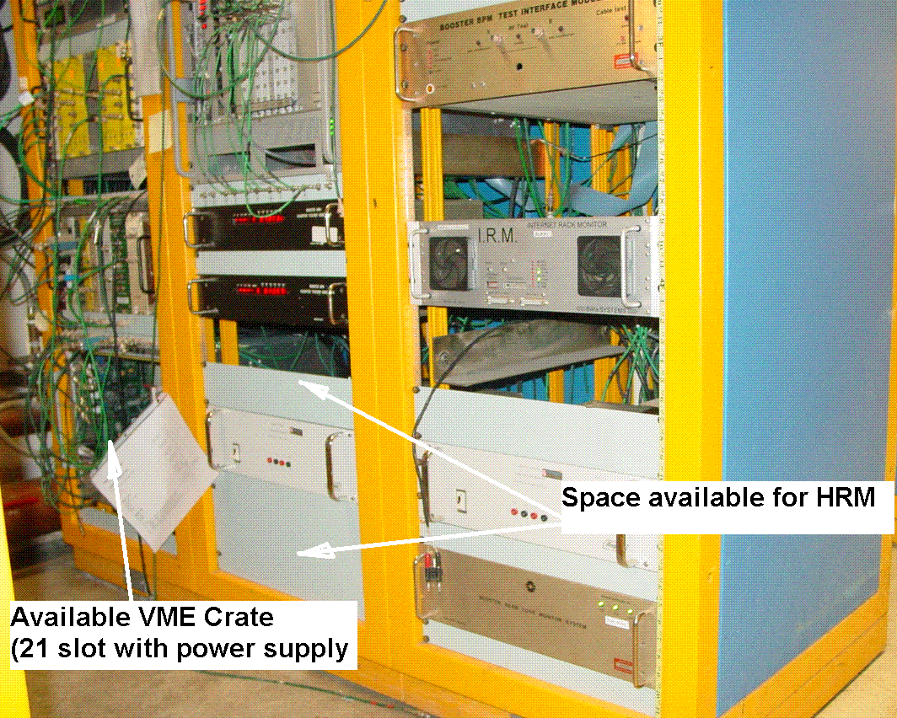
Figure II.2 G01-RR5 racks (front, bottom).
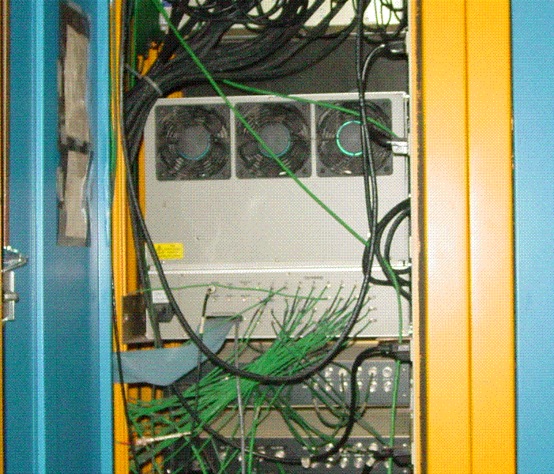
Figure II.3 G01-RR5 Digitizer VME crate (rear).

Period 1 -- TODO
- Procure components for the Lemo to 37 pin Dsub cable assembly. See length chart for cable length requirements.
- Build Lemo to 37 pin Dsub cable assembly.
- Install HRM into rack G01-RR6-2.
- Make BPM position signal cable modifications.
  - Label existing BPM position signal cables at the VME IO panel if necessary.
  - Attach to each signal cable a new Lemo Tee and reconnect to the VME IO panel in the correct port.
  - Run the multi-RG174 Lemo to 37 pin Dsub cable assembly in the rack.
  - Connect the cable for the assigned HRM channel to the appropriate position signal Lemo Tee.
  - Connect the 37 pin Dsub end of the assembly to the 50 Ohm connector adapter.
  - Connect the cable assembly with adapter to the HRM.
- Monitor the Turn-By-Turn and HRM data to ensure proper connections

Period 21 Racks
Status: Consider removing old corrector power supplies.
Once the old sextupole magnet power supplies are removed from Rack G21-RR5-1 there will be more than enough room for a VME crate at the location. A 5 slot VME crate and an HRM could be fit into G21-RR5-2 regardless of whether the old corrector power supplies are removed, however. The VME processor here could receive data from an HRM located here at period 21 and an HRM down the hall in the North-West corner of the Booster Gallery.
Rack Numbers: G21-RR5-1, G21-RR5-2, G21-RR5-3.
BPM’s Serviced Here:
VME Crate: BBPM21
Name | Period | Demod Rack # | VME alias | VME MOD | VME CHAN | HRM alias | HRM CHAN | HRM PIN
HL21 | 21 | G21-RR5-2 | HP21L | 0 | 0 | HL21P | 0 | 1,20
VL21 | 21 | G21-RR5-2 | VP21L | 0 | 1 | VL21P | 1 | 2,21
HS21 | 21 | G21-RR5-2 | HP21S | 0 | 2 | HS21P | 2 | 3,22
VS21 | 21 | G21-RR5-2 | VP21S | 0 | 3 | VS21P | 3 | 4,23
HL22 | 21 | G21-RR5-2 | HP22L | 1 | 0 | HL22P | 4 | 5,24
VL22 | 21 | G21-RR5-2 | VP22L | 1 | 1 | VL22P | 5 | 6,25
HS22 | 21 | G21-RR5-2 | HP22S | 1 | 2 | HS22P | 6 | 7,26
VS22 | 21 | G21-RR5-2 | VP22S | 1 | 3 | VS22P | 7 | 8,27
HL23 | 21 | G21-RR5-2 | HP23L | 2 | 0 | HL23P | 8 | 9,28
VL23 | 21 | G21-RR5-2 | VP23L | 2 | 1 | VL23P | 9 | 10,29
HS23 | 21 | G21-RR5-2 | HP23S | 2 | 2 | HS23P | 10 | 11,30
VS23 | 21 | G21-RR5-2 | VP23S | 2 | 3 | VS23P | 11 | 12,31

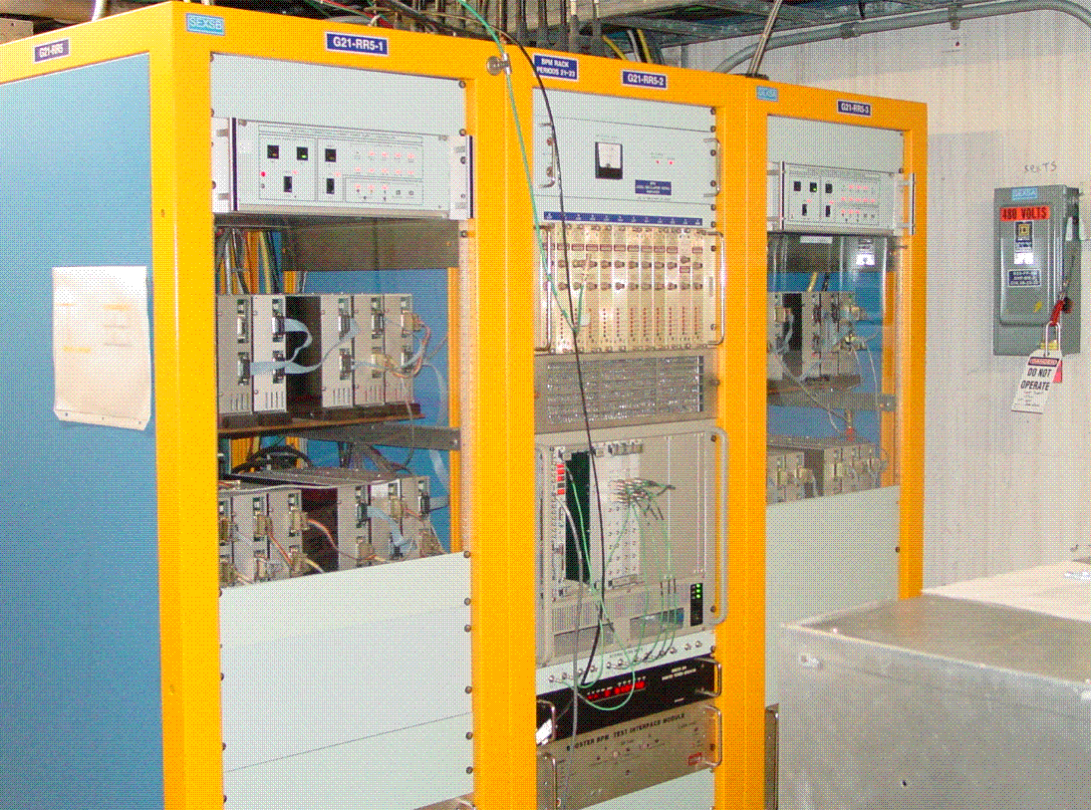
Figure III.1 G21-RR5 racks (front).
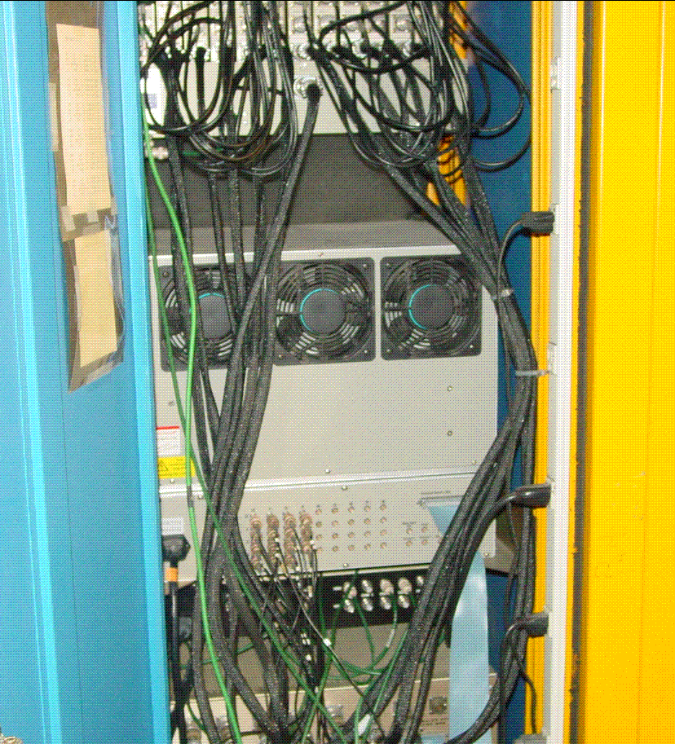
Figure III.2 G21-RR5-2 Digitizer VME crate (rear).
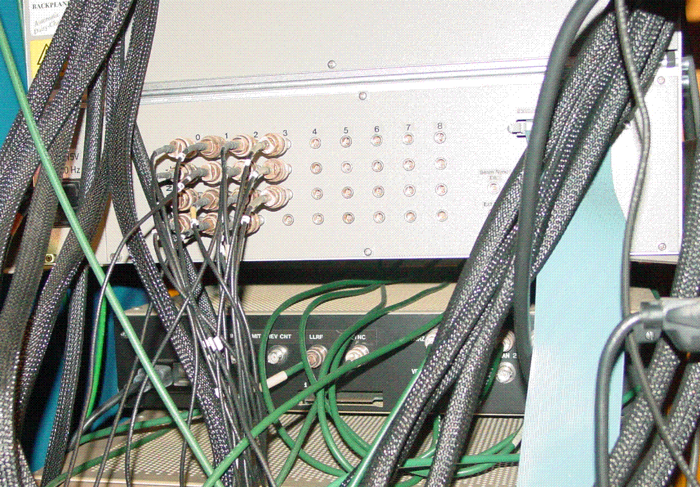
Figure III.3 G21-RR5-2 Digitizer VME crate close-up.

Period 21 -- TODO
- Procure components for the Lemo to 37 pin Dsub cable assembly. See length chart for cable length requirements.
- Build Lemo to 37 pin Dsub cable assembly.
- Install HRM and 5 Slot VME Crate into rack G21-RR5-2. The BPM RF Module Power Supply will need to be move upward or downward in the rack to make room.
- Run Hotlink cable from G21-RR5-2 down to the HRM in the Period 18 rack.
- Make BPM position signal cable modifications.
  - Label existing BPM position signal cables at the VME IO panel if necessary.
  - Remove existing BNC to Lemo adapter.
  - Attach to each signal cable the new BNC to Lemo cable and Lemo Tee and reconnect to the VME IO panel in the correct port.
  - Run the multi-RG174 Lemo to 37 pin Dsub cable assembly in the rack.
  - Connect the cable for the assigned HRM channel to the appropriate position signal Lemo Tee.
  - Connect the 37 pin Dsub end of the assembly to the 50 Ohm connector adapter.
  - Connect the cable assembly with adapter to the HRM.
- Monitor the Turn-By-Turn and HRM data to ensure proper connections

Period 18 Rack (BGW-North Corner)
Status: Difficult, limited space. Run Hotlink to VME at period 21.
This is a difficult location. We would need to squeeze in the HRM chassis and run the Hotlink data link down the hall to period 21 where the processor there would handle the data from both this HRM at period 18 and the HRM at period 21. The cable length for the Hotlink would be just under the 30 meter limit. The figures below indicate how we would squeeze in the HRM.
Rack Numbers: Period 18 - 20.
BPM’s Serviced Here:
VME Crate: BBPM18
Name | Period | Demod Rack # | VME alias | VME MOD | VME CHAN | HRM alias | HRM CHAN | HRM PIN
HL18 | 18 | P. 18-20 (BGW-North) | HP18L | 0 | 0 | HL18P | 0 | 1,20
VL18 | 18 | P. 18-20 (BGW-North) | VP18L | 0 | 1 | VL18P | 1 | 2,21
HS18 | 18 | P. 18-20 (BGW-North) | HP18S | 0 | 2 | HS18P | 2 | 3,22
VS18 | 18 | P. 18-20 (BGW-North) | VP18S | 0 | 3 | VS18P | 3 | 4,23
HL19 | 18 | P. 18-20 (BGW-North) | HP19L | 1 | 0 | HL19P | 4 | 5,24
VL19 | 18 | P. 18-20 (BGW-North) | VP19L | 1 | 1 | VL19P | 5 | 6,25
HS19 | 18 | P. 18-20 (BGW-North) | HP19S | 1 | 2 | HS19P | 6 | 7,26
VS19 | 18 | P. 18-20 (BGW-North) | VP19S | 1 | 3 | VS19P | 7 | 8,27
HL20 | 18 | P. 18-20 (BGW-North) | HP20L | 2 | 0 | HL20P | 8 | 9,28
VL20 | 18 | P. 18-20 (BGW-North) | VP20L | 2 | 1 | VL20P | 9 | 10,29
HS20 | 18 | P. 18-20 (BGW-North) | HP20S | 2 | 2 | HS20P | 10 | 11,30
VS20 | 18 | P. 18-20 (BGW-North) | VP20S | 2 | 3 | VS20P | 11 | 12,31

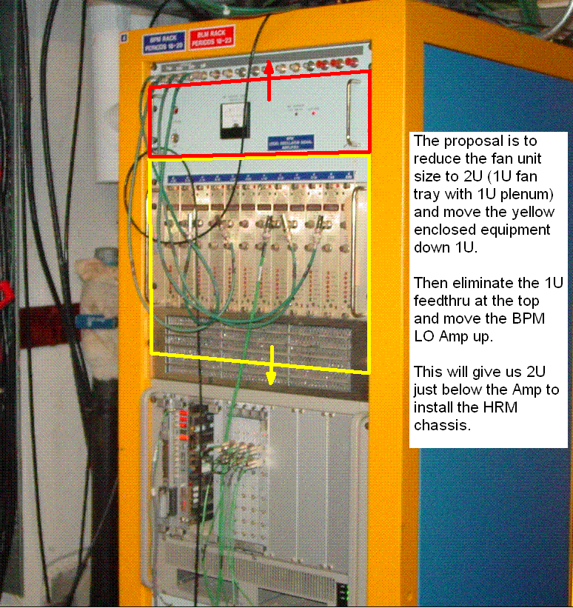
Figure IV.1. Period 18 rack (front) with modification proposal.
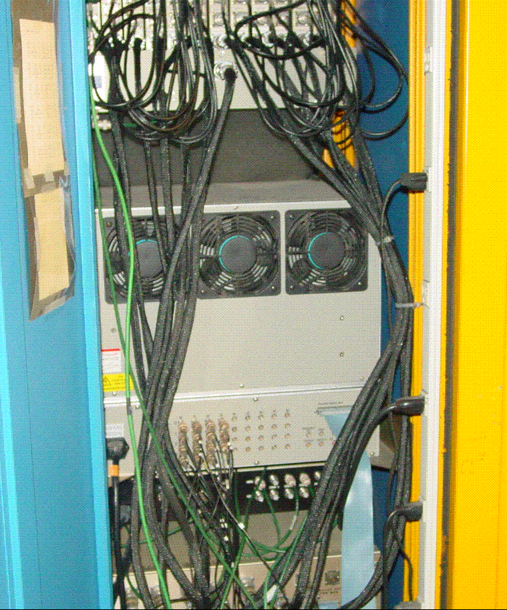
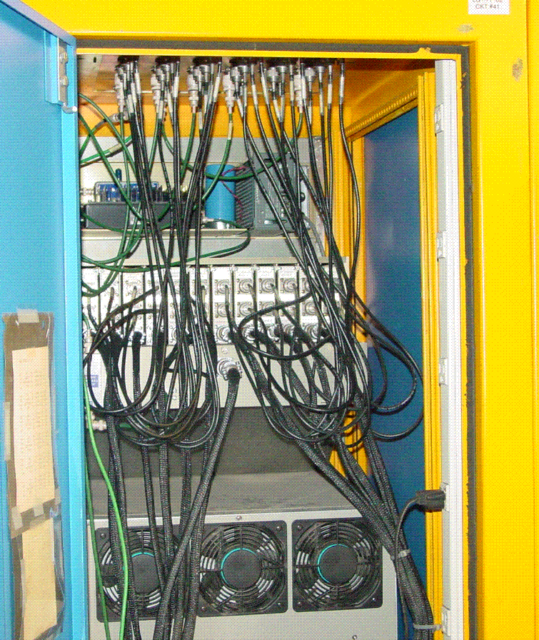

Figure IV.2 Period 18 rack rear views.

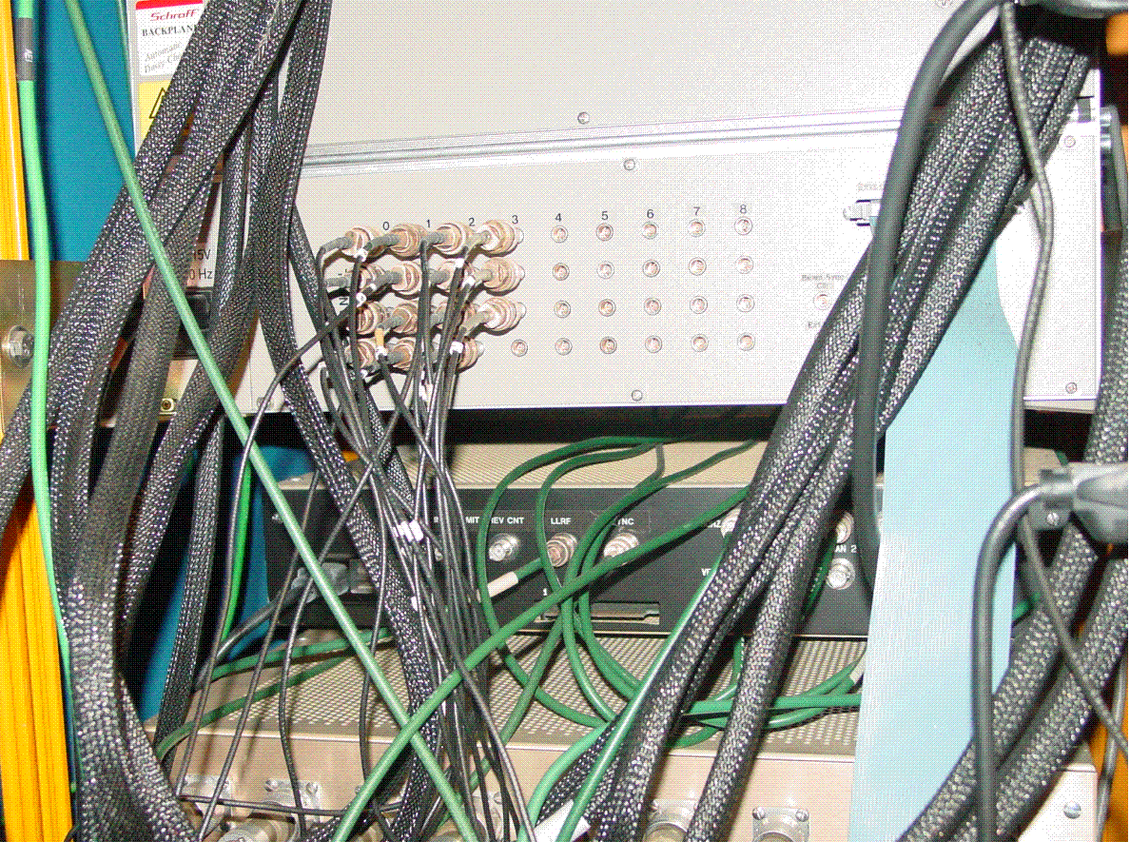
Figure IV.3 Period 18 Digitizer VME crate close-up.

Period 18 -- TODO
- Procure components for the new 2U fan unit.
  - Panel Chasis, 1.75” High x 8” Deep x 17” Wide, Newark # 52F6474.
  - Slotted Ventilation Panel, 1U High, Newark # 94B8070.
  - AC Fan Tray, three fans, 1.75” High x 7.5” Deep x 17” Wide, Newark# 93B7361.
- Assemble fan unit components.
- Procure components for the Lemo to 37 pin Dsub cable assembly. See length chart for cable length requirements.
- Build Lemo to 37 pin Dsub cable assembly.
- Submit shutdown work request for powering down the rack and moving the chassis.
- Make rack modifications.
  - Remove existing fan, filter and plenum.
  - Install 90 degree shelf brackets for supporting the crate in the new position.
  - Lower the NIM crate into the new position.
  - Install new fan unit below the NIM crate.
  - Install new signal feedthru above the IRM chassis.
  - Move IRM signals from the top feedthru panel to the new panel.
  - Remove the top feedthru panel.
  - Move the BPM LO Amplifier up 1U.
- Install HRM into the new 2U opening.
**** Power can be returned to rack at this point and shutdown can end.
- Make BPM position signal cable modifications.
  - Label existing BPM position signal cables at the VME IO panel if necessary.
  - Remove existing BNC to Lemo adapter.
  - Attach to each signal cable the new BNC to Lemo cable and Lemo Tee and reconnect to the VME IO panel in the correct port.
  - Run the multi-RG174 Lemo to 37 pin Dsub cable assembly in the rack.
  - Connect the cable for the assigned HRM channel to the appropriate position signal Lemo Tee.
  - Connect the 37 pin Dsub end of the assembly to the 50 Ohm connector adapter.
  - Connect the cable assembly with adapter to the HRM.
- Monitor the Turn-By-Turn and HRM data to ensure proper connections

Period 17 Racks
Status: Consider removing old corrector power supplies in rack G17-RR1-1.
The nearby rack G17-RR1-3 can be used to house both the VME crate, VME processor and the HRM chassis. With the HRM chassis in G17-RR1-3 a longer cable assembly with the analog BPM signals would have to be run over from G17-RR2.
Rack Numbers: G17-RR2, G17-RR1-3.
BPM’s Serviced Here:
VME Crate: BBPM15
Name | Period | Demod Rack # | VME alias | VME MOD | VME CHAN | HRM alias | HRM CHAN | HRM PIN
HL15 | 17 | G17-RR2 | HP15L | 0 | 0 | HL15P | 0 | 1,20
VL15 | 17 | G17-RR2 | VP15L | 0 | 1 | VL15P | 1 | 2,21
HS15 | 17 | G17-RR2 | HP15S | 0 | 2 | HS15P | 2 | 3,22
VS15 | 17 | G17-RR2 | VP15S | 0 | 3 | VS15P | 3 | 4,23
HL16 | 17 | G17-RR2 | HP16L | 1 | 0 | HL16P | 4 | 5,24
VL16 | 17 | G17-RR2 | VP16L | 1 | 1 | VL16P | 5 | 6,25
HS16 | 17 | G17-RR2 | HP16S | 1 | 2 | HS16P | 6 | 7,26
VS16 | 17 | G17-RR2 | VP16S | 1 | 3 | VS16P | 7 | 8,27
HL17 | 17 | G17-RR2 | HP17L | 2 | 0 | HL17P | 8 | 9,28
VL17 | 17 | G17-RR2 | VP17L | 2 | 1 | VL17P | 9 | 10,29
HS17 | 17 | G17-RR2 | HP17S | 2 | 2 | HS17P | 10 | 11,30
VS17 | 17 | G17-RR2 | VP17S | 2 | 3 | VS17P | 11 | 12,31

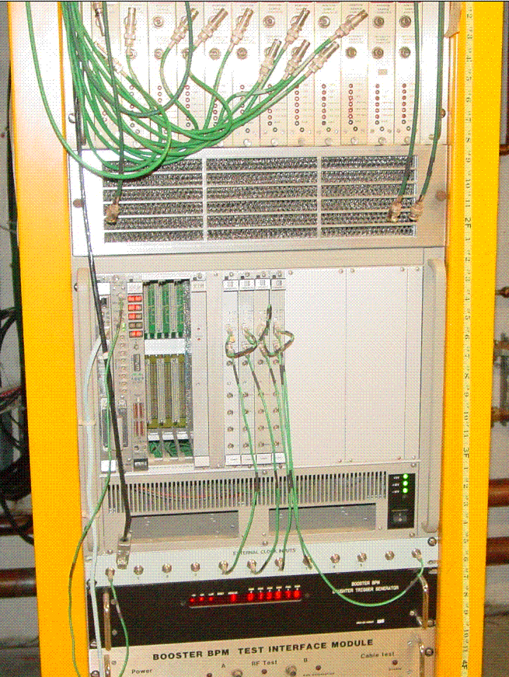
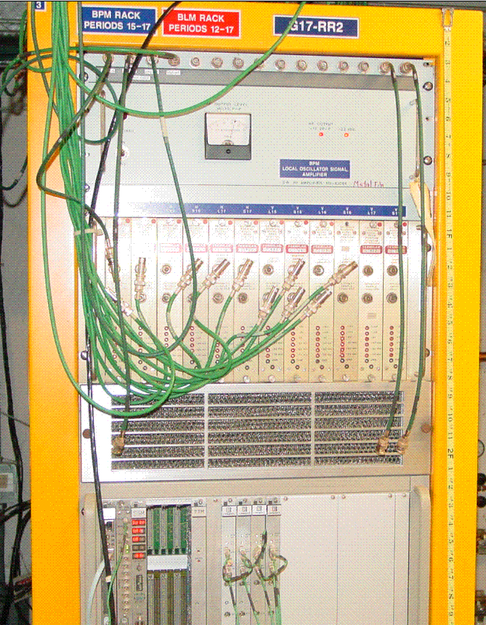
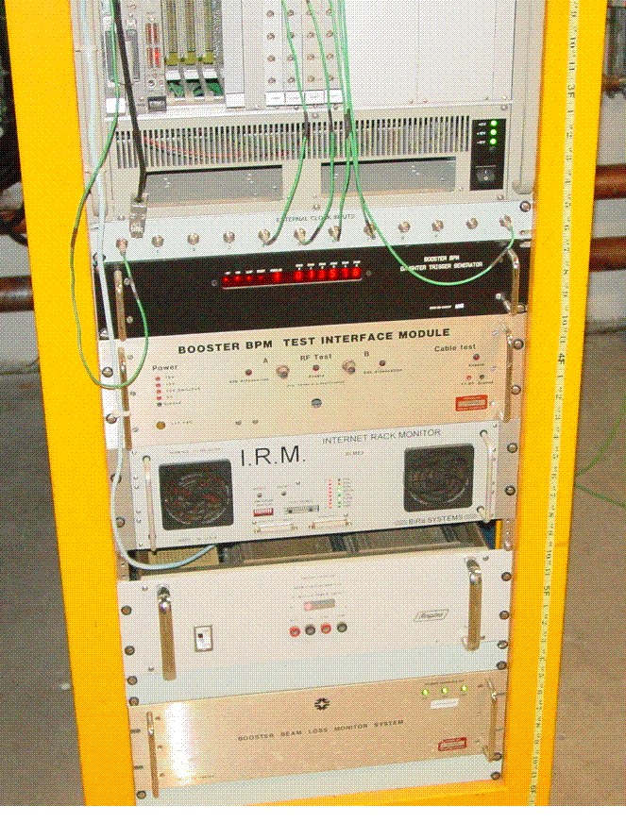
Figure V.1 G17-RR2 rack front views.

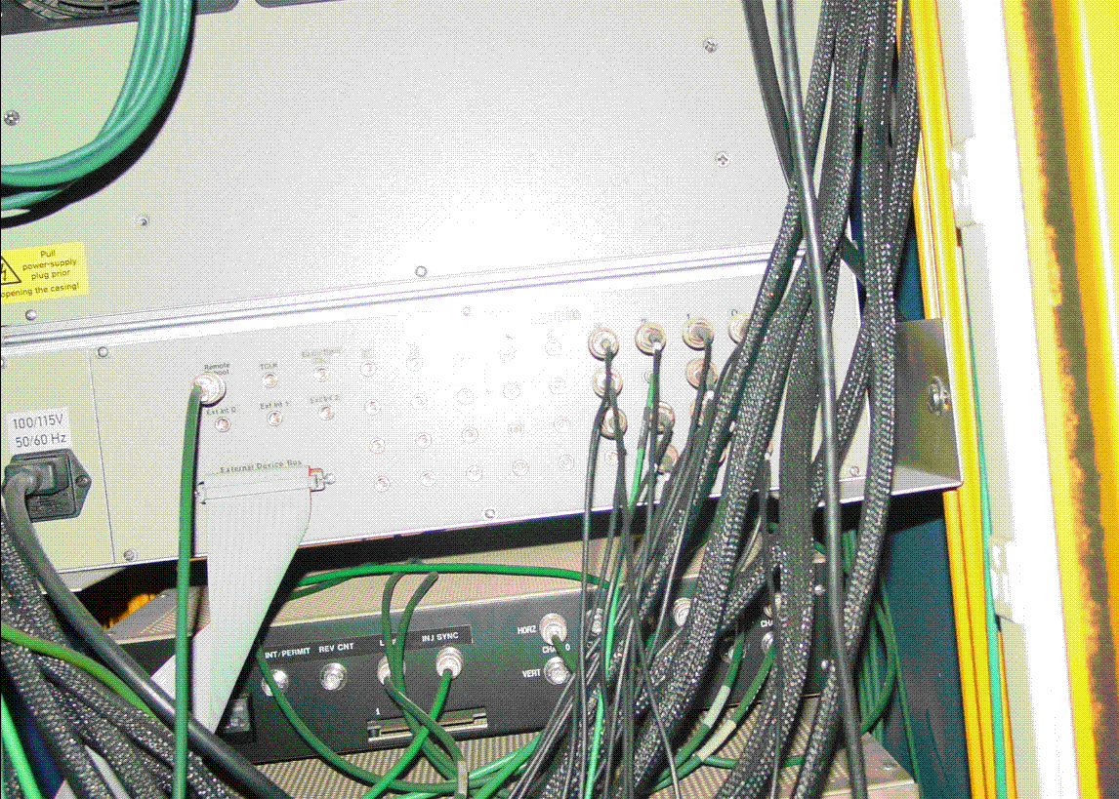
Figure V.2 G17-RR2 Digitizer VME crate close-up.
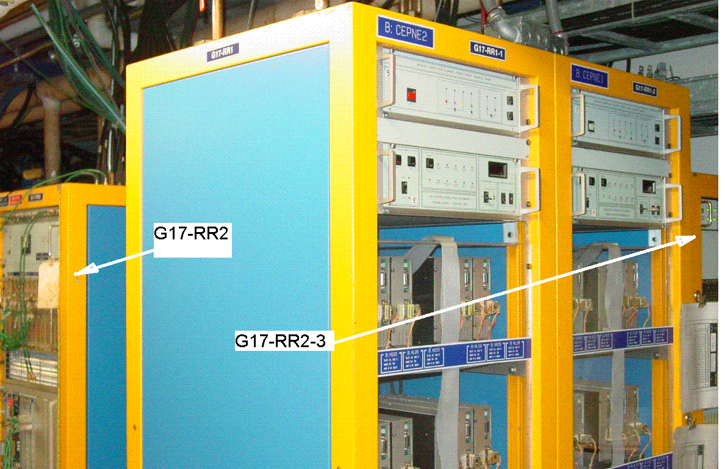
Figure V.3 G17-RR1-1 rack. Possible location of the HRM and VME Crate
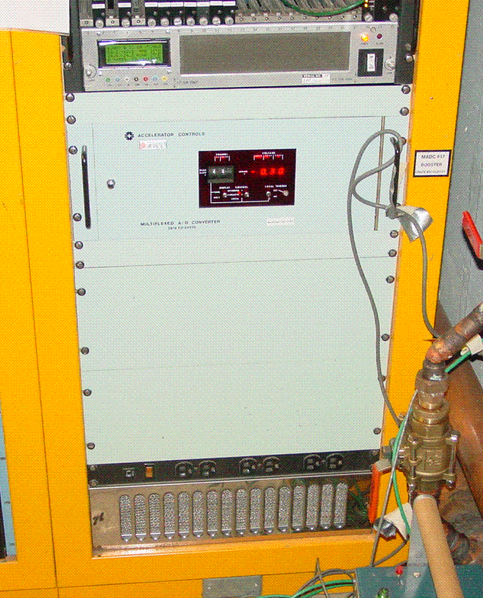
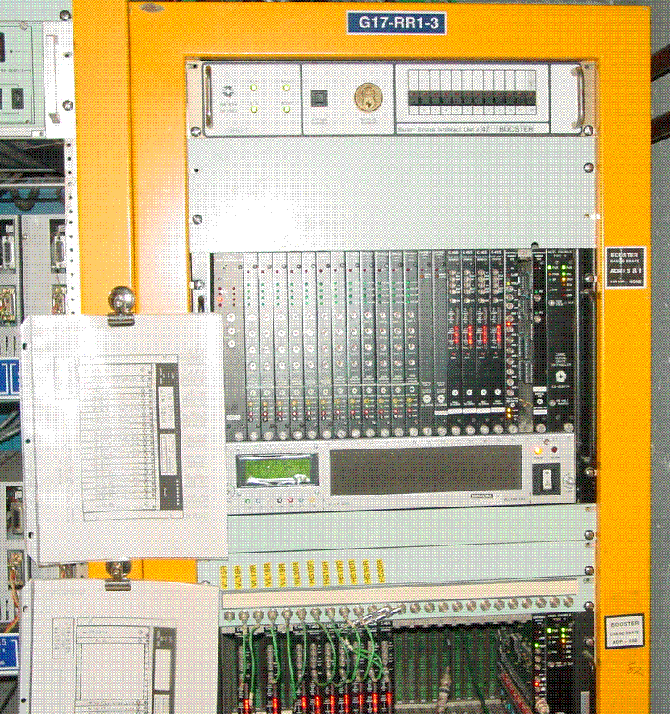

Figure V.4 G17-RR1-3 rack front views.

Period 17 -- TODO
- Procure components for the Lemo to 37 pin Dsub cable assembly. See length chart for cable length requirements.
- Build Lemo to 37 pin Dsub cable assembly.
- Install HRM and 5 Slot VME Crate into rack G17-RR1-3. The BPM RF Module Power Supply will need to be move upward or downward in the rack to make room.
- Make BPM position signal cable modifications.
  - Label existing BPM position signal cables at the VME IO panel if necessary.
  - Remove existing BNC to Lemo adapter.
  - Attach to each signal cable the new BNC to Lemo cable and Lemo Tee and reconnect to the VME IO panel in the correct port.
  - Run the multi-RG174 Lemo to 37 pin Dsub cable assembly from rack G15-RR2 to G17-RR1-3.
  - Connect the cable for the assigned HRM channel to the appropriate position signal Lemo Tee.
  - Connect the 37 pin Dsub end of the assembly to the 50 Ohm connector adapter.
  - Connect the cable assembly with adapter to the HRM.
- Monitor the Turn-By-Turn and HRM data to ensure proper connections

Period 14 Racks
Status: Space available.
HRM and VME Equipment can go in the bottom portion of G14-RR1.
Rack Numbers: G14-RR1.
BPM’s Serviced Here:
VME Crate: BBPM12
Name | Period | Demod Rack # | VME alias | VME MOD | VME CHAN | HRM alias | HRM CHAN | HRM PIN
HL12 | 14 | G14-RR1 | HP12L | 0 | 0 | HL12P | 0 | 1,20
VL12 | 14 | G14-RR1 | VP12L | 0 | 1 | VL12P | 1 | 2,21
HS12 | 14 | G14-RR1 | HP12S | 0 | 2 | HS12P | 2 | 3,22
VS12 | 14 | G14-RR1 | VP12S | 0 | 3 | VS12P | 3 | 4,23
HL13 | 14 | G14-RR1 | HP13L | 1 | 0 | HL13P | 4 | 5,24
VL13 | 14 | G14-RR1 | VP13L | 1 | 1 | VL13P | 5 | 6,25
HS13 | 14 | G14-RR1 | HP13S | 1 | 2 | HS13P | 6 | 7,26
VS13 | 14 | G14-RR1 | VP13S | 1 | 3 | VS13P | 7 | 8,27
HL14 | 14 | G14-RR1 | HP14L | 2 | 0 | HL14P | 8 | 9,28
VL14 | 14 | G14-RR1 | VP14L | 2 | 1 | VL14P | 9 | 10,29
HS14 | 14 | G14-RR1 | HP14S | 2 | 2 | HS14P | 10 | 11,30
VS14 | 14 | G14-RR1 | VP14S | 2 | 3 | VS14P | 11 | 12,31

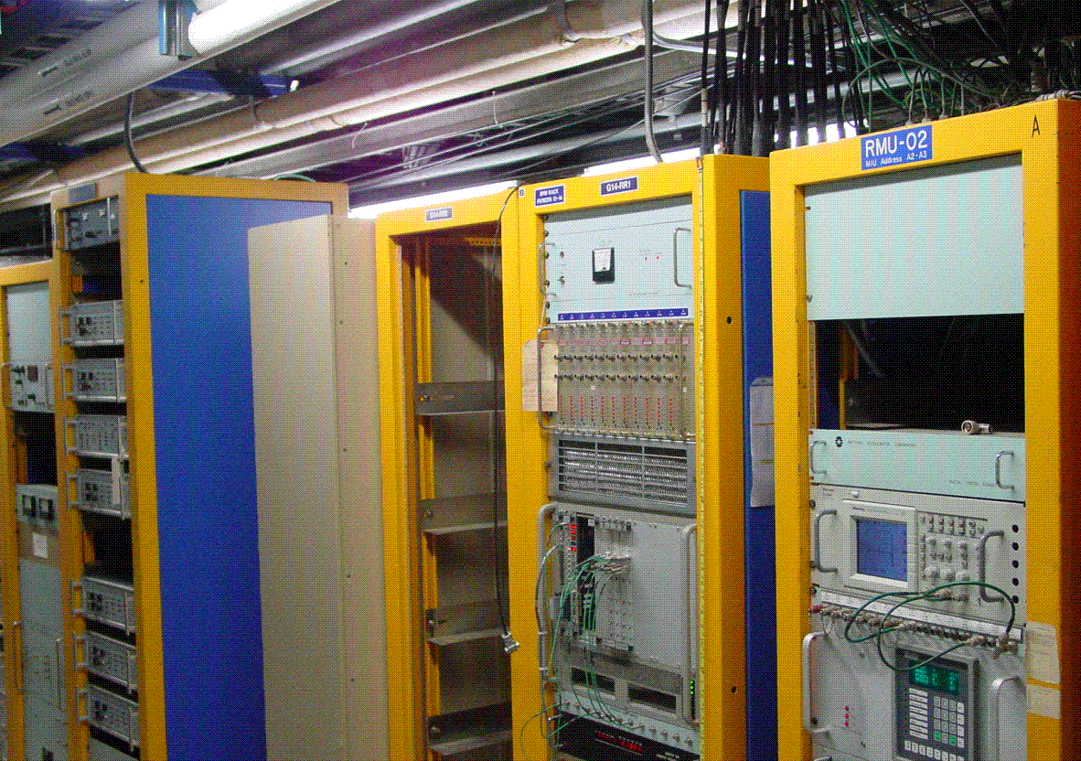
Figure VI.1 G14-RR2 rack (front).
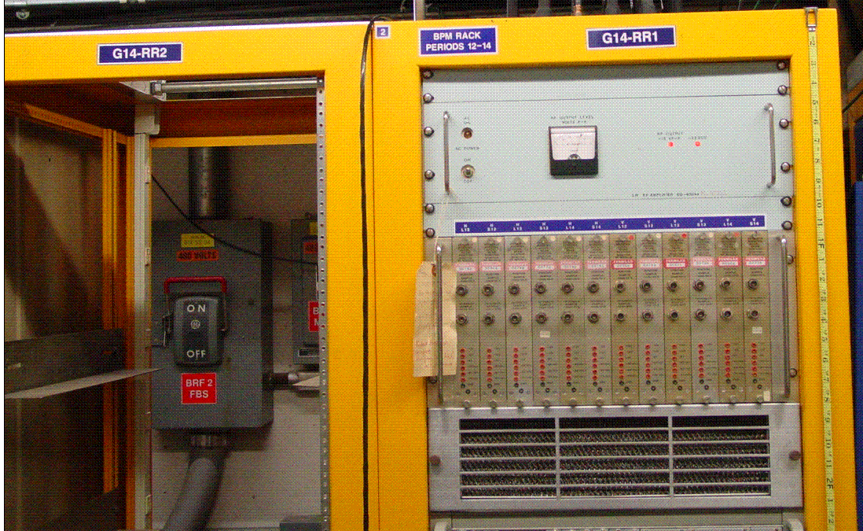
Figure VI.2 G14-RR1 rack (top, front).
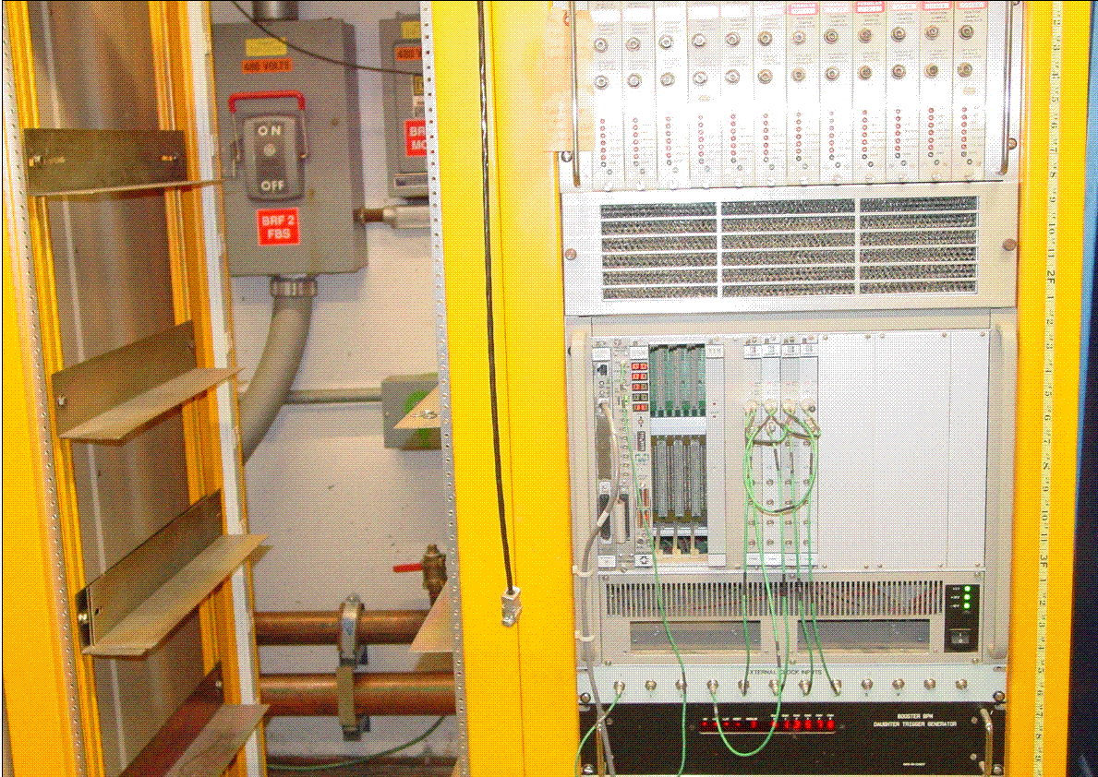
Figure VI.3 G14-RR1 rack (mid, front).
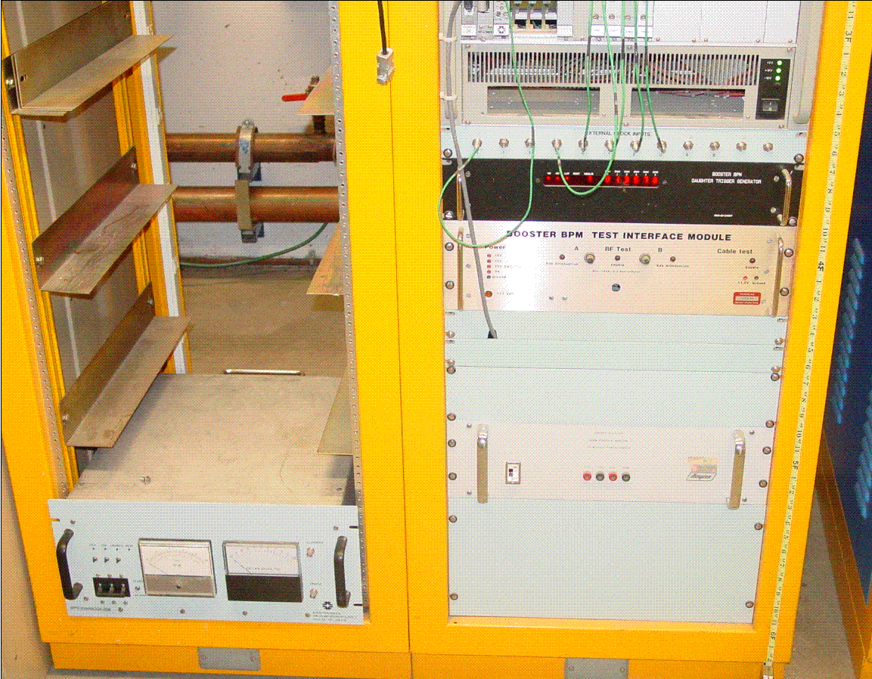
Figure VI.4 G14-RR1 rack (bottom, front).

Period 14 -- TODO
- Procure components for the Lemo to 37 pin Dsub cable assembly. See length chart for cable length requirements.
- Build Lemo to 37 pin Dsub cable assembly.
- Install HRM and 5 Slot VME Crate into bottom portion of rack G14-RR1. The BPM RF Module Power Supply will need to be move upward or downward in the rack to make room.
- Make BPM position signal cable modifications.
  - Label existing BPM position signal cables at the VME IO panel if necessary.
  - Remove existing BNC to Lemo adapter.
  - Attach to each signal cable the new BNC to Lemo cable and Lemo Tee and reconnect to the VME IO panel in the correct port.
  - Run the multi-RG174 Lemo to 37 pin Dsub cable assembly in the rack.
  - Connect the cable for the assigned HRM channel to the appropriate position signal Lemo Tee.
  - Connect the 37 pin Dsub end of the assembly to the 50 Ohm connector adapter.
  - Connect the cable assembly with adapter to the HRM.
- Monitor the Turn-By-Turn and HRM data to ensure proper connections

Period 11 Racks
Status: Space available for HRM, VME crate already installed.
The BPM racks at Period 11 have plenty of space for an HRM and the VME crate is already installed.
Rack Numbers: G11-RR6-1, G11-RR6-2, G11-RR6-3.
BPM’s Serviced Here:

VME Crate: BBPM06
Name | Period | Demod Rack # | VME alias | VME MOD | VME CHAN |  | HRM alias | HRM CHAN | HRM PIN
HL6 | 11 | G11-RR6-2 | HP06L | 0 |  | 0 | HL06P | 0 | 1,20
VL6 | 11 | G11-RR6-2 | VP06L | 0 |  | 1 | VL06P | 1 | 2,21
HS6 | 11 | G11-RR6-2 | HP06S | 0 |  | 2 | HS06P | 2 | 3,22
VS6 | 11 | G11-RR6-2 | VP06S | 0 |  | 3 | VS06P | 3 | 4,23
HL7 | 11 | G11-RR6-2 | HP07L | 1 |  | 0 | HL07P | 4 | 5,24
VL7 | 11 | G11-RR6-2 | VP07L | 1 |  | 1 | VL07P | 5 | 6,25
HS7 | 11 | G11-RR6-2 | HP07S | 1 |  | 2 | HS07P | 6 | 7,26
VS7 | 11 | G11-RR6-2 | VP07S | 1 |  | 3 | VS07P | 7 | 8,27
HL8 | 11 | G11-RR6-2 | HP08L | 2 |  | 0 | HL08P | 8 | 9,28
VL8 | 11 | G11-RR6-2 | VP08L | 2 |  | 1 | VL08P | 9 | 10,29
HS8 | 11 | G11-RR6-2 | HP08S | 2 |  | 2 | HS08P | 10 | 11,30
VS8 | 11 | G11-RR6-2 | VP08S | 2 |  | 3 | VS08P | 11 | 12,31
HL9 | 11 | G11-RR6-1 | HP09L | 3 |  | 0 | HL09P | 12 | 13,32
VL9 | 11 | G11-RR6-1 | VP09L | 3 |  | 1 | VL09P | 13 | 14,33
HS9 | 11 | G11-RR6-1 | HP09S | 3 |  | 2 | HS09P | 14 | 15,34
VS9 | 11 | G11-RR6-1 | VP09S | 3 |  | 3 | VS09P | 15 | 16,35
HL10 | 11 | G11-RR6-1 | HP10L | 4 |  | 0 | HL10P | 16 | 1,20
VL10 | 11 | G11-RR6-1 | VP10L | 4 |  | 1 | VL10P | 17 | 2,21
HS10 | 11 | G11-RR6-1 | HP10S | 4 |  | 2 | HS10P | 18 | 3,22
VS10 | 11 | G11-RR6-1 | VP10S | 4 |  | 3 | VS10P | 19 | 4,23
HL11 | 11 | G11-RR6-1 | HP11L | 5 |  | 0 | HL11P | 20 | 5,24
VL11 | 11 | G11-RR6-1 | VP11L | 5 |  | 1 | VL11P | 21 | 6,25
HS11 | 11 | G11-RR6-1 | HP11S | 5 |  | 2 | HS11P | 22 | 7,26
VS11 | 11 | G11-RR6-1 | VP11S | 5 |  | 3 | VS11P | 23 | 8,27
HUL6 | 11 | G11-RR6-3 | HP06LU | 7 |  | 0 | HL06UP | 24 | 9,28
VUL6 | 11 | G11-RR6-3 | VP06LU | 7 |  | 1 | VL06UP | 25 | 10,29
HUL7 | 11 | G11-RR6-3 | HP07LU | 7 |  | 2 | HL07UP | 26 | 11,30
VUL7 | 11 | G11-RR6-3 | VP07LU | 7 |  | 3 | VL07UP | 27 | 12,31

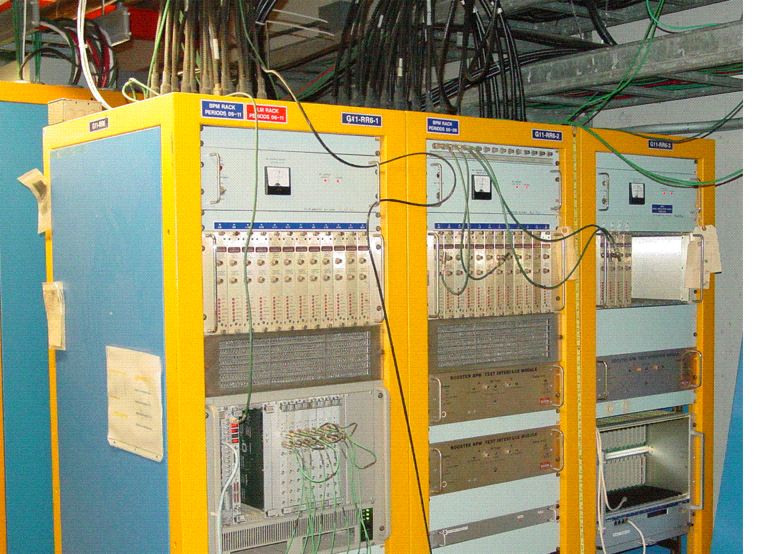
Figure VII.1 G11-RR5 racks (top, front).
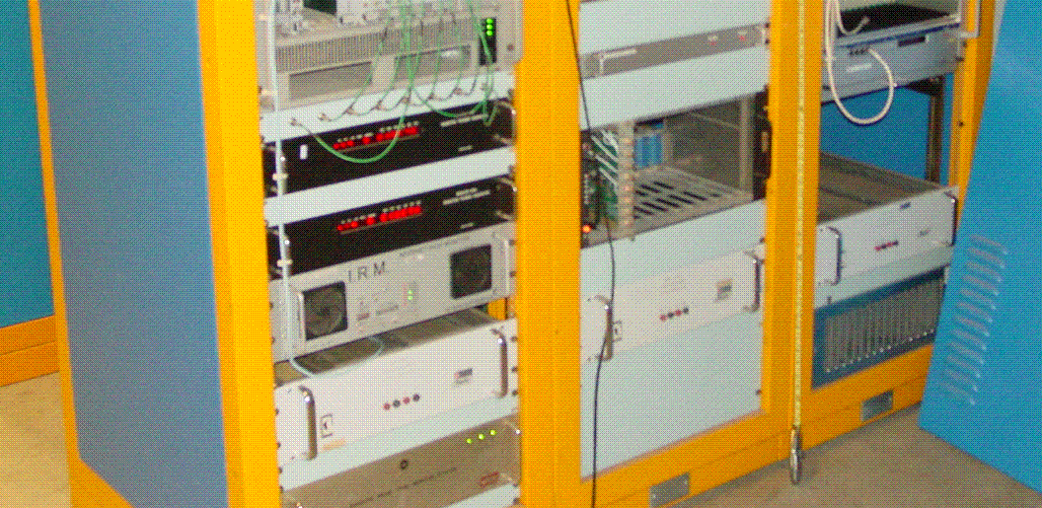
Figure VII.1 G11-RR5 racks (bottom, front).

Period 11 -- TODO
- Procure components for the Lemo to 37 pin Dsub cable assembly. See length chart for cable length requirements.
- Build Lemo to 37 pin Dsub cable assembly.
- Install HRM and 5 Slot VME Crate into bottom portion of rack G11-RR5-2. The BPM RF Module Power Supply will need to be move upward or downward in the rack to make room.
- Make BPM position signal cable modifications.
  - Label existing BPM position signal cables at the VME IO panel if necessary.
  - Remove existing BNC to Lemo adapter.
  - Attach to each signal cable the new BNC to Lemo cable and Lemo Tee and reconnect to the VME IO panel in the correct port.
  - Run the multi-RG174 Lemo to 37 pin Dsub cable assembly in the rack.
  - Connect the cable for the assigned HRM channel to the appropriate position signal Lemo Tee.
  - Connect the 37 pin Dsub end of the assembly to the 50 Ohm connector adapter.
  - Connect the cable assembly with adapter to the HRM.
- Monitor the Turn-By-Turn and HRM data to ensure proper connections

BPM Listing
VME Crate: BBPM24
Name | Period | Demod Rack # | VME alias | VME MOD | VME CHAN | HRM alias | HRM CHAN | HRM PIN
HL24 | 24 | G01-RR6-1 | HP24L | 0 | 0 | HL24P | 0 | 1,20
VL24 | 24 | G01-RR6-1 | VP24L | 0 | 1 | VL24P | 1 | 2,21
HS24 | 24 | G01-RR6-1 | HP24S | 0 | 2 | HS24P | 2 | 3,22
VS24 | 24 | G01-RR6-1 | VP24S | 0 | 3 | VS24P | 3 | 4,23
HL1 | 1 | G01-RR6-1 | HP01L | 1 | 0 | HL01P | 4 | 5,24
VL1 | 1 | G01-RR6-1 | VP01L | 1 | 1 | VL01P | 5 | 6,25
HS1 | 1 | G01-RR6-1 | HP01S | 1 | 2 | HS01P | 6 | 7,26
VS1 | 1 | G01-RR6-1 | VP01S | 1 | 3 | VS01P | 7 | 8,27
HL2 | 2 | G01-RR6-1 | HP02L | 2 | 0 | HL02P | 8 | 9,28
VL2 | 2 | G01-RR6-1 | VP02L | 2 | 1 | VL02P | 9 | 10,29
HS2 | 2 | G01-RR6-1 | HP02S | 2 | 2 | HS02P | 10 | 11,30
VS2 | 2 | G01-RR6-1 | VP02S | 2 | 3 | VS02P | 11 | 12,31
HL3 | 3 | G01-RR6-2 | HP03L | 3 | 0 | HL03P | 12 | 13,32
VL3 | 3 | G01-RR6-2 | VP03L | 3 | 1 | VL03P | 13 | 14,33
HS3 | 3 | G01-RR6-2 | HP03S | 3 | 2 | HS03P | 14 | 15,34
VS3 | 3 | G01-RR6-2 | VP03S | 3 | 3 | VS03P | 15 | 16,35
HL4 | 4 | G01-RR6-2 | HP04L | 4 | 0 | HL04P | 16 | 1,20
VL4 | 4 | G01-RR6-2 | VP04L | 4 | 1 | VL04P | 17 | 2,21
HS4 | 4 | G01-RR6-2 | HP04S | 4 | 2 | HS04P | 18 | 3,22
VS4 | 4 | G01-RR6-2 | VP04S | 4 | 3 | VS04P | 19 | 4,23
HL5 | 5 | G01-RR6-2 | HP05L | 5 | 0 | HL05P | 20 | 5,24
VL5 | 5 | G01-RR6-2 | VP05L | 5 | 1 | VL05P | 21 | 6,25
HS5 | 5 | G01-RR6-2 | HP05S | 5 | 2 | HS05P | 22 | 7,26
VS5 | 5 | G01-RR6-2 | VP05S | 5 | 3 | VS05P | 23 | 8,27
HP03LU | 3 | G01-RR6-3 | HP03LU | 7 | 2 | HL03UP | 24 | 9,28
VP03LU | 3 | G01-RR6-3 | VP03LU | 7 | 3 | VL03UP | 25 | 10,29
HRM Patch Panel Connections
 |  | G01-RR6-1 |  |  |  | Input 26 | 26 | 11,30
 |  | G01-RR6-1 |  |  |  | Input 27 | 27 | 12,31
 |  | G01-RR6-1 |  |  |  | Input 28 | 28 | 13,32
 |  | G01-RR6-1 |  |  |  | Input 29 | 29 | 14,33
 |  | G01-RR6-1 |  |  |  | Input 30 | 30 | 15,34
 |  | G01-RR6-1 |  |  |  | Input 31 | 31 | 16,35
VME Crate: BBPM21
Name | Period | Demod Rack # | VME alias | VME MOD | VME CHAN | HRM alias | HRM CHAN | HRM PIN
HL21 | 21 | G21-RR5-2 | HP21L | 0 | 0 | HL21P | 0 | 1,20
VL21 | 21 | G21-RR5-2 | VP21L | 0 | 1 | VL21P | 1 | 2,21
HS21 | 21 | G21-RR5-2 | HP21S | 0 | 2 | HS21P | 2 | 3,22
VS21 | 21 | G21-RR5-2 | VP21S | 0 | 3 | VS21P | 3 | 4,23
HL22 | 21 | G21-RR5-2 | HP22L | 1 | 0 | HL22P | 4 | 5,24
VL22 | 21 | G21-RR5-2 | VP22L | 1 | 1 | VL22P | 5 | 6,25
HS22 | 21 | G21-RR5-2 | HP22S | 1 | 2 | HS22P | 6 | 7,26
VS22 | 21 | G21-RR5-2 | VP22S | 1 | 3 | VS22P | 7 | 8,27
HL23 | 21 | G21-RR5-2 | HP23L | 2 | 0 | HL23P | 8 | 9,28
VL23 | 21 | G21-RR5-2 | VP23L | 2 | 1 | VL23P | 9 | 10,29
HS23 | 21 | G21-RR5-2 | HP23S | 2 | 2 | HS23P | 10 | 11,30
VS23 | 21 | G21-RR5-2 | VP23S | 2 | 3 | VS23P | 11 | 12,31
VME Crate: BBPM18
Name | Period | Demod Rack # | VME alias | VME MOD | VME CHAN | HRM alias | HRM CHAN | HRM PIN
HL18 | 18 | P. 18-20 (BGW-North) | HP18L | 0 | 0 | HL18P | 0 | 1,20
VL18 | 18 | P. 18-20 (BGW-North) | VP18L | 0 | 1 | VL18P | 1 | 2,21
HS18 | 18 | P. 18-20 (BGW-North) | HP18S | 0 | 2 | HS18P | 2 | 3,22
VS18 | 18 | P. 18-20 (BGW-North) | VP18S | 0 | 3 | VS18P | 3 | 4,23
HL19 | 18 | P. 18-20 (BGW-North) | HP19L | 1 | 0 | HL19P | 4 | 5,24
VL19 | 18 | P. 18-20 (BGW-North) | VP19L | 1 | 1 | VL19P | 5 | 6,25
HS19 | 18 | P. 18-20 (BGW-North) | HP19S | 1 | 2 | HS19P | 6 | 7,26
VS19 | 18 | P. 18-20 (BGW-North) | VP19S | 1 | 3 | VS19P | 7 | 8,27
HL20 | 18 | P. 18-20 (BGW-North) | HP20L | 2 | 0 | HL20P | 8 | 9,28
VL20 | 18 | P. 18-20 (BGW-North) | VP20L | 2 | 1 | VL20P | 9 | 10,29
HS20 | 18 | P. 18-20 (BGW-North) | HP20S | 2 | 2 | HS20P | 10 | 11,30
VS20 | 18 | P. 18-20 (BGW-North) | VP20S | 2 | 3 | VS20P | 11 | 12,31
VME Crate: BBPM15
Name | Period | Demod Rack # | VME alias | VME MOD | VME CHAN | HRM alias | HRM CHAN | HRM PIN
HL15 | 17 | G17-RR2 | HP15L | 0 | 0 | HL15P | 0 | 1,20
VL15 | 17 | G17-RR2 | VP15L | 0 | 1 | VL15P | 1 | 2,21
HS15 | 17 | G17-RR2 | HP15S | 0 | 2 | HS15P | 2 | 3,22
VS15 | 17 | G17-RR2 | VP15S | 0 | 3 | VS15P | 3 | 4,23
HL16 | 17 | G17-RR2 | HP16L | 1 | 0 | HL16P | 4 | 5,24
VL16 | 17 | G17-RR2 | VP16L | 1 | 1 | VL16P | 5 | 6,25
HS16 | 17 | G17-RR2 | HP16S | 1 | 2 | HS16P | 6 | 7,26
VS16 | 17 | G17-RR2 | VP16S | 1 | 3 | VS16P | 7 | 8,27
HL17 | 17 | G17-RR2 | HP17L | 2 | 0 | HL17P | 8 | 9,28
VL17 | 17 | G17-RR2 | VP17L | 2 | 1 | VL17P | 9 | 10,29
HS17 | 17 | G17-RR2 | HP17S | 2 | 2 | HS17P | 10 | 11,30
VS17 | 17 | G17-RR2 | VP17S | 2 | 3 | VS17P | 11 | 12,31
VME Crate: BBPM12
Name | Period | Demod Rack # | VME alias | VME MOD | VME CHAN | HRM alias | HRM CHAN | HRM PIN
HL12 | 14 | G14-RR1 | HP12L | 0 | 0 | HL12P | 0 | 1,20
VL12 | 14 | G14-RR1 | VP12L | 0 | 1 | VL12P | 1 | 2,21
HS12 | 14 | G14-RR1 | HP12S | 0 | 2 | HS12P | 2 | 3,22
VS12 | 14 | G14-RR1 | VP12S | 0 | 3 | VS12P | 3 | 4,23
HL13 | 14 | G14-RR1 | HP13L | 1 | 0 | HL13P | 4 | 5,24
VL13 | 14 | G14-RR1 | VP13L | 1 | 1 | VL13P | 5 | 6,25
HS13 | 14 | G14-RR1 | HP13S | 1 | 2 | HS13P | 6 | 7,26
VS13 | 14 | G14-RR1 | VP13S | 1 | 3 | VS13P | 7 | 8,27
HL14 | 14 | G14-RR1 | HP14L | 2 | 0 | HL14P | 8 | 9,28
VL14 | 14 | G14-RR1 | VP14L | 2 | 1 | VL14P | 9 | 10,29
HS14 | 14 | G14-RR1 | HP14S | 2 | 2 | HS14P | 10 | 11,30
VS14 | 14 | G14-RR1 | VP14S | 2 | 3 | VS14P | 11 | 12,31
VME Crate: BBPM06
Name | Period | Demod Rack # | VME alias | VME MOD | VME CHAN |  | HRM alias | HRM CHAN | HRM PIN
HL6 | 11 | G11-RR6-2 | HP06L | 0 |  | 0 | HL06P | 0 | 1,20
VL6 | 11 | G11-RR6-2 | VP06L | 0 |  | 1 | VL06P | 1 | 2,21
HS6 | 11 | G11-RR6-2 | HP06S | 0 |  | 2 | HS06P | 2 | 3,22
VS6 | 11 | G11-RR6-2 | VP06S | 0 |  | 3 | VS06P | 3 | 4,23
HL7 | 11 | G11-RR6-2 | HP07L | 1 |  | 0 | HL07P | 4 | 5,24
VL7 | 11 | G11-RR6-2 | VP07L | 1 |  | 1 | VL07P | 5 | 6,25
HS7 | 11 | G11-RR6-2 | HP07S | 1 |  | 2 | HS07P | 6 | 7,26
VS7 | 11 | G11-RR6-2 | VP07S | 1 |  | 3 | VS07P | 7 | 8,27
HL8 | 11 | G11-RR6-2 | HP08L | 2 |  | 0 | HL08P | 8 | 9,28
VL8 | 11 | G11-RR6-2 | VP08L | 2 |  | 1 | VL08P | 9 | 10,29
HS8 | 11 | G11-RR6-2 | HP08S | 2 |  | 2 | HS08P | 10 | 11,30
VS8 | 11 | G11-RR6-2 | VP08S | 2 |  | 3 | VS08P | 11 | 12,31
HL9 | 11 | G11-RR6-1 | HP09L | 3 |  | 0 | HL09P | 12 | 13,32
VL9 | 11 | G11-RR6-1 | VP09L | 3 |  | 1 | VL09P | 13 | 14,33
HS9 | 11 | G11-RR6-1 | HP09S | 3 |  | 2 | HS09P | 14 | 15,34
VS9 | 11 | G11-RR6-1 | VP09S | 3 |  | 3 | VS09P | 15 | 16,35
HL10 | 11 | G11-RR6-1 | HP10L | 4 |  | 0 | HL10P | 16 | 1,20
VL10 | 11 | G11-RR6-1 | VP10L | 4 |  | 1 | VL10P | 17 | 2,21
HS10 | 11 | G11-RR6-1 | HP10S | 4 |  | 2 | HS10P | 18 | 3,22
VS10 | 11 | G11-RR6-1 | VP10S | 4 |  | 3 | VS10P | 19 | 4,23
HL11 | 11 | G11-RR6-1 | HP11L | 5 |  | 0 | HL11P | 20 | 5,24
VL11 | 11 | G11-RR6-1 | VP11L | 5 |  | 1 | VL11P | 21 | 6,25
HS11 | 11 | G11-RR6-1 | HP11S | 5 |  | 2 | HS11P | 22 | 7,26
VS11 | 11 | G11-RR6-1 | VP11S | 5 |  | 3 | VS11P | 23 | 8,27
HUL6 | 11 | G11-RR6-3 | HP06LU | 7 |  | 0 | HL06UP | 24 | 9,28
VUL6 | 11 | G11-RR6-3 | VP06LU | 7 |  | 1 | VL06UP | 25 | 10,29
HUL7 | 11 | G11-RR6-3 | HP07LU | 7 |  | 2 | HL07UP | 26 | 11,30
VUL7 | 11 | G11-RR6-3 | VP07LU | 7 |  | 3 | VL07UP | 27 | 12,31

