Analysis of BNB Beam Position Target Scan Performed 2018.10.31
Alyssa R Miller | 2019.02.07

The BNB target face was scanned vertically and horizontally with beam to determine the central points based on normalized losses. The study results indicate that beam is off center both vertically and horizontally. Autotune settings will be updated accordingly.

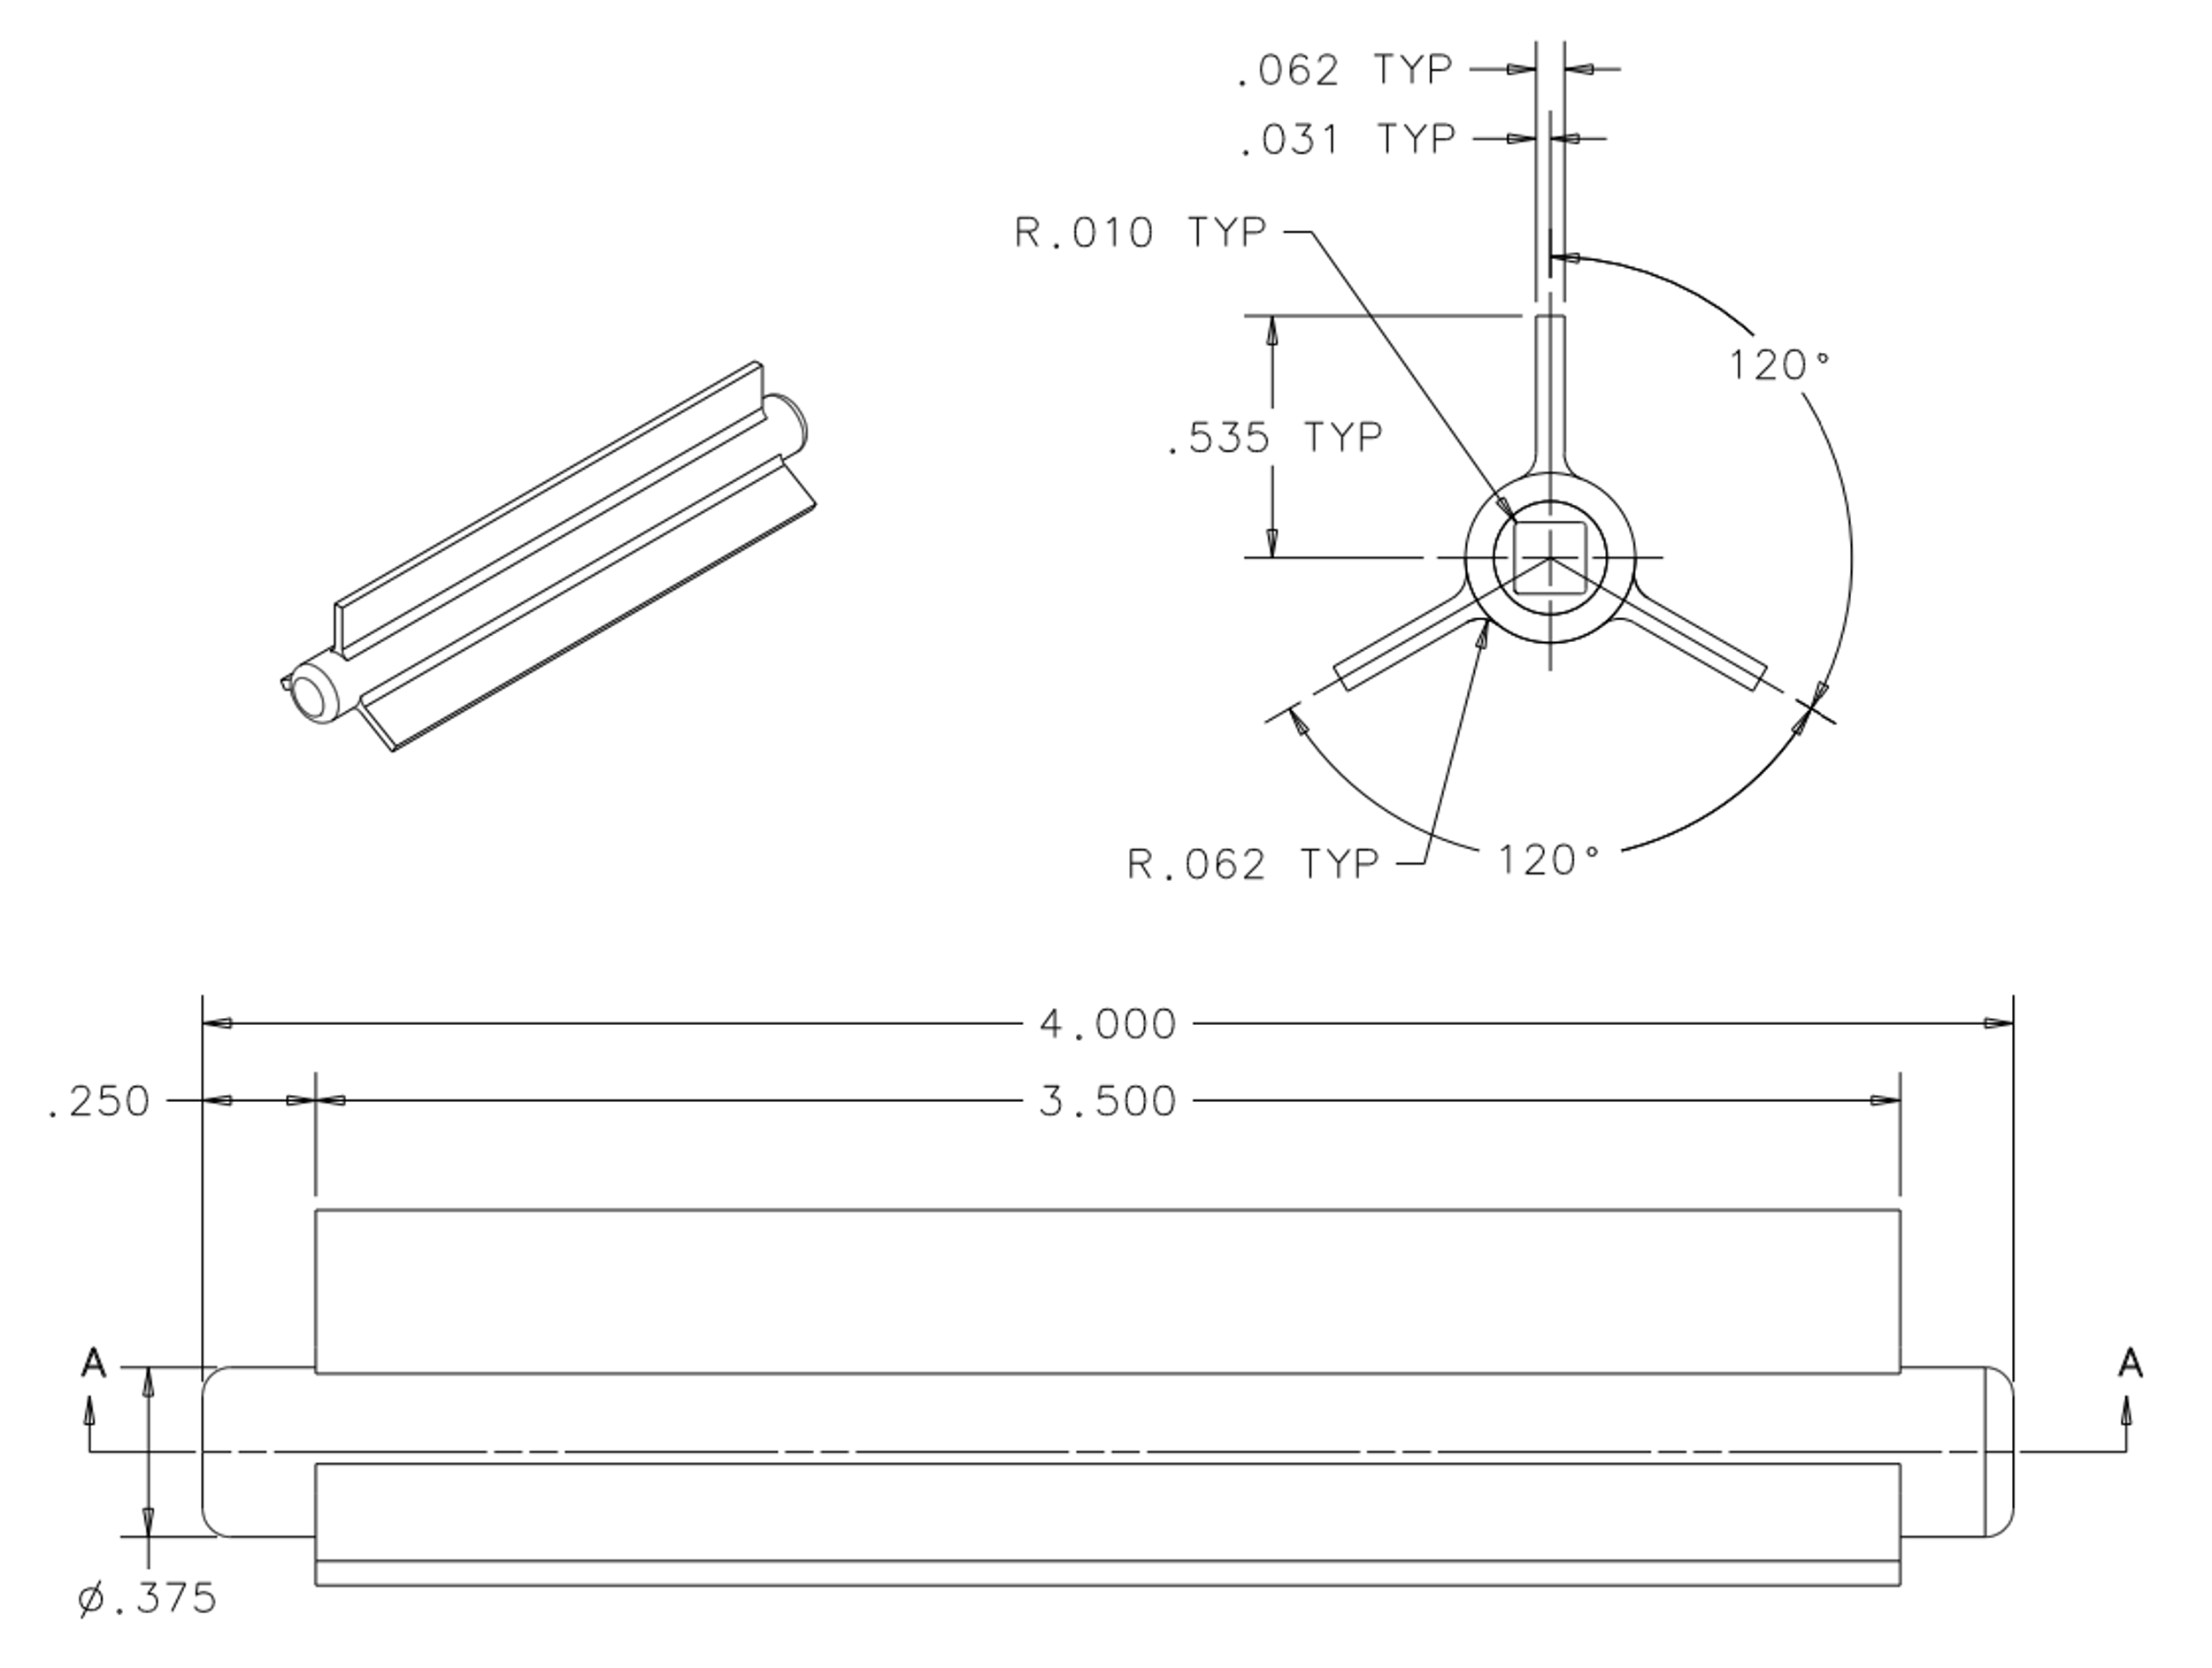
Figure 1: Pictured are the relevant BNB target assembly dimensions. The top left image shows the target slug orientation for the drawing, complete with three radial fins. The top right image shows the target as seen from upstream, looking downstream. Note that the target is positioned such that the top fin is centered at the bottom. The fins are 0.062 inches (1.57 mm) wide. The bottom image shows the target slug from the side. The diameter of the target without the fins is 0.375 inches (10.2 mm).

The BNB autotune program uses BPMs VP875, VPTG1, HP875, and HPTG1 to steer beam on target. These indicate the beam positions in each transverse plane at their relative positions. VP875 and HP875 are about 4.5 meters upstream of the target, while VPTG1 and HPTG1 are closer to the target, about 1.5 meters upstream.

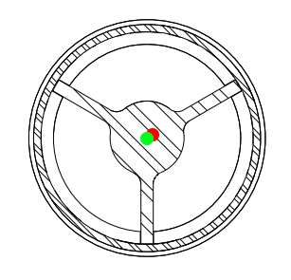
Figure 2: An illustration of the true orientation of the target looking downstream, with the green circle representing new, centered beam coordinates from VPTG1 and HPTG1, and the red circle representing the offset in beam steered by present autotune settings.

Study

Loss monitors E:LM875A, E:LM875B and E:LM875C were used to determine what the beam was hitting. Losses are normalized to toroid TOR875 to account for intensity fluctuations.

Four trim magnets, VT871, VT873, HT872, and HT873 were used to perform the target scan in their respective planes. Their current settings were incrementally changed together as a ”mult” (VT871 with VT873, then HT872 with HT873), creating a two-bump. The mult was implemented to keep the changing beam positions parallel to the nominal positions.

Autotune was disabled for this study. The target was scanned vertically from the center, to the top, and to the bottom. One clean scan from the top edge to the bottom fin was selected for analysis. The horizontal scan was performed while the beam was positioned vertically over the fin.

These scans illustrate the vertical width of the target and the horizontal width of the fin. Since the fin is centered horizontally, linear estimates were used to extrapolate both the vertical and horizontal centers. Maximum losses were expected when beam was steered vertically on target and horizontally on the fin.

Analysis
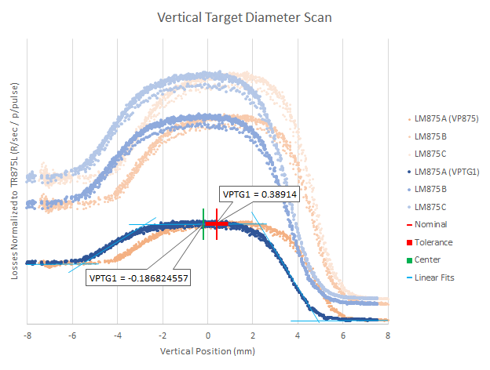
Figure 3: Pictured is a plot of losses upstream of the target with respect to position while incrementally changing the upstream trim magnets’ currents. The three distinct blue traces represent losses from three different monitors while VPTG1 changes. The orange traces represent losses while VP875 changes over the same scan. Also depicted are the VPTG1 nominal and tolerance values used by autotune and the extrapolated target center.

According to VPTG1, beam hit the fin between -8 and -5 mm, passed over the diameter of the target from the fin to the top between -5 and 4 mm, and hit the space between the edge of the target and the outer tube between 4 and 8 mm. Beam is fully on target between -2 and 1 mm.

Figure 4: Pictured is a portion of the vertical scan emphasizing VP875 nominal, tolerance, and extrapolated center values.

Figure 5: Pictured is a plot of losses with respect to position during the horizontal scan. The blue traces represent losses while HPTG1 changes, and orange traces represent losses while HP875 changes over the same scan. HPTG1 nominal, tolerance, and extrapolated center values are also depicted. Note: The polarity of values for HP875 used in this analysis has been reversed for ease of comparison.

According to HPTG1, beam passed over the fin evenly between -2 and 2 mm and hit the space between the fin and outer tube between 2 and 4 mm. Losses increased after 4 mm moving positively as beam began to hit the outer tube. The sharp loss increase which began as positions moved negatively from -2 mm may be due to beam approaching the target at an angle from normal to the target face.

Figure 6: Pictured is a portion of the horizontal scan emphasizing HP875 nominal, tolerance, and extrapolated center values.

Device | Autotune setting (mm) | Extrapolated center (mm) | Out of tolerance | Difference (mm)
VP875 | 1.47511 +/- 0.5 | 0.947212 | yes | 0.527898
HP875 | 3.40271 +/- 0.5 | 3.09576 | no | 0.306951
VPTG1 | 0.389140 +/- 0.5 | -0.186825 | yes | 0.575965
HPTG1 | 0.457014 +/- 0.5 | -0.311223 | yes | 0.768238

Table 1: A summary of numerical analysis and results.

The bunch rotation feature for extracted Booster beam destined for NuMI was made operational for BNB beam 2019.01.14. This allows higher intensity beam to be sent to BNB without increasing loss in the 8 GeV Line above operational limits. This target scan was performed before this period. Another scan will be performed with bunch rotation on.

Resources

Target drawing: https://admscad.fnal.gov/MSDMain/DWGS/MBOONE_416/pdf/416455--1.pdf

