Meeting Minutes
Craig C. Drennan
Principle Engineer
AD / Instrumentation
P.O. Box 500, MS 308
Kirk Road and Pine Street
Batavia, Illinois 60510-5011 USA
Office: 630.840.2160
cdrennan@fnal.gov

Date: February 18, 2019
Re: Meeting Minutes, PIP-II DAQ Discussion, Meeting 1

Meeting Time: 2:00 pm to 3:00 pm
Meeting Location: AD / Huddle
Attendees:
Craig Drennan, AD/Instrumentation
Brian Chase, AD/RF
Peter Prieto, AD/Instrumentation
Nathan Eddy, AD/Instrumentation
Vic Scarpine, AD/Instrumentation
Arden Warner, AD/SC Linac
Rich Neswold, AD/Controls
Kevin Martin, AD/Controls
Edward Cullerton, AD/Proton Source
Brian Schupbach, AD/Proton Source
Dennis Nicklaus, AD/Controls

Request for Feedback:
Please send any additions, corrections, rephrasing and/or comments to Craig Drennan. There has been liberal use of paraphrasing in recalling what others have said in the meeting. There may also be some editorializing and introduction of new thoughts that could use some review. Thank You.
Minutes:
Introduction
Craig Drennan started the meeting by stating that there was a desire to begin looking at possible architectures and specifications for Instrumentation and RF data acquisition and the interfaces to the MPS system and ACNET, for PIP-II. He suggested that we start looking for common elements between various control and data acquisition systems and begin developing specifications and standards that the designers of the various systems could use. The Machine Protection System receives inputs from many different systems and the formats and protocols should be established.
Discussion
Craig mentioned that the AD/Controls Modernization effort will be starting 2/27/2019. We hope our discussion will be a complement to this effort. We expect to see specification from AD/Controls regarding the interface to the control system and the connections to the machine clock and timing systems.
Brian Chase commented that the projects physics and other departments will be contributing to the requirements. It is not all on AD/Controls to do that. All of the departments will need to be diligent to determine and express their requirements for the control system.
Jim Steimel said that a system interface document is available to help determine the specifications that need to be developed. The interface spreadsheet does not have technical specifications at this point, but simply a listing of the interfaces that will exist.
Paul Derwent has setup a meeting with engineers on 2/26/2019 to go through a Value Engineering Workshop for PIP-II to gather recommendations for reducing system costs. The workshop slides and documents can be found at
https://pip2-docdb.fnal.gov/cgi-bin/private/DisplayMeeting?conferenceid=919
Vic Scarpine is the Level 3 manager for Instrumentation and has collected Basis of Estimates (BOEs) for these systems. These documents state how many instruments of each type we expect to provide, but further measurement specifications are not listed in these documents.
Explanation of Slides
Craig’s slides 3, 4 and 5 that showed the concept that requirements of the physics and the accelerator would be expressed through different components of the DAQ and control system. Slide 3 expressed how physics and machine requirements would impact the specifications of the Control System which in turn would place requirements on the different sub-systems (RF, instrumentation, cryo, power supply control, etc.). Slide 4 expressed how physics and the machine requirements would impact the specification of the sub-systems which in turn would place requirements on the Control System. And finally, in Slide 5, how the physics and the machine requirements would specify the Machine Protection System (MPS) and that in turn place requirements on the sub-systems.
It is believed that the MPS will have the requirements that drives the architecture of the DAQ and controls and the specification of high speed optical data links used.
Slide 6 was a short list of various specifications for the analog front-end, the signal processing and data transfer.
Brian Chase added that we will need to specify timing accuracy, accurate timestamps. It would be nice to agree on specific system-wide clocks. Every front-end does not have its own time base. We would like better alignment of our data. We should try to setup a meeting to specifically address timing and clocks. Post-mortem buffer data from all of the system has been requested in previous requirement documents. This data will need timestamps, or some means of aligning data from all over the machine.
Slide 7 was a list of DAQ circuit components and processes that add latency (delay) between the beam events detected and the decision to stop the beam by the Machine Protection System (MPS). Something similar to the diagram below was drawn on the white board to help describe the things that contributed to the total latency.
There will be discussions of the Machine Protection System will occur in the near future. Currently in is believed that the time between the beam event to when the beam is halted is required to be 10 micro-seconds. Arden Warner reminded us that this specification applies to the points furthest from the MPS, to include the transfer line to the Booster and Booster itself.
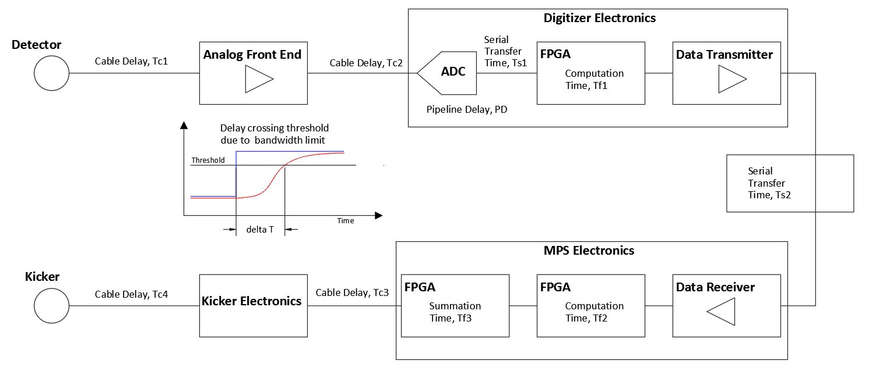
Figure 1. Diagram used to describe latency in the MPS.

Vic Scarpine pointed out that the bandwidth of the measurement will impact the latency. This is illustrated in Figure 1. also. The specification of the bandwidth and the number of digitizer sample that may be averaged, will be specified by the desired signal to noise and other resolution and accuracy specifications for the measurement. There may be trade offs between accurate measurement of small signals and threshold detection of large signals.
Arden Warner also pointed out that the various measurements used in making MPS decision may be working on different time scales. There will be the “primary” events that need low latency detection to quickly make the MPS decision and shut off the beam, and there will be slower “secondary” events that do not need to be responded to as quickly.
Craig’s last slide list some agenda items for future meetings.
- Determine which specifications will be common to multiple systems.
- Determine who will work out specification details and begin a draft specification.
- Arrange presentations for specification and hardware proposals.
- Arrange presentations by vendors to educate ourselves on technology and product availability.

For those making hardware proposals, we are asking for the presenter to
- Show what specification the architecture would provide.
- Present pricing data and quotes
- Determine the level of in-house design required.
- Estimate the man-hours to develop and test a prototype system.

If you remember something you found important that we should include in these minutes, let me know and I will add it.

