Meeting Minutes
Craig C. Drennan
Principle Engineer
AD / Instrumentation
P.O. Box 500, MS 308
Kirk Road and Pine Street
Batavia, Illinois 60510-5011 USA
Office: 630.840.2160
cdrennan@fnal.gov

Date: February 18, 2019
Re: Meeting Minutes, PIP-II DAQ Discussion, Meeting 1

Meeting Time: 2:00 pm to 3:00 pm
Meeting Location: AD / Huddle
Attendees:
Craig Drennan, AD/Instrumentation
Vic Scarpine, AD/Instrumentation (PIP-II Level 3)
Nathan Eddy, AD/Instrumentation
Peter Prieto, AD/Instrumentation
Jim Steimel, PIP-II Technical Integration Office
Brian Chase, AD/RF
Philip Varghese, AD/RF
Arden Warner, AD/Accel. Sys. – SC Linac
Rich Neswold, AD/Controls
Dennis Nicklaus, AD/Controls
Kevin Martin, AD/EE Support
Edward Cullerton, AD/Proton Source
Brian Schupbach, AD/Proton Source

Request for Feedback:
Please send any additions, corrections, rephrasing and/or comments to Craig Drennan. There has been liberal use of paraphrasing in recalling what others have said in the meeting. There may also be some editorializing and introduction of new thoughts that could use some review. Thank You.
Minutes:
Introduction
Craig Drennan started the meeting by stating that there was a desire to begin looking at possible architectures and specifications for Instrumentation and RF data acquisition and the interfaces to the MPS system and ACNET, for PIP-II. He suggested that we start looking for common elements between various control and data acquisition systems and begin developing specifications and standards that the designers of the various systems could use. The Machine Protection System receives inputs from many different systems and the formats and protocols should be established.
Discussion
Craig mentioned that the AD/Controls Modernization effort will be starting 2/27/2019. We hope our discussion will be a complement to this effort. We expect to see specification from AD/Controls regarding the interface to the control system and the connections to the machine clock and timing systems.
Brian Chase commented that the projects physics and other departments will be contributing to the requirements. It is not all on AD/Controls to do that. All of the departments will need to be diligent to determine and express their requirements for the control system.
Jim Steimel said that a system interface document is available to help determine the specifications that need to be developed. The interface spreadsheet does not have technical specifications at this point, but simply a listing of the interfaces that will exist.
Paul Derwent has setup a meeting with engineers on 2/26/2019 to go through a Value Engineering Workshop for PIP-II to gather recommendations for reducing system costs. The workshop slides and documents can be found at
https://pip2-docdb.fnal.gov/cgi-bin/private/DisplayMeeting?conferenceid=919
Vic Scarpine is the Level 3 manager for Instrumentation and has collected Basis of Estimates (BOEs) for these systems. These documents state how many instruments of each type we expect to provide, but further measurement specifications are not listed in these documents.
Explanation of Slides
Craig’s slides 3, 4 and 5 showed that requirements of the physics and the accelerator would be expressed through different components of the DAQ and control system. Slide 3 expressed how physics and machine requirements would impact the specifications of the Control System which in turn would place requirements on the different sub-systems (RF, instrumentation, cryo, power supply control, etc.). Slide 4 expressed how physics and the machine requirements would impact the specification of the sub-systems which in turn would place requirements on the Control System. And finally, in Slide 5, how the physics and the machine requirements would specify the Machine Protection System (MPS) and that would in turn place requirements on the sub-systems.
It is believed that the MPS will have the requirements that drive the architecture of the DAQ, controls and the specification of high-speed optical data links.
Slide 6 was a short list of various specifications for the analog front-end, the signal processing and data transfer.
Brian Chase added that we will need to specify timing accuracy, accurate timestamps. It would be nice to agree on specific system-wide clocks. Every front-end does not have its own time base. We would like better alignment of our data. We should try to setup a meeting to specifically address timing and clocks. Post-mortem buffer data from all of the system has been requested in previous requirement documents. This data will need timestamps, or some means of aligning data from all over the machine.
Slide 7 was a list of DAQ circuit components and processes that add latency (delay) between the beam events detected and the decision to stop the beam by the Machine Protection System (MPS). Something similar to the diagram below was drawn on the white board to help describe the things that contributed to the total latency.
There will be discussions of the Machine Protection System that will occur in the near future. Currently it is believed that the time between the beam event and when the beam is halted is required to be 10 micro-seconds.
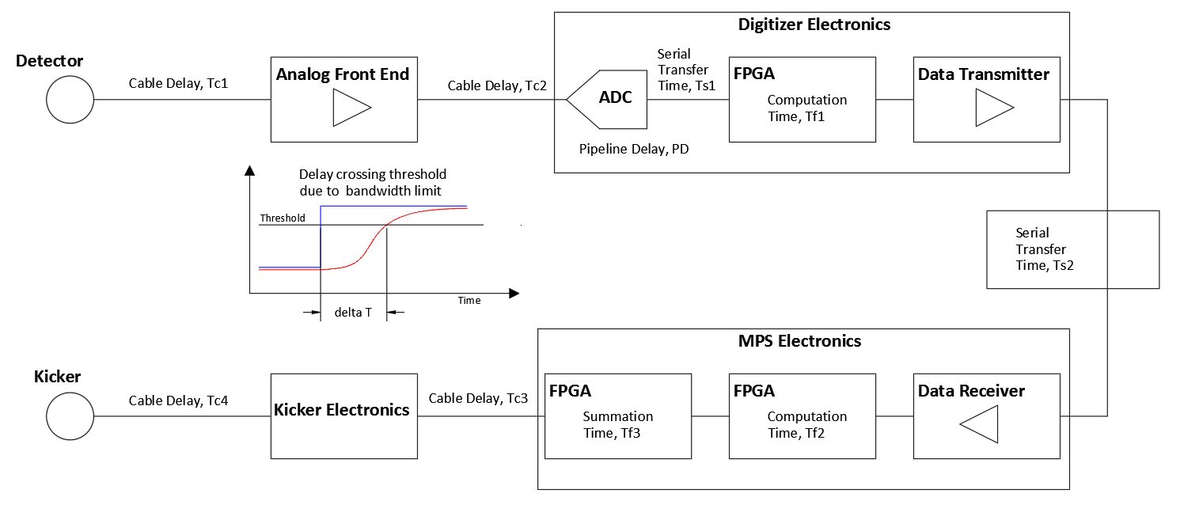
Figure 1. Diagram used to describe latency in the MPS.

Vic Scarpine pointed out that the bandwidth of the measurement will impact the latency. This is illustrated in Figure 1. also. The specification of the bandwidth and the number of digitizer samples that may be averaged, will be specified by the desired signal to noise and other resolution and accuracy specifications for the measurement. There may be trade offs between accurate measurement of small signals and threshold detection of large signals.
Arden Warner pointed out that the various measurements used in making MPS decision may be working on different time scales. There will be the “primary” events that need low latency detection to quickly make the MPS decision and shut off the beam, and there will be slower “secondary” events that do not need to be responded to as quickly. Arden said that the MPS will not only be concerned with the Linac but also with the transport line to Booster and will receive machine status from the Booster also.
Craig’s last slide list some agenda items for future meetings.
- Determine which specifications will be common to multiple systems.
- Determine who will work out specification details and begin a draft specification.
- Arrange presentations for specification and hardware proposals.
- Arrange presentations by vendors to educate ourselves on technology and product availability.

For those making hardware proposals, we are asking for the presenter to
- Show what specification the architecture would provide.
- Present pricing data and quotes
- Determine the level of in-house design required.
- Estimate the man-hours to develop and test a prototype system.

Estimation of Latency Numbers
Some time was spent estimating the latency and delays from the items in Figure 1. It was initially felt that the 10 micro-second requirement to shut off the Linac after a threat to the machine is detected is aggressive. Estimate values for the delays and latencies were offered by the group.
Cables do come up from the detectors in the Linac to electronics upstairs. An estimate cable length is 300 feet (~500 ns). Curtis Baffes said he would send me some more information on cable lengths.
The other rough estimates were; digitization 0.4 us, FPGA signal processing 1.2 us (100 MHz clock) or possibly 0.2 us (600 MHz clock), MPS FPGA processing 1.0 us. The latency budget seems to leave 7 us for the fiber link from digitizer to MPS and rise time delays due to finite signal bandwidths. It was felt that we should aim for a latency in the data link from digitizer to MPS of 3us or less. Philip Varghese and others felt that this was doable.
Arden Warner said that the 10 us MPS shutdown specification was partially based on what people thought we could do. SNS, for instance, design their MPS to respond in 25 us and are achieving 15 to 20 us. Arden said that the 10 us wasn’t based on damage potential. There were some calculations Arden said were based on radiation damage. He would rather consider damaged caused by running power into a solid surface and how much time you need to shut the machine off. This would better describe the damage potential.

PIP2IT Experience with the MPS Configurations
There was some thought that we should consider a distributed MPS system where threshold decisions are made early in the signal chain so that sending digital words over fiber links and the associated latency would not be an issue.
Vic explained that AD/Instrumentation got in trouble at PIP2IT because they had first setup the instrumentation digitizers to make MPS decisions. It is a safety issue mixing MPS and diagnostic code in the same FPGA or front-end. A lot of safety people do not like this, because when we want to experiment and modify the diagnostic code, we could inadvertently break the MPS system. So, we will want dedicated MPS signal processing so that no one else touches it. So once MPS is running it is forbidden to touch it. SNS had gone through this. You want to lock it down. Any changes to the MPS signal path would require recertification.
Review of System Proposals from 2018
Back in March of 2018 a preliminary MPS Functional Requirements Specification (FRS) was being proposed and Craig had given a presentation on specifying the DAQ and its architecture. He presented block diagrams for three possible system configurations. These configurations are illustrated in slides 18 to 24 of the PowerPoint available in docDB, Beams-doc-7025.
Self-test Validation on each Node
Brian Chase recommended that each node, or digitizer, data path for the MPS have a self-test validation feature. Validating code on the bench and at commissioning may not be enough. Perhaps a Tclk event that can cause calibrated analog signals to be injected with code to test the digitized results, and predetermined data that can be used to verify the data links. Electronics could be tested without beam and then with beam to provide for an end to end test.
Future MPS Discussion
It has been seen that the MPS system will determine much of the architecture of the DAQ system. The folks responsible with coming up with details for the PIP-II MPS are Arden Warner, Elvin Harms and our new physicist Eduard Pozdeyev. We are hoping for a presentation from this group that outlines the AD/Instrumentation inputs to the MPS, and other requirements being considered for the MPS.
Looking at other DAQ/MPS Systems
Nathan Eddy expressed that we are starting this DAQ specification very late. He believes that we cannot try to start the design from the ground up and should be looking at what other similar machines have done and copy their architectures and data link specifications. We could consider LCLS II, FRIB, ESS. SNS is a similar machine but is considered old. Brian believes LCLS-II is a very similar machine with respect to the electronics and it is a more current design. Nathan believes that the links, and how they pass data around and what you use for your timing system is what we should look at.
It was recommended that we talk to Steve Lidia at FRIB. This is someone that Vic knows.

Follow-up Items
- MPS group will come and present in a future meeting.
- Get information on LCLS II DAQ systems.
- Contact Steve Lidia at FRIB for information on their DAQ systems.
- Schedule presentation on architecture ideas and proposals.
- Work up functional diagrams of system architecture proposals to discuss pros and cons.
- Look into getting a presentation and discussion of PIP-II Timing and clocks.
- Pursue vendors that may provide off the shelf components for the DAQ.

If you remember something you found important that we should include in these minutes, let me know and I will add it.

