LCLS-II Fermilab CMTS Cavity Field Calculation Errors

Ed Cullerton, Brian Chase

11/7/2017

The cavity field calculation at Fermilab CMTS is based on the forward power measurement at the output of the amplifier and measurement of loaded Q.

Ecav (MV/m) = sqrt(4*Pf*Ql*(R/Q)) / length
Where,
Pf = Forward power measured at the amplifier output(W)
Ql = Loaded Q measured from decay
R/Q = Characteristic impedance(1012- accepted value)
Length = 1.038 m
Assumptions:
- The Pf error is small due to the isolator between the amplifier and the cavity.
- The Pf directional coupler has good directivity.
- The Pf calibration has small errors.
- Energy stored in the waveguide is << cavity stored energy.
Using the above assumptions, the errors in calibration are estimated using simulation of the RF components from the amplifier to the cavity. The simulation of the RF components is done using Keysight ADS software. The simulation schematic is shown in Figure 1.
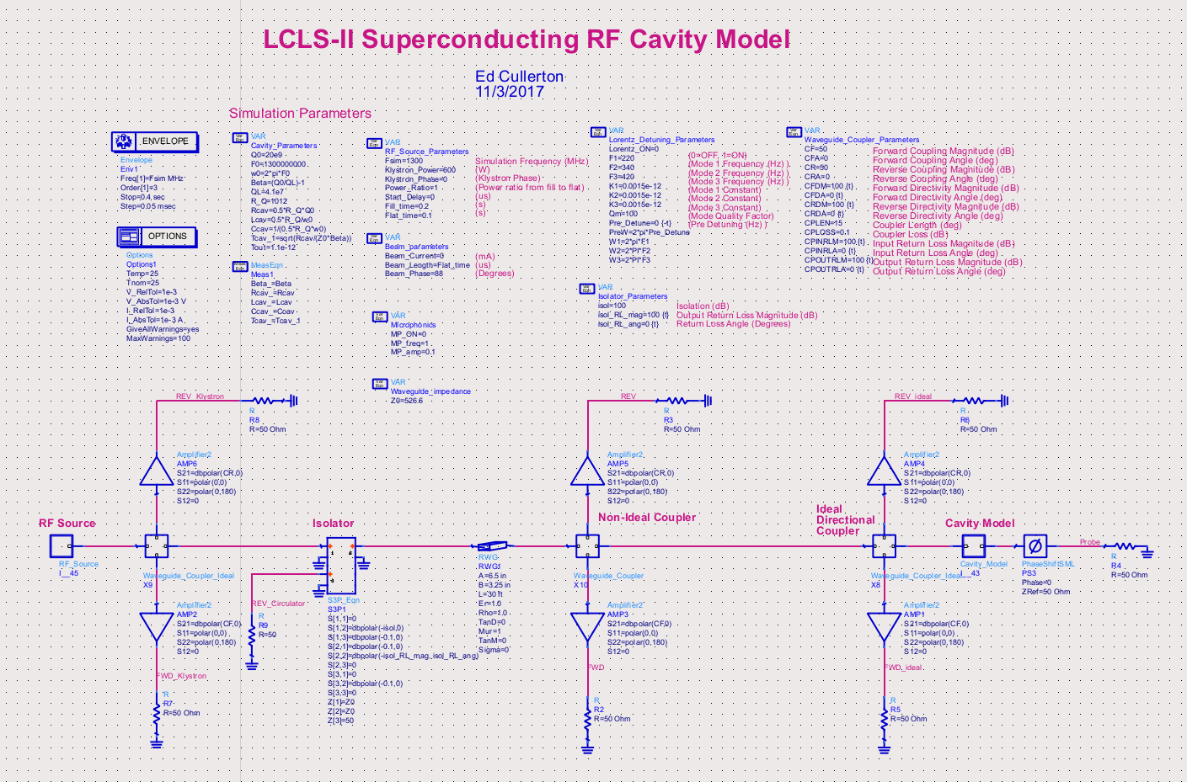

Figure 1. Keysight ADS simulation schematic.
The first simulation is of the system with ideal components. Some key parameters of the simulation is listed below:
- Pf = 600 Watts
- Forward power is turned on for 300 ms.
- Forward power is measured at the amplifier output and at the cavity input.
- Ql = 4.1e7 (used to calculate Beta of cavity coupler)
- Ql is calculated from the simulated cavity decay
- Amplifier isolator isolation = -100 dB
- Directional coupler directivity = 100 dB
- Output return loss of amplifier isolator = -100 dB
- Length of waveguide from amplifier to cavity = 30 ft
The above parameters are very much ideal RF components. The simulation results for this simulation are shown in figure 2. The simulated values are all as expected.
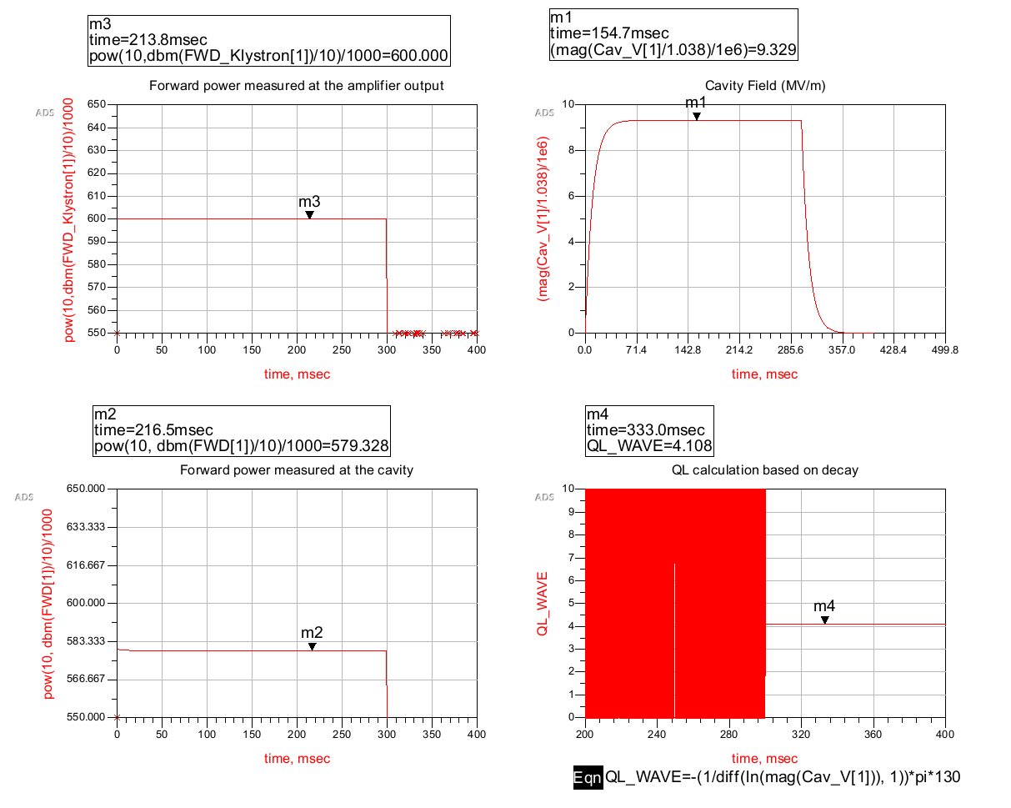

Figure 2. Simulation results with ideal RF components.

The above simulation shows the forward power loss is about 20 Watts between the amplifier and the cavity. This becomes an error in cavity field calibration:
For Pf =600 W, Ecav = 9.5844
For Pf = 580 W, Ecav = 9.452
This is an error of -1.3%
Next, a simulation is done reducing the output return loss of the isolator at the amplifier from -100 dB to a more realistic number of -20 dB. The phase of the output return loss is rotated +/- 90 degrees to get the minimum and maximum values for the simulation parameters. Figure 3 shows the results of this simulation.
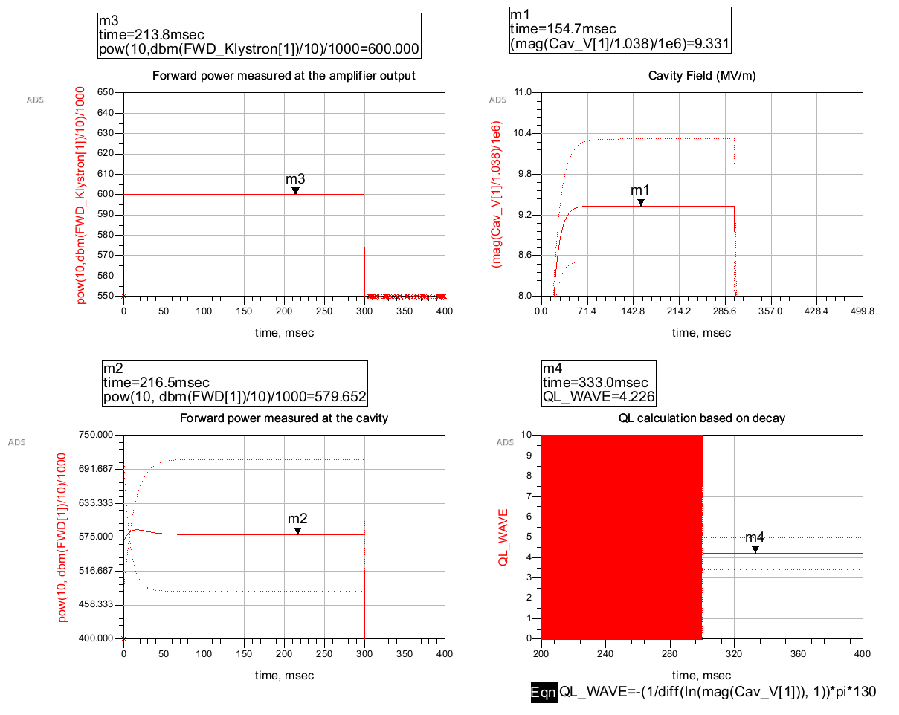

Figure 3. Simulation of cavity parameters with an output return loss of -20 dB on the amplifier isolator.

The cavity field is calculated using the minimum and maximum values of Ql from the simulation, then that number is compared to the simulation values of cavity field to find the error.
For Ql = 4.98e7 (maximum),
Ecav(Ql) = sqrt(4*600*4.98e7*1012)/1.038 = 10.59 MV/m
Ecav(sim) = 10.32 MV/m
Error = +2.7%
For Ql = =3.39e7 (minimum),
Ecav(Ql) = sqrt(4*600*3.39e7*1012)/1.038 = 8.74 MV/m
Ecav(sim) = 8.51 MV/m
Error = +2.7%
To conclude, the cavity field gradient calibration error is estimated to be less than 5% based on the simulated results and assumptions described in this note.

