LCLS-II CMTS Cavity Probe Calibrations
Ed Cullerton, Brian Chase, John Reid, Genfa Wu, Timergali Khabiboulline, Mohamed Hassan, Paolo Berrutti
9/16/2016

Two measurement procedures for the LCLS-II cryomodule cavity probe calibration at the LLRF front panel monitor are presented in this note for comparison. Both measurement procedures were repeated for cavities 1 and 4. The results of the two measurement procedures are presented, along with final measurement results for all eight cavities in the cryomodule.
The first measurement procedure for the cavity probe calibration at the LLRF front panel monitor is shown in figure 1. A S11 measurement of the cable back to the cavity probe is made from the back of LLRF rack 231. This measurement is added to a S21 measurement to the front panel monitor of the LLRF rack to obtain the total loss to the monitor, as shown in figure 1.

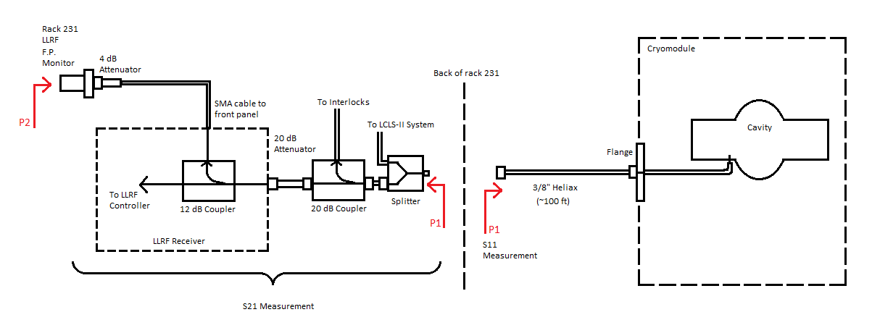
Figure 1. Measurement procedure 1 of losses to the LLRF monitor.

The measured S11 data for cavities 1 and 4 are shown in figure 2. The internal reflections of the cables and the imperfect short of the cavity probe is seen in the measurement. The reflections cause an impedance rotation around the real value for losses in the cable. This measurement is just a circle moving along the real axis of a smith chart, and the center of the circle is the loss of the cable. The value of the cable loss is shown by line in green.
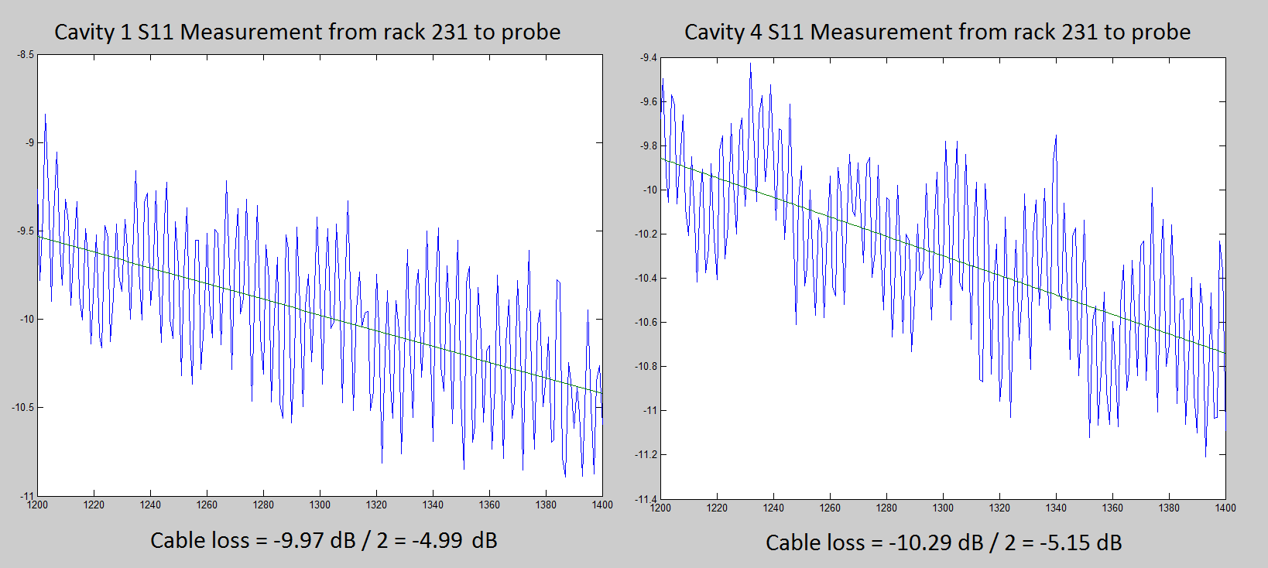
Figure 2. S11 measurements from rack 231 to cavity probe.

The measured S21 data is shown in figure 3. The measurement is straightforward and does not need any interpretation.

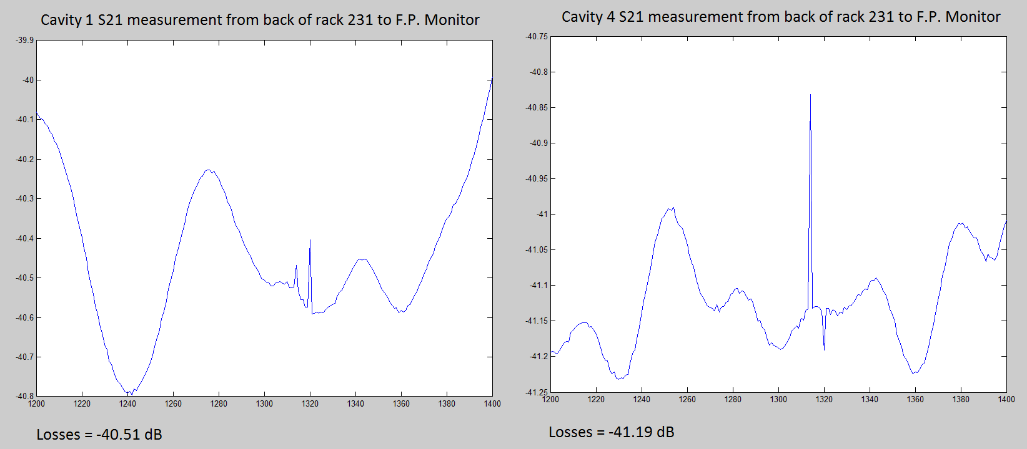
Figure 3. S21 measurements of component losses from back of rack to front panel monitor.

The total calculated loss using measurement procedure 1 is shown in the table 1 below:
 | Cable losses to the probe | Component losses to the front panel | Total Loss
Cavity 1 | -4.99 dB | -40.51 dB | -45.5 dB
Cavity 4 | -5.15 dB | -41.19 dB | -46.34 dB
Table 1. Total loss calculated using measurement procedure 1.

The second measurement procedure of the losses to the LLRF monitor is shown in figure 4. A S11 measurement is made at the cryomodule flange to the cavity probe. This measurement is added to the losses of the cable and components to the LLRF front panel to obtain the total loss to the monitor. The measurement of the cable and component losses is made using a synthesizer and power meters as shown in figure 4.
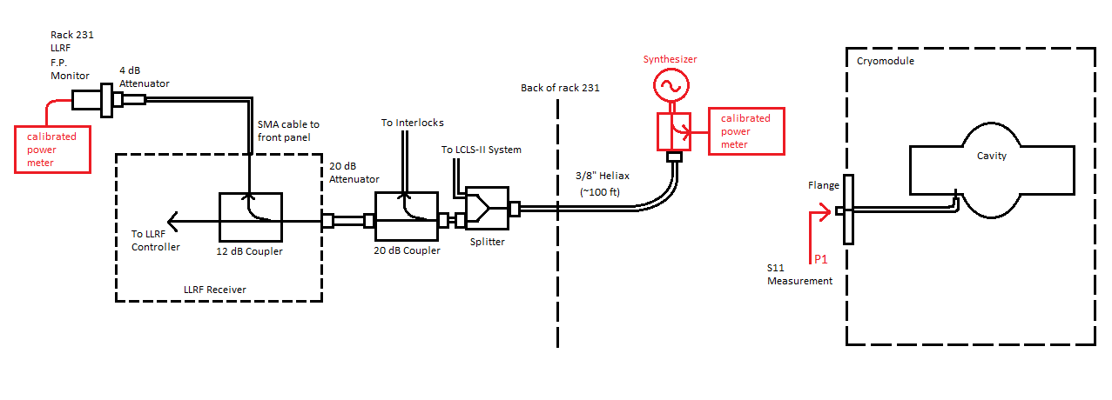
Figure 4. Measurement procedure 2 of losses to the LLRF monitor.

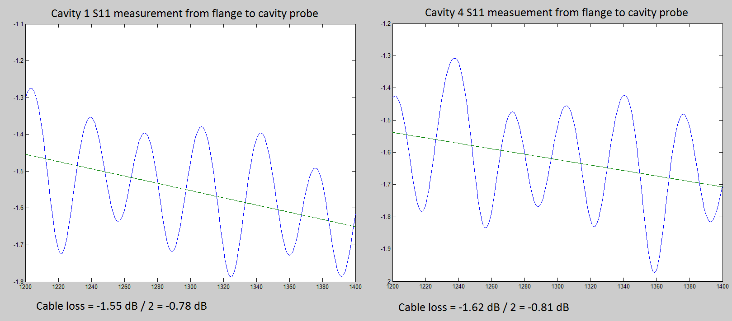
Figure 5. S11 measurement of cable losses from the flange to the cavity probe.
Power meter readings for measurement of cable and component losses to the front panel are listed in table 2 below:
 | Power Meter at Source | Power Meter at Front Panel | Total loss
Cavity 1 | 9.25 dBm | -35.34 dBm | -44.59 dB
Cavity 4 | 9.26 dBm | -36.23 dBm | -45.49 dB
Table 2. Cable and component losses measured using synthesizer and power meters.

The total calculated loss using measurement procedure 2 is shown in the table 3 below:
 | Cable losses flange to probe | Component + cable losses to front panel | Total loss
Cavity 1 | -0.78 dB | -44.59 dB | -45.37 dB
Cavity 4 | -0.81 dB | -45.49 dB | -46.3 dB
Table 3. Total loss calculated using measurement procedure 2.

A comparison of the two measurements is shown in Table 4.
 | Measurement 1 | Measurement 2 | Difference
Cavity 1 | -45.5 dB | -45.37 dB | 1.5%
Cavity 4 | -46.34 dB | -46.3 dB | 0.5%
Table 4. Comparison of the two measurement procedures.
With such a small error between the two measurements, it was decided to continue measuring the remaining cavities using measurement 1. Measurement 1 has a three advantages over measurement 2. First, the connection to the flange does not have to be disconnected. Second, entry into the cave is not required. Third, termination problems can be detected with the cables all the way back to the probe.
A MATLAB script has been written for a 1st order polynomial fit of the S11 data and is shown below. The script reads and plots S11 and S21 data from the measurements, and calculates total loss.
% MATLAB script to read in data from CMTS calibration NA measurement
% Ed Cullerton
% 9/16/2016

clear all
% Open the .dat file
fid=fopen('S11_LLRFC1_Calibrated.NWA');
fgets(fid); % Skip the first line
data=fscanf(fid, '%f'); % Get the data
% Close the .dat file
fclose(fid);

num_points = size(data,1)/3;
for lcv = 1:num_points
NA_freq(lcv)=data(1+(lcv-1)*3);
S11_real(lcv)=data(2+(lcv-1)*3);
S11_imag(lcv)=data(3+(lcv-1)*3);
S11_mag(lcv)= 20*log10((sqrt(S11_real(lcv)^2+S11_imag(lcv)^2))/1000);
end
fit = polyfit(NA_freq, S11_mag, 1);
S11_fit = fit(1)*NA_freq+fit(2);

% Open the .dat file
fid=fopen('S21_LLRFC1port_FrontPanelCav1.NWA');
fgets(fid); % Skip the first line
data=fscanf(fid, '%f'); % Get the data
% Close the .dat file
fclose(fid);

num_points = size(data,1)/3;
for lcv = 1:num_points
NA_freq(lcv)=data(1+(lcv-1)*3);
S21_real(lcv)=data(2+(lcv-1)*3);
S21_imag(lcv)=data(3+(lcv-1)*3);
S21_mag(lcv)= 20*log10((sqrt(S21_real(lcv)^2+S21_imag(lcv)^2))/1000);
end
Total_loss = S11_fit(101)/2 + S21_mag(101)

figure(1)
plot(NA_freq, S11_mag, NA_freq, S11_fit)
figure(2);
plot(NA_freq, S21_mag)

Using the MATLAB script above to calculate total losses, measurement data for all eight cavities are listed in table 5 below. There is about 3 dB difference between cavities 1-4 and 5-8 due to splitters inline that send signals to the LCLS-II LLRF system in rack 233.
 | Total Loss
Cavity 1 | -45.49 dB
Cavity 2 | -46.18 dB
Cavity 3 | -45.43 dB
Cavity 4 | -46.34 dB
Cavity 5 | -42.90 dB
Cavity 6 | -43.38 dB
Cavity 7 | -42.55 dB
Cavity 8 | -43.64 dB

Table 5. Total Loss to the LLRF front panel monitor from the cavity probe.
Below is the MATLAB S11 and S22 plot data for each cavity using measured data.
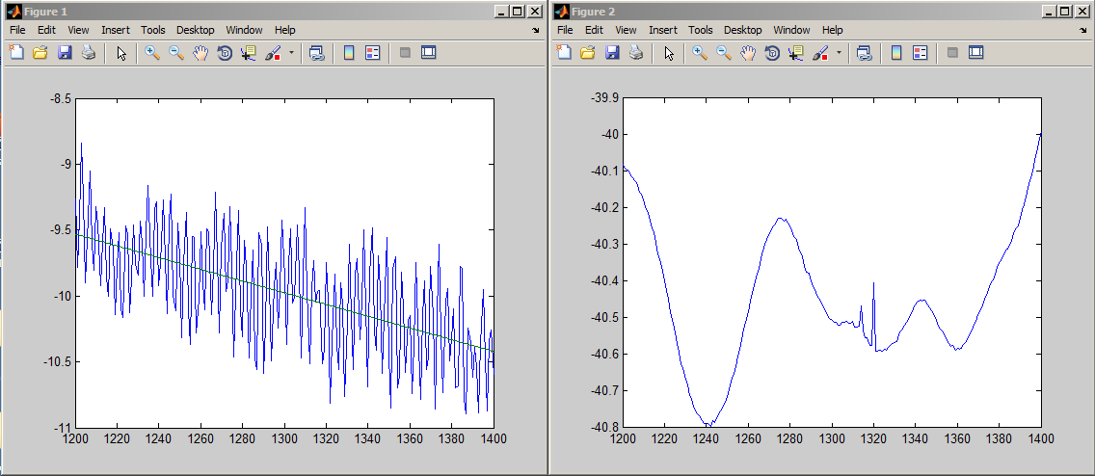
Figure 6. Cavity 1 data and results.
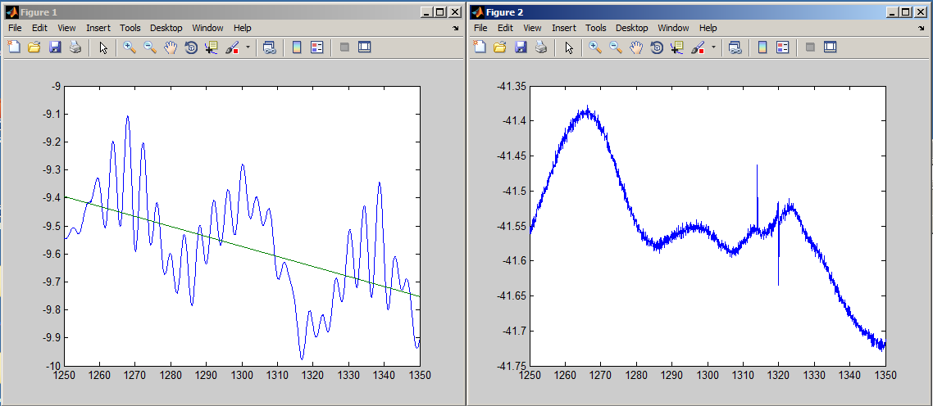
Figure 7. Cavity 2 data and results.

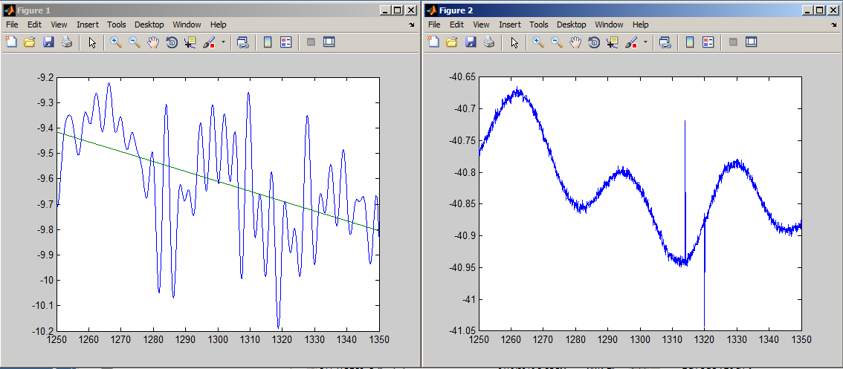
Figure 8. Cavity 3 data and results.

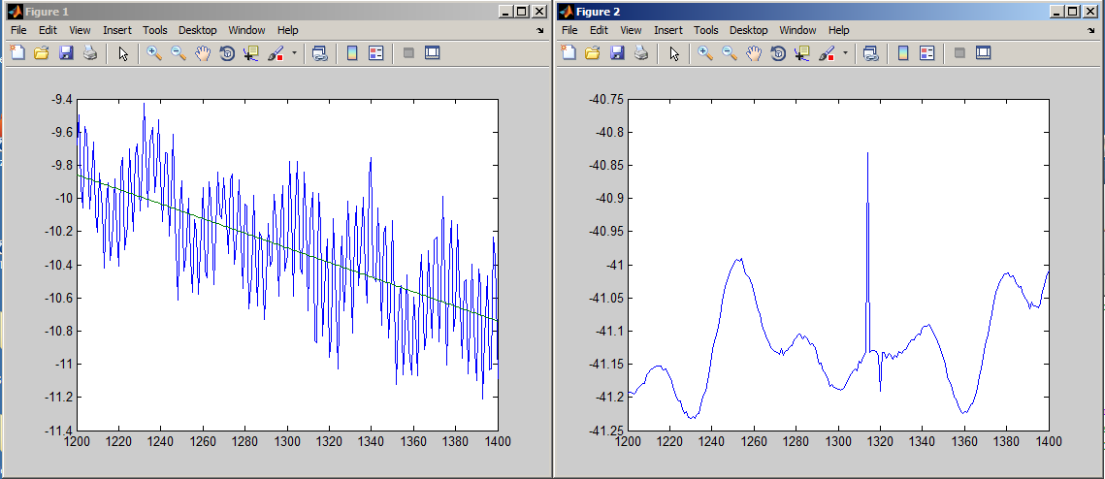
Figure 9. Cavity 4 data and results.
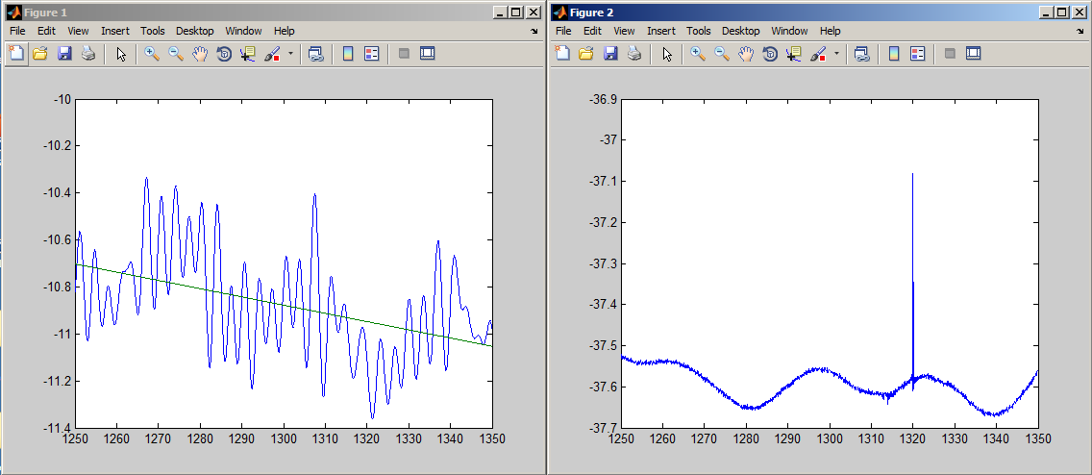
Figure 10. Cavity 5 data and results.

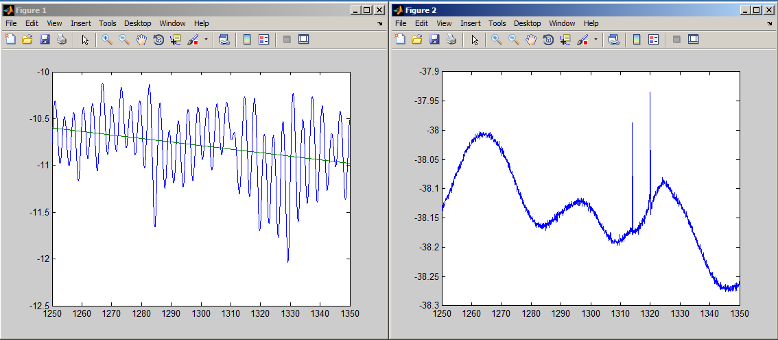
Figure 11. Cavity 6 data and results.

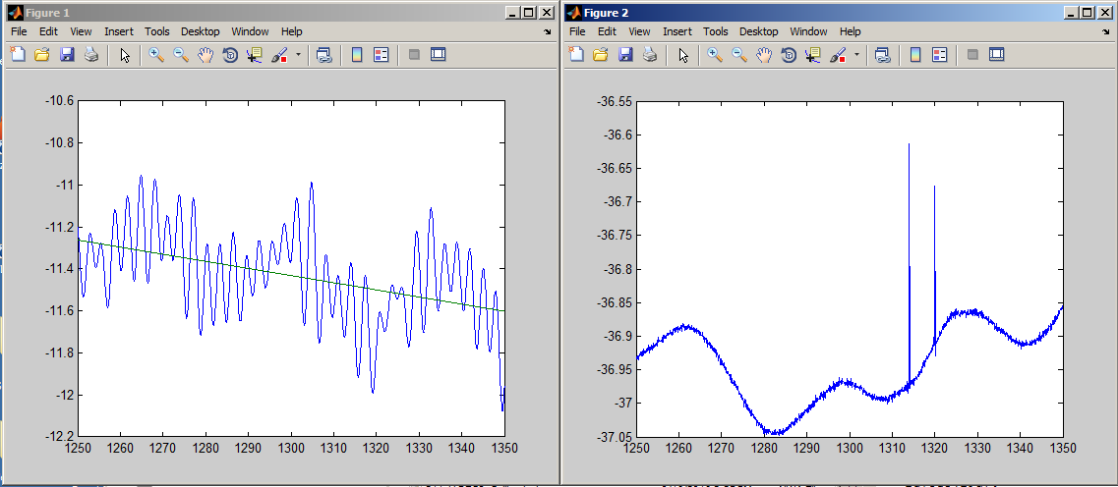
Figure 12. Cavity 7 data and results.

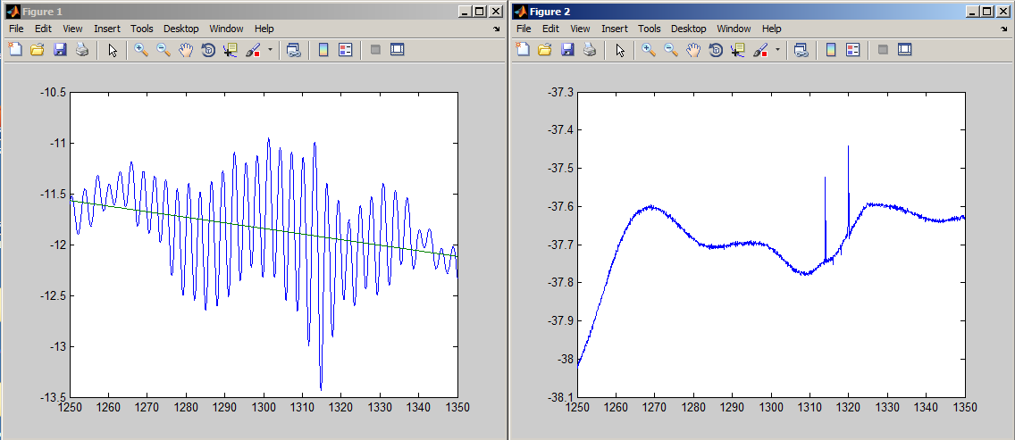
Figure 13. Cavity 8 data and results.

