Ql Measurement Error due to RF Components at MESON Building 1300MHz HTS
Ed Cullerton
2/27/2015

The measurement accuracy of Ql depends on the quality of RF components in the RF drive line. The components that could significantly affect Ql measurement are the circulator and the directional coupler. When the forward power is shut off and the decay seen on the cavity probe is being measured, power is also going out of the cavity into the RF drive line. The output return loss of the RF components in the RF drive line (circulator, cables, and coupler) will reflect power coming out of the cavity and inject power back into the cavity, which will change the decay seen on the cavity probe. We will assume, for these simulations that the cables do not significantly contribute to the reflections. The purpose of this note is determine that relationship of Ql measurement errors and RF component specification. Most specifically, the output return loss of the above components.
Using Agilent (now Keysight) ADS RF simulation software, a RF model of the cavity and RF drive system has been put together. The model is shown in Figure 1. Details of the model are described in [1].
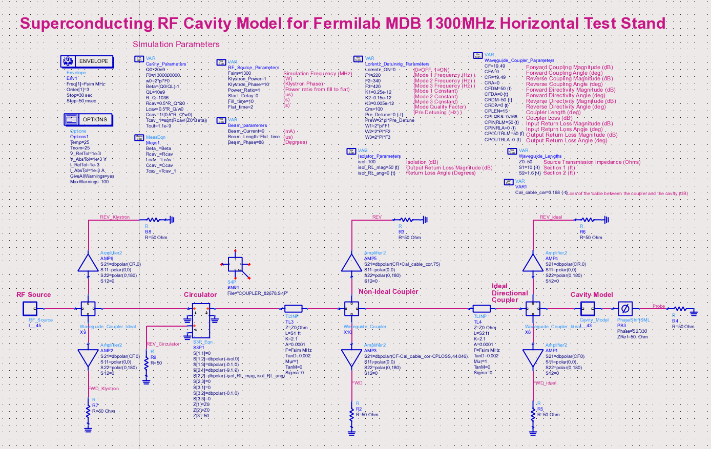
Figure 1. ADS model of the MESON building 1300 MHz HTS.

Figure 2 shows simulation results of the model under ideal conditions. The cavity is critically coupled with Q0=2e10 and Ql=1e10. The circulator and the coupler have an output return loss of 50 dB. The Ql is calculated from the decay seen on the cavity probe and is calculated to be 10.053e9, which is pretty close to the expected value.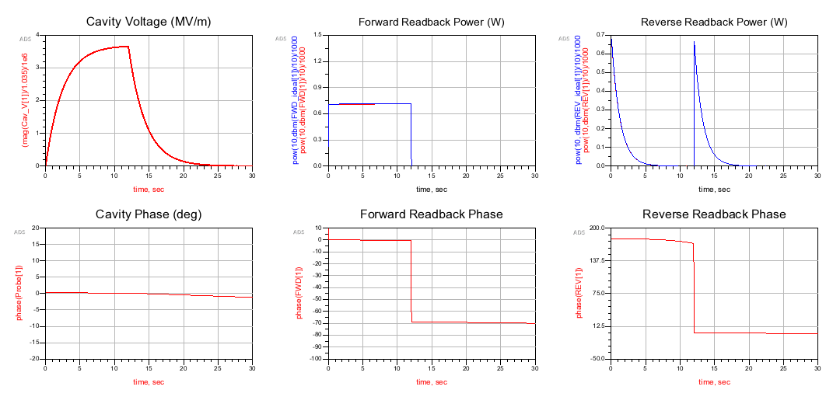
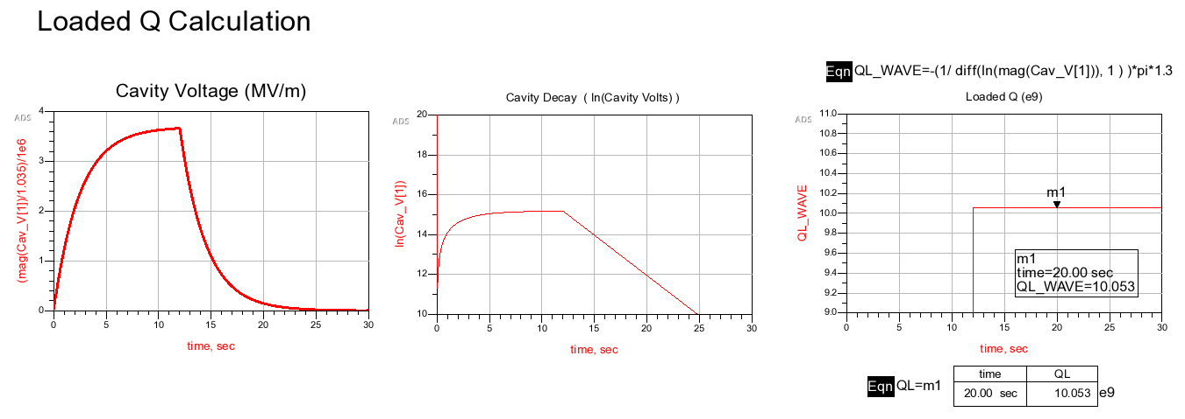
Figure 2. Cavity under ideal conditions.

For the next simulation, the circulator output return loss is set to 20 dB. The circulator at HTS has not been measured, but referring to the manufacture’s data sheet, the output return loss may be as high as 17 dB. In the simulation, the angle of the return loss is rotated through 180 degrees to vary the reflection angle of the power back into the cavity, and Ql is measured. Figure 3 shows the variation in measurement of QL and also variations in forward power. The simulation shows Ql measurement varies by +/- 7%. Notice the zoomed in forward power decay due to the reflections directly after turn off.
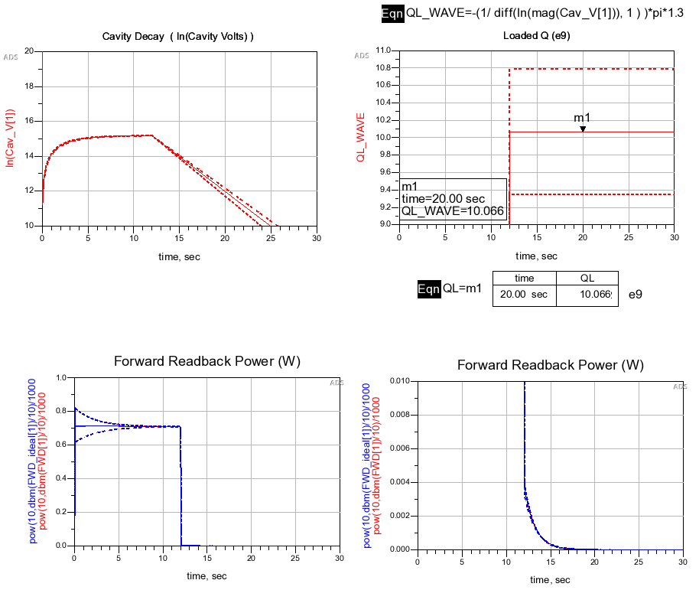
Figure 3. Variation of Ql measurement with a circulator output return loss of 20 dB.
At HTS, a Narda 3022 directional coupler is used. The data sheet specifies better than 23 dB return loss. For the next simulation, a worst case scenario is simulated. The circulator return loss angle is set for maximum error to Ql, and the coupler output return loss is set to 23 dB with the angle set to maximally add to Ql error. The simulation shows Ql measurement can vary up to +/- 14%.
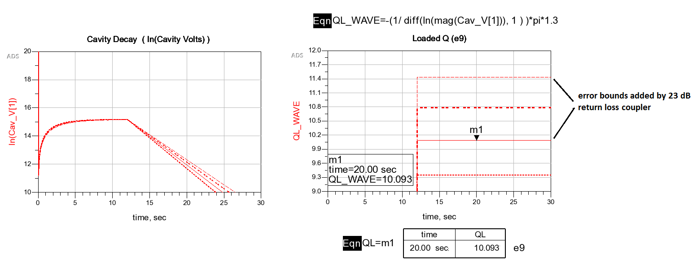
Figure 4. Error added by 23 dB return loss coupler.
The above measurements show that care should be take when selecting RF components in the RF drive path. Since non-ideal components will always be part of the RF drive, a simple solution is to place a trombone between the circulator and the directional coupler and measure Ql while rotating the trombone through 180 degrees. The average value obtained from this measurement will give the correct value for Ql.

References
[1] E. Cullerton, B. Chase, J Branlard. “Superconducting Cavity Model and Simulation for Fermilab’s NML Test Facility”, Fermilab Internal Note.

