Moving a repository from GitHub.com to

ghe-pip2.fnal.gov

Last saved: 6/12/2020 1:14 PM
Elliott McCrory

The basics of this process are found here: https://coderwall.com/p/istvca/how-to-move-git-repo-from-one-server-to-another
Getting the tokens in place so you can ssh with the various servers is probably the hardest part. (There is likely a simpler way to do this.)
(I am doing the transfer for my PHP “AD Attendance” repository as I write this document. Thus the choices of username and repository name.)
First, make a an RSA key for github.com:
linux $ ssh-keygen -t rsa -b 4096 -C "emccrory@github.com"
Then clone the repository using the “--bare” tag:
linux $ git clone git@github.com:emccrory/ad-attendance.git --bare
Cloning into bare repository 'ad-attendance.git'...
X11 forwarding request failed on channel 0
remote: Enumerating objects: 159, done.
remote: Counting objects: 100% (159/159), done.
remote: Compressing objects: 100% (99/99), done.
remote: Total 159 (delta 96), reused 105 (delta 52), pack-reused 0
Receiving objects: 100% (159/159), 100.61 KiB | 0 bytes/s, done.
Resolving deltas: 100% (96/96), done.

Now you have a cloned, bare version of your repository:
linux $ ls -l *.git
total 0
drwxrwxr-x. 7 mccrory mccrory 138 Jun 12 11:25 ad-attendance.git
linux $ cd ad-attendance.git/
linux $ ls -l
total 16
drwxrwxr-x. 2 mccrory mccrory 6 Jun 12 11:25 branches
-rw-rw-r--. 1 mccrory mccrory 133 Jun 12 11:25 config
-rw-rw-r--. 1 mccrory mccrory 73 Jun 12 11:25 description
-rw-rw-r--. 1 mccrory mccrory 23 Jun 12 11:25 HEAD
drwxrwxr-x. 2 mccrory mccrory 242 Jun 12 11:25 hooks
drwxrwxr-x. 2 mccrory mccrory 21 Jun 12 11:25 info
drwxrwxr-x. 4 mccrory mccrory 30 Jun 12 11:25 objects
-rw-rw-r--. 1 mccrory mccrory 98 Jun 12 11:25 packed-refs
drwxrwxr-x. 4 mccrory mccrory 31 Jun 12 11:25 refs

Next step is to create an empty repository on our GitHub enterprise server. This is done through the web browser:
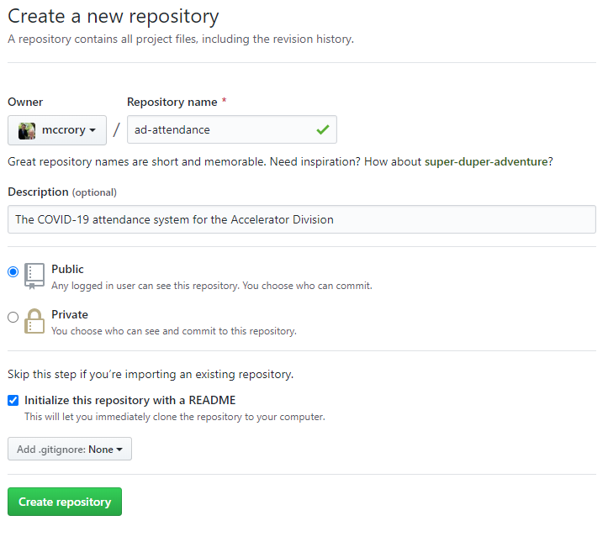
The next step is to generate a key for the PIP-2 repository. There must be a simpler way to do this that what I show here, but here it is.
linux $ cd ~/.ssh
linux $ ls -l
total 24
-rw-------. 1 mccrory mccrory 3243 Jun 5 11:28 id_rsa
-rw-r--r--. 1 mccrory mccrory 745 Jun 5 11:28 id_rsa.pub
-rw-r--r--. 1 mccrory mccrory 6088 Jun 5 16:32 known_hosts
linux $ mv id_rsa id_rsa1
linux $ mv id_rsa.pub id_rsa1.pub
Now you can generate keys for our PIP-2 GitHub:
linux $ ssh-keygen -t rsa -b 4096 -C "mccrory@ghe-pip2.fnal.gov"
linux $ ls -l
total 24
-rw-------. 1 mccrory mccrory 3243 Jun 5 11:35 id_rsa
-rw-------. 1 mccrory mccrory 3243 Jun 5 11:28 id_rsa1
-rw-r--r--. 1 mccrory mccrory 745 Jun 5 11:28 id_rsa1.pub
-rw-r--r--. 1 mccrory mccrory 751 Jun 5 11:35 id_rsa.pub
-rw-r--r--. 1 mccrory mccrory 6088 Jun 5 16:32 known_hosts

With these ssh file in place, you can now push this bare repository onto the new server:
linux $ git push --mirror git@ghe-pip2.fnal.gov:mccrory/ad-attendance.git
X11 forwarding request failed on channel 0
Counting objects: 159, done.
Delta compression using up to 8 threads.
Compressing objects: 100% (55/55), done.
Writing objects: 100% (159/159), 100.61 KiB | 0 bytes/s, done.
Total 159 (delta 96), reused 159 (delta 96)
remote: Resolving deltas: 100% (96/96), done.
To git@ghe-pip2.fnal.gov:mccrory/ad-attendance.git
+ 78e5fd0...497b3af master -> master (forced update)

To verify, go to our Enterprise GitHub server to see what just happened:
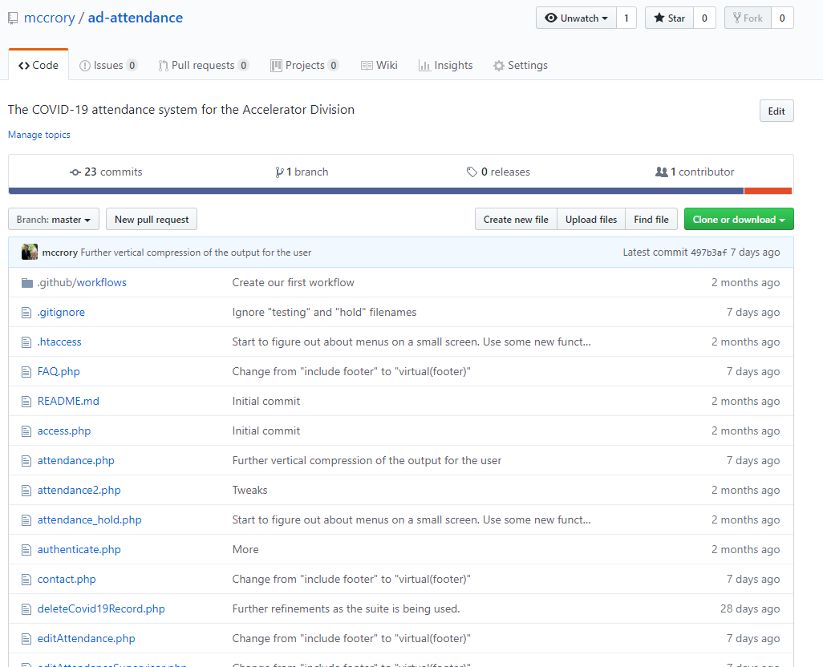

Task complete.

