**FERMILAB-TM-2472-AD**

Beam Losses for the PIP-III Linac to Recycler/Main Injector

*David Neuffera*

aFermilab, PO Box 500, Batavia IL 60510 USA

**Abstract.** The PIP-III linac produces 8 GeV H-  beam for injection into the Recycler or Main Injector (MI). Beam losses throughout the system must remain low to ensure high intensity in the MI cycle and to manage radiation effects to acceptable levels, including enabling practical maintenance of the facility. Beam loss mechanisms in the system include magnetic stripping, blackbody radiation, intrabeam stripping, beam gas scattering, and injection related losses. Injection related losses due to the multiturn injection and painting scenario with multiple beam-foil interactions are a particularly significant concern.

Keywords: muon, beams, PIP-II

# introduction

The PIP-II project will provide a 800 MeV proton beam with cw capability, with beam power up to the MW level available for user experiments.[1] However, the amount of beam that can be transmitted to the Main Injector (MI) is limited by the 0.8—8.0 GeV Booster capacity. The next Fermilab upgrade should include a replacement for the Booster. The project-X design proposal included some options for that replacement, based on a continuation of the 800 MeV linac to 2—3 GeV followed by either a Rapid Cycling Synchrotron (RCS) or continuing the Linac to 8 GeV.[2] While an 8 GeV Linac would be expected to be very expensive, it may be made relatively affordably by using relatively inexpensive ILC-style cryomodules that use 1300 MHz SRF cavities, that have already been designed and mass-produced.

In this note we will focus on the 8 GeV Linac option. We begin with some discussion of the beam requirements and potential layouts for the Linac. Constraints on accelerating gradients and magnetic fields are discussed. We then progress to discussion of injection from the 8 GeV Linac into the Recycler ring or MI. The injection process involves foil stripping of the incoming H- beam to obtain multiturn injection. Potential beam-loss problems exist in magnetic stripping of H- beam, intrabeam scattering, black-body radiation stripping, beam-gas losses, halo losses, stripping efficiency, foil damage and radiation in the injection region. An optimum “beam painting’ strategy is needed. First calculations of these effects are obtained and critical difficulties related to beam losses are discussed.

# Linac Scenarios

The initial design specification for the PIP-III upgrade is that it should enable at least ~2.5 MW from the MI. With a 120 GeV beam energy and a MI period of 1.2 s, this requires 1.5625*1015 p/cycle, or 25 ma-ms of injected beam. The 800 MeV beam PIP-II beam can provide up to 2 ma of cw beam, so 12.5 ms of injection would be sufficient. This minimal requirement corresponds to 167 kW of 8 GeV beam. More beam would of course be desirable, and the 8 GeV Linac should enable at least another 160kW for other 8 GeV beam programs.

Scenarios for an 8 GeV Linac scenario were developed within the project X program.[3] Fig. 1 shows a possible scenario. The 800 MeV Linac is extended to ~1 GeV. The beam exiting that Linac is bent at a steep angle into a 1🡪3 GeV linac (~280 m long). In the Project X scenario that linac is a cw linac that uses the same 650 MHz cryomodules as the end of the PIP-II linac. The beam then goes through a bend of approximately 100° to be pointed toward injection into the Recycler. A ~390m 3🡪8 GeV pulsed linac, consisting of ILC 1300 MHz cryomodules takes the beam toward the MI. Parameters of the different linac components are shown in Table 1.

The curves away from the MI and back toward the MI are needed to fit the somewhat longer linac segments into the relatively short space between PIP-II and the MI. The current PIP-II is moved ~ 100 feet to the right from the position shown in Fig. 1. This places it slightly further from the MI injection point which can be used to fit a slightly larger curved linac (or the large angle into the initial linac could be reduced). A much longer linac design would not fit easily within this relatively confined space. The degree of curvature that could be added is limited by the fact that H- ions must be accelerated and transported to the MI, and the bending fields must be low enough to avoid magnetic stripping.

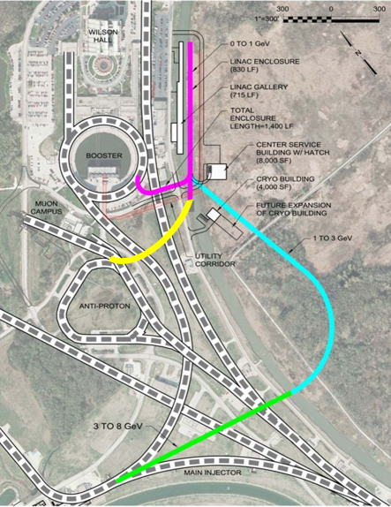

**Figure .** Layout on the 8 GeV Linac as envisioned in Project X (from ref. 3).

In the Project X design, the 3 GeV linac was designed to feed high-intensity Kaon physics experiments. In earlier versions the cw linac went only to 2 GeV, which was adequate for some experiments, but was inefficient in Kaon production. A high-intensity Kaon program may not be as important as in 2012, so this transition point could be reevaluated. The MI is intrinsically pulsed and needs the Linac for only 26 ma-ms per 1.2s. It is expected that 1300 MHz mass-produced pulsed ILC cryomodules would be much cheaper than alternatives, which would need additional development. Therefore the 3🡪8 GeV Linac was initiated as a pulsed Linac design.

The 8 GeV beam will also have some other functions. It could feed a continuation of the present short-baseline neutrino experiments, which currently use 8 GeV Booster beam. It could also be a primary beam source for a continuation of the g-2 experiment or other experiments. The pulsed linac could provide ~400 kW to such experiments. The Fermilab Project X also considered conversion of this linac to cw mode as a future upgrade, which could then provide up to ~8 MW for ultra high-intensity applications such as a “neutrino factory”.

The MI ring is partnered with a same circumference Recycler ring (RR). The recycler ring consists of permanent magnets, fixed to 8 GeV proton energy. In the present MI operation, protons are collected in the RR during the MI acceleration cycle, to be injected into the MI at the beginning of its accelerator cycle. The same mode of operation could be adopted in PIP-III, for both linac and RCS scenarios.

The aperture and acceptance of the RR is a bit smaller than the MI (24π versus ~30π, 95% , normalized), so use of it restricts MI intensity. Also the injection is fixed to 8 GeV. A higher energy injection would increase that acceptance, following a factor of βγ.

In the Linac scenario, beam could be injected directly into the MI in a single 26 ma-ms injection pulse (13ms at 2ma); but, as discussed below, stripper foil heating is increased. For an RCS, multiple RCS pulses are required to feed the MI, which would then require an extended injection time, which would reduce the total intensity delivered by the MI. (Accumulation in the RR from the RCS avoids that extension.)

**Table 1:** Parameters of the Project X 8 GeV Linac

|  |  |  |  |  |  |  |
| --- | --- | --- | --- | --- | --- | --- |
| Section | Length | Maximum bending field | Rf frequency | Total bending angle | **Cav/mag/CM** | Cryomodule length |
| 1GeV transport | 48 m | 0.277T |  | -60° |  |  |
| 1🡪3 GeV Linac | 240m | 650 MHz | 650 MHz,cw |  | 120/20/ 20 | 9.5m |
| 3 GeV bend | 200m | 0.13T |  | 105° |  |  |
| 3🡪8 GeV Linac | 390m | 1300 MHz | 1300MHz, 10Hz |  | 224 /28/28 | 12m |
| 8GeV injection |  | 0.055T |  |  |  |  |

# Beam loss constraints and mechanisms

One of the basic problems in the design and operation of high-power acceleration is to keep the radioactivation of the beam line components low enough for ‘‘hands-on maintenance’’. For this, activation levels must be below ~100 mrem/hr at 30 cm from a component surface, after extended operation [2, 4]. From previous accelerator experience this implies losses of less than ~1 W/m. This is quantified as less than 0.25 W/m at an unshielded beam pipe and ~3—10 W/m within a shielded magnet transport. We would prefer losses to a factor of five or more smaller, which would set a safety limit of ~0.2 W/m, and would allow relatively unrestricted maintenance.

## Magnetic stripping constraints

The 8 GeV Linac beam must be transmitted as H-, for compatibility with H- injection into the Recycler, and the bending fields in the 8 GeV PIP-III transports are limited to ~0.05T to avoid magnetic stripping to H0. The 8 GeV Linac has three locations with significant amounts of bending magnets: the initial bend of ~60°following the PIP-II Linac where the beam is ~1 GeV, the bend of ~105° at the end of the 3 GeV cw linac, and smaller bends at 8 GeV associated with injection into the recycler/Main Injector.

The stripping time can be estimated using the formula of Schrek:

 seconds,

where *p* = is the H- momentum, Bt is the magnetic field and *a* and *b* are parameters fitted from data. [5, 6] Keating et al. obtained *a* = 3.073 10-14and *b* =44.14 from 800 MeV data. [7] The stripping length L is given by L = *βγcτ*.

For 1 GeV protons the transport is a mirror image of the PIP-II transport to the Booster. For that transport, the PIP-II design set a limit of 0.277 T , at which τ=0.12s, and L=6.43×107. Losses per meter would be 1.6×10-8 , which would be 0.032 W/m at 2MW beam power. The 60° requires ~21.4 m of bend, which must be included in an achromatic lattice, requiring ~30 m of transport with, perhaps, additional matching transport. The total losses be ~3.5×10-7, which is relatively small.

The 1 GeV Bend is followed by the 1—3 GeV Linac, which leads into the 3 GeV 105° bend. For 3 GeV H- we set B=0.13T, at which τ=0.022s, and L=2.7×107 m. Losses per meter would be 3.7×10-8, which would be 0.074 W/m at 2MW beam power. The 105° bend requires ~180m of bending magnet in a ~200m transport. The total losses be ~6.7×10-6, which is relatively small.

The 8 GeV beam does not have a long transport before recycler injection and would have a minimal amount of bending. In the Project X design the maximum allowed bending field was 0.055T at which τ=0.036s, and L=1.0×108 m. Losses per meter would be 1.0×10-8, which would be 0.020 W/m at 2MW beam power, which would require cw operation. At pulsed operation this would be an order of magnitude smaller. The injection requires H- transport through a 6m, B=0.055T magnet. Magnetic stripping losses should be less than ~10-7, and should be much less than foil-related losses.

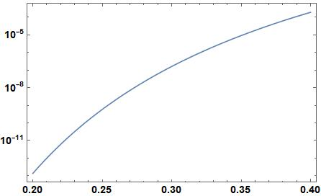 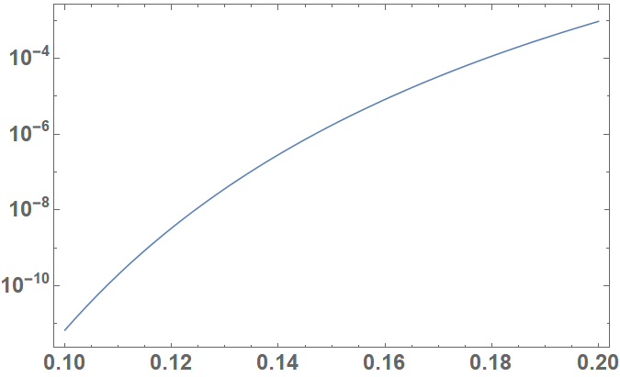

**Figure 2:** Magnetic stripping rate (m-1) as a function of B(T) for 1 and 3 GeV H- .

## Black-body radiation stripping

The beam pipe would be filled with low-energy photons from thermal black body radiation. At room temperature (300°K), kT =0.02587 eV and the spectral energy distribution peaks at ~0.06 eV. A much larger exchange of E0 = 0.754 eV is needed to ionize H- at rest. The photons are Doppler shifted by a factor of up to 2γ in the H- ion rest frame at high energies. At 8 GeV, the peak is shifted above that threshold and H- stripping can occur. [8, 9]

The photodetachment cross section is:



where σmax = 4.2×10-21and E' is the photon energy in the H- rest frame:

The stripping rate can be calculated using the following equation:



We evaluated this expression to be ~7.81×10-7 /m, in good agreement with Carneiro, et al. [8] This is a fairly large value. The pulsed version of the 8 GeV beam (~200 kW) would have 0.156 W/m while a cw version at 2 MW would have 1.56 W/m. The transport at 8 GeV is relatively short, so the resulting beam loss should be manageable (1.56×10-5 in 20m). The radiation stripping can be greatly reduced by cooling the beam pipe to a lower temperature, which reduces the photon energy spectrum proportionately. A reduction to 150°K (from liquid nitrogen cooling) would reduce losses to ~2.5×10-8, enabling easier maintenance and more manageable cw operation.

Black-body stripping also occurs at 3 GeV. The present scenario has a relatively long 3 GeV transport, which implies a relatively large integrated loss. This is calculated as ~1.3×10-7 /m, which would integrate to 2.6×10-5 over 200 m. If used for 2 MW of cw beam, this would be 0.26 W/m. Most of this would be in shielded magnets. If the bend is only used to feed pulsed beam into the 3🡪8 GeV Linac, the activation and beam loss would be ~5×10-10 , a much smaller number.

Throughout most of the linac segments the beam pipe is at cryogenic temperatures within cryomodules, and the black-body stripping should be much smaller.

## Beam-gas stripping

Collisions of H- with background gas molecules can strip the H- ions, causing beam loss. [8, 9] The lifetime τm  of an H- ion in the presence of residual gas is given by:



where dm is the gas particle density and σm  is the interaction cross section. The beam fraction loss per unit length is:

.

This is to be summed over gas components. If we assume the gas is “air”, then σm =~0.65×10-18 cm2and dm = 3.2×1022P (torr) m at T =300° K then L-1 = 2.1 P (torr) m-1 . With a vacuum of 10-8 Torr, losses are 2.1×10-8 /m. or 0.042 W/m for a 2 MW beam. Ref. 12 used a generic vacuum of 70% H2, 10% H2O, 10% CO2, 10% CO), which would make the average value of σm = ~0.15×10-18, and reduce the losses by a factor of ~4 at the listed pressure.

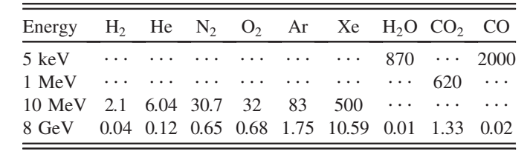**Table 2:** Electron-loss cross sections per molecule tor H- in units of 10-18 cm2, as presented in ref. 8, using data from ref. [10, 11].

## Intrabeam Scattering and Stripping Beam Loss

An unexpected beam loss mechanism in the H- linac at SNS was identified by Lebedev as due to neutralization from intrabeam stripping. The PIP-III linac is also H- and is therefore vulnerable to this loss mechanism. An equation for the beam loss due to intrabeam stripping is presented in ref. [12]:



where σmax= ~4×10-15 cm-2, N is the number of H- ions/bunch, σx, σy, σz are beam sizes in the beam frame, σvx, σvy, σvz are beam velocity spreads and 

Transforming to the lab frame, we find the fractional loss per length is given by:

.

N is the number of H- ions/bunch, which is ~1.9×108 at 5 ma peak current, σx = (εn,xβx/βγ)1/2, θx,rms=(εn,x/βx/βγ)1/2, θ,rms =δp/p and σs is the bunch length. The integrated function F is close to 1 at Project X parameters. At typical parameters (εn­ = 0.3×10-6 m-rad, βx,y = 10 m, γ = 2.07 to 9.53 (1🡪 8 GeV), σs = 1.5 mm, θ=~0.0003), dN/ds/N is ~4×10-8/m (1GeV) to ~2×10-8/m (8 GeV). This would correspond to 0.04 to 0.02 W/m at 1MW. A more complete evaluation of these was made by Ostiguy for project X, with evaluation of beam sizes from tracking through the lattice. [13] Those results were similar to the present evaluation.

# Injection losses

## Beam Transport and stripper location

The baseline scenario for injection into the MI or Recycler is into the MI10 area, which will have to be modified to accommodate stripper foil injection. Betatron functions in that region are displayed in figure 3.[4, 14] The betatron functions are somewhat enlarged to 70 m by 30 m from that in the rest of the recycler ring. This reduces the foil heating by reducing the density of the hits on foil. The injection straight section includes fast-ramping kicker magnets and deflecting dipoles that direct the injected and recirculating beams together, and the stripping foil followed by defecting magnets that return the circulating beam to the accelerator central with fast ramping kickers. The programmed kicker magnets paint the injected beam into the circulating beam. Figure 4 shows the injection magnet and kicker geometry used for that purpose.

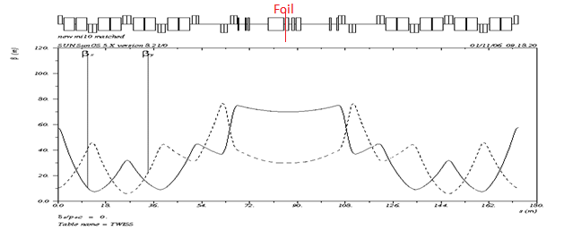

36 m

**Figure 3.** Betatron functions in the Recycler injection region (from ref. 2). The ~36m straight section reserved for injection is shown.

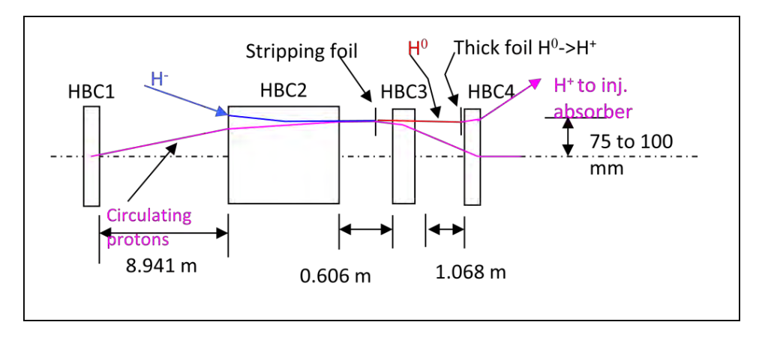

**Figure 4:** Injection insert components to be placed in the large β straight section shown above.

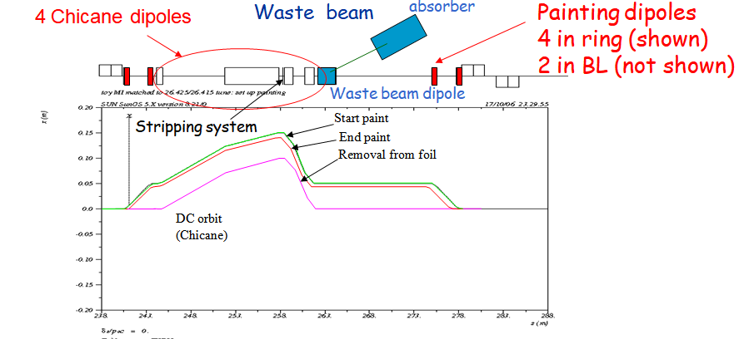

**Figure 5.** Injection insert components with kickers, and orbit variations used for injection with painting on the foil.

## Beam Injection components

Table 3 shows parameters of components of the injection system, which are displayed in figures 4 and 5. The HBC1 magnet kicks the beam out from the central orbit HBC2 where the circulating H+ orbits combine with the injection H- beam. It has a low field (~0.05T) to avoid stripping the H- before hitting the foil immediately after HBC2. The dipole HBC3, which follows the stripper, separates the circulating H+ from the H0 and the H- (which are stripped to H0 at the entrance of the dipole), which continue through undeflected. The magnetic field of HBC3 is large enough for magnetic stripping of H- but small enough to avoid stripping H0, except for highly excited atomic states. (B= ~0.55 T is used) After HBC3, the H0 and H+ are sufficiently separated to allow a displaced thick foil to strip the H0. The large aperture HBC4 deflects these toward the injection absorber while restoring the circulating H+ to the central orbit (see Fig. 4).

**Table 3:** Injection Insert components and parameters.

|  |  |  |  |  |
| --- | --- | --- | --- | --- |
| Element | Type | Field strength  (T) | Length  (m) | Drift after  (to next element) |
| K1 | Kicker |  | 1.0 | 1.2 |
| K2 | Kicker |  | 1.0 | 0.5 |
| HBC1 | Bending Magnet | 0.357 | 0.7 | 7.94116 (8.941) |
| HBC2 | Bending Magnet | -0.046356 | 6.0 | 0.40644 |
|  |  |  | -- | 0.098398 |
| Foil |  |  | 0.00025 | 0.102 |
| HBC3 | Bending Magnet | 0.5562 | 2.0 | 1.067 |
| HBC4 | Bending magnet | 1.142 | 1.0 | 0.5 |
| HD5 | Magnetic septum | 1.2 (extracted beam) | 2.0 | 8.98 |
| K3 | Kicker |  | 1.0 | 1.2 |
| K4 | Kicker |  | 1.0 |  |
|  |  |  |  |  |

## Stripping Foil efficiency

In the foil the H- ions are stripped to H0 and H+, and H0 ions are stripped to H+. Equations for stripping versus foil thickness have been developed by Gulley et al.,[15] from fits to measured stripping data. The equations are:[16]







where *β* = *v/c*  is the usual kinematic factor for the incident H-, *t* is the carbon foil thickness in μgm/cm2.  For a 500 μgm/cm2 thick foil, 98.6% of initial H- are stripped to H+ (protons). For graphite (at ρ = 2.0 gm/cm3), this is a 2.5 μm thick foil, or 1.4 μm thick for diamond (*ρ*=3.6). Figure 2 shows the variation of ion fraction through a foil with thickness of 500μg/cm2.

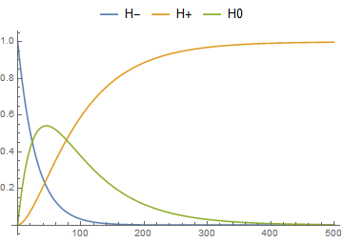

**Figure** 6**.** Fraction of beam that is H-, H0, or H+ as it passes through a C foil with final thickness of 500 μg/cm2. At 400 μg/cm2, the beam is ~96.4% H+, and 3.6% H0. At 500 μg/cm2, it is ~98.6% H+. At 600 μg/cm2, it would be ~99.5% H+.

More specifically, H0 states are populated into different atomic states, characterized by the electron orbit number n=1, 2, 3 ….. It was estimated that ~95% of the H0 states would be in the n=1 or 2 Stark states.[18] The 5% in Stark states ≥ 3 would be stripped to H+ in the HBC3 magnet, contributing to the accumulated beam. The remaining H0 are undeflected in the magnet and are separated from the accumulated beam and proceed toward the injection absorber.

## Multiple Scattering and Losses

It is important that the multiple scattering caused by the foil be small compared to the emittance of the beam. The normalized emittance of the PIP-II H- injected beam is ~0.3 mm-mrad. The multiple scattering increase in the emittance is given by: , (1)

where *Pbeam*= 8889 MeV/c, *mbeam* =938 MeV/c, and *X0* = 42.7 gm/cm2, the radiation length for carbon (C). For *t* =0.0005 gm/cm2and a focusing betatron function of *βT* of 70, we obtain *ΔεN* = ~ 0.009 mm-mrad in a single turn. This effect is magnified by the mean number of turns of particle passage through the foil, which is ~60 in a typical scenario,[19] and that increases *ΔεN* to ~ 0.5 mm-mrad. This is larger than the injected emittance but smaller than the accumulated injected emittance (~4 mm-mrad rms). The effect is significant but probably tolerable. The scattering may also cause some losses that must be considered in controlling activation in the ring or near the injection area.

Energy loss for protons in graphite is ~4.0 MeV/cm or ~1 keV in a 2.5 μm foil; this is ~ 10-7. Increase in energy spread is an order of magnitude smaller. The beam energy spread is relatively unaffected by passage through the foil. Beam particle losses occur when particles are scattered to large amplitudes. For Project X, this was estimated by passing a simulated beam with 95% emittance of 25 mm-mrad through a single pass of a foil, and counting a particle as lost if the amplitude is scattered to greater than 40 mm-mrad.[14] Under these conditions ~7×10-5 particles are lost per foil passage. In the injection scenario developed by Drozhdin et al.,[19] the injected beam passes through the foil an average of 60 turns, which would multiply the losses to ~4×10-3. This would imply beam losses of ~600 W at an injected power of 160 kW, or ~0.2 W/m if distributed around the Recycler ring. This could possibly be distributed to develop hot spots above the desired loss limit of < 1W/m, and is therefore somewhat worrisome, although the method was expected to overestimate losses.

To mitigate the loss effects, beam collimation will be used to localize the losses to shielded enclosures. The injection painting scenario could be modified to reduce the number of foil hits. The loss estimation method is also not very accurate, and was expected to overestimate losses. A more accurate loss estimate, verified by operational measured losses in the Fermilab Booster, should be developed.

## Nuclear interactions

The nuclear collision length and inelastic interaction length are 60 and 86 gm/cm2 , respectively. With a 500 μg/cm2 foil the probability of an interaction is ~6—8×10-6 / crossing. In the Drozhdin painting scenario, the mean number of crossings per proton is 60, which would increase this to ~ 4×10-4. If we conservatively assume that each interaction leads to a proton beam loss, this corresponds to a beam power of ~60 W. This would increase to ~200 W if 360 kW is injected in the ring, with the same multiturn painting program. Much of this loss is likely to be deposited near the injection foil, so careful shielding may be needed to avoid unacceptable hot spots.

## Injection Absorber

Injected beam that misses the foil and beam that is not fully stripped is deflected though a separated dump dipole toward an injector absorber. From the foil stripping study above, we expect ~1.6% of the beam would be incompletely stripped, and ~2% of the injected beam will miss the foil. With less favorable performance, ~2% `would be incompletely stripped and ~3% would miss the foil. The absorber is designed to handle twice that, ~10% of 360 kW injection.

Figure 7 shows a MARS model of the injection absorber which has a 6 inch diameter graphite core inside a water-cooled aluminum jacket with 3 inch walls (red). The inner shielding is tapered tungsten with the maximum thickness of 6 inches, followed by 20 inches of iron, and 8 inches of concrete. A 6 inch outer layer of marble is added for personnel safety. MARS simulation results show that residual radiation is reduced to < 100 mrem /hr after acceleration operation and cooling. [14]

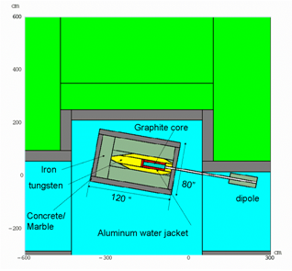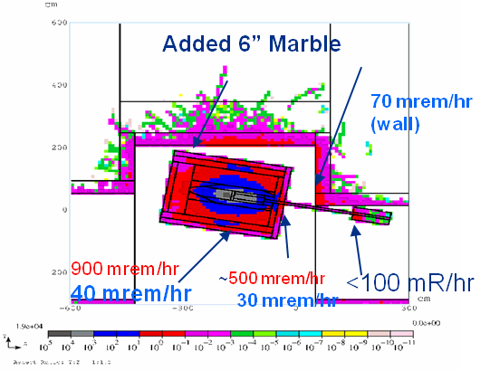

Figure 7: Overview of the injection absorber, with components shown (left). MARS simulation results show the resulting radiation pattern, which is reduced to < 100mR / hr after 1-day cooldown. [from ref. 4, 14 ]

## Summary of loss mechanisms and estimates

In Table 4 we summarize the loss mechanisms and discussion, listing key parameters of the effects and estimates of the losses. Most of the parameters in the linac and transport appear manageable. The major problems would appear to be associated with injection, and stripping. An important problem is the relatively large number of injection turns and the resulting multiple passes of the beam through the foil with resulting scattering and interactions. Modifying the injection to reduce foil passages would be desirable; a higher injection current and a more efficient painting strategy could help. The injection region must be designed to manage the losses and avoid excessive activation. As this is a modification of the existing RR/MI system, rather than a new system, improvements may be relatively difficult.

## Future Variations and Studies

In the present study we considered multicycle injection in the Recycler followed by transfer to the Main Injector. A similar painting injection directly into the Main Injector could be done, but would require holding the MI at injection energy throughout the beam accumulation. For example, if the MI injection cycle requires 0.3 s, the 120 GeV cycle period is increased to 1.5s. Maintaining the same power would thus require injecting 25% more beam. This however may be compensated by the fact that the MI acceptance is larger, and the injection energy could be changed. A higher energy would enable greater acceptance. This option should be studied.

.

Another option is to use laser assisted stripping.[19, 20] This is under development at SNS and could also be used as an upgrade for RCS systems. Laser stripping may be much easier with 8 GeV proton beam, since the incident light is Doppler shifted into higher energies in the beam frame. Infrared lasers, which are much more readily available, can be used instead of the UV light required for 1—2 GeV stripping. Laser stripping would avoid foil heating limitations, and might make a single pulse injection directly into the MI easier. The losses under laser assisted stripping will need further study; losses from beam that is not properly ionized by the system may be greater.

# Acknowledgments

This manuscript has been authored by Fermi Research Alliance, LLC under Contract No. DE-AC02-07CH11359 with the U.S. Department of Energy, Office of Science, Office of High Energy Physics. We thank D. Johnson for providing helpful material from the Project X Injection.

# References

1. M. Ball et al., The PIP-II Conceptual Design Report (2017).

2. Project X Accelerator Reference Design, Physics Opportunities, Broader Impacts, June 2013 Fermilab TM-2557.

3. S. Holmes, Proton Improvement Plan II, presentation to Fermilab Users meeting, June 11, 2014

4. D. Johnson “Conceptual Design Report of 8 GeV H- Transport and Injection for the Fermilab Proton Driver”, Beams-doc 2597 (2007).

5. W. Chou et al., “8 GeV H− ions: transport and injection,” Proc. PAC 2005, Knoxville, TE, p. 1222 (2005).

6. L.R. Scherk, Canadian J. of Phys, 57, 558 (1979).

7. P.B. Keating et al., Phys. Rev. A 52, 4547 (1995).

8. J. P. Carneiro, B. Mustapha, P. N. Ostroumov, “Numerical simulations of stripping effects in high-intensity hydrogen ion linacs”, Phys. Rev. STAB 12,040102 (2009).

9. J. P. Carneiro, “H-Stripping Equations and Application to the High Intensity Neutrino Source,” Beams-doc-2740, April 2007.

10. G. H. Gillepsie, Phys. Rev. A. 52, 4547 (1995).

11. Y. Nakai et al., At. Data Nucl. Data Tables 37, 69 (1987).

12. V. Lebedev et al., “Intrabeam stripping in H- Linacs, Proc. LINAC2010, Tsukuba, Japan, p.929 (2010).

13. J.-F. Ostiguy, “Intrabeam Stripping”, Project-X Note 698 (2010).

14. S. Nagaitsev, D. E. Johnson,and J. Lackey “Project X: 8 GeV Recycler Injection” Project X doc. 74 (2007).

15. M. S. Gulley et al., *Physical Review* A 53, 3201-3210 (1996).

16. M. Plum, “Stripper Foils for H- Beams”, in Handbook of Accelerator Physics and Engineering, second edition, A. W. Chou, K. H. Weiss, M. Tigner and F. Zimmermann, eds., p. 574 (2013).

17. W. Chou, A. Drozhdin, “Lifetime of Stark States of Hydrogen in Magnetic Field”, Beams-doc 2202, June 2008.

18. A. I. Drozhdin, I. L. Rakhno, S. I. Striganov, and L. G. Vorobiev, Phys. Rev. STAB 15, 011002 (2012).

19. I. Yamane, H- charge-exchange injection without hazardous stripping foils, Phys. Rev. Accel. Beams 1, 053501 (1998).

20. S. Cousineau et al, “High efficiency laser-assisted H- charge exchange for microsecond duration.” Phys. Rev. Accel. Beams 20, 120402 (2017).

21. M. Checcin, “PIP-III SRF Linac Costs”, unpublished seminar, April 2018.

**Table 4:** Loss mechanisms, expected effects and mitigation.

|  |  |  |  |  |
| --- | --- | --- | --- | --- |
| **Loss process** | **Key parameters** | **Loss per meter** | **Estimated Losses** | **Mitigation Strategies** |
| Magnetic stripping | B(1 GeV) < 0.28T  B(3 GeV) <0.13T  B(8 G) < 0.055T | 1.6×10-8  3.7×10-7  10-8 | 3×10-7  7×10-5  10-7 | Limiting B-fields |
| Black-body Radiation | 1 GeV  3 GeV  8 GeV T=300K | 3.7×10-8  1.3×10-7 7.8×10-8 | 10-6  2.6×10-5  10-6 | Shorter, shielded transport  Cooled beam pipe |
| Beam-gas interactions | P ~10-8Torr | 2.1×10-8 /m | < ~10-5 | Vacuum |
| Intrabeam stripping | N=2×108 /bunch | 2—4×10-8 /m | <~10-5 | Short transport |
|  |  |  |  |  |
|  |  |  |  |  |
| **Foil** –beam missed | 500 μg/cm2 C foil |  | ~2—3% | Collimation before foil,  Matching, absorber |
| Foil- H0 |  |  | ~1—2% | Injection absorber |
| Foil-large-angle scattering | 40 mm-mrad aceptance |  | 400W | Collimation, reduce foil crossings |
| Foil-nuclear interaction | LN=60--86 |  | 60W | Collimation, shielding |
|  |  |  |  |  |