MC2 Pinhole Attenuation
Archived e-log searches for MC operation at 120 GeV are in progress. Data from previous MC operations was deemed more important following a Zoom meeting with Safety than Turtle simulations of the beamline. Work on relearning how to run Turtle is in progress but have not had much time to work on this aspect of the MC2 pinhole attenuation simulation.
Among the more interesting e-log entries are the following:
Entry into External Beamlines e-log from 11:18:53, 6 July 2004 with appended comments by chuckB (Chuck Brown?). Note MC6IC = 1.603E6 and MC1SEM = 4.095E11 (thus MC6IC/MC1SEM = 3.91E-6). Pinhole positions are given for upstream up stream and down stream horizontal and vertical positions. No entry on momentum of beam given in these entries. MT5U current reading shows 959 A. According to Carol Johnstone’s Sept. 2003 bsheet for MCenter beam at 100 GeV, the current is 838.45 Amps. Scaling Carol’s current to 120 GeV, 1.2*838.45 = 1002.54 Amp. Carols current differs from the e-log entry. There are and have been questions about the accuracy of the current setting/readings for the MC6D power supply, could the 43.54 Amp difference (which is less than 5%) be due to calibration issues of the power supply? Don’t know the answer yet.

- Wed Jul 6 11:21:58 comment by...chuckb -- I have gone to much higher intensity (while closing MC6CV in order to protect MIPP) and tuned up the positions at MC5WC and MC6WC using MC2CV and CH and MC5CV1 and CH1 with the collimators in MC3 closed just enough so that I could see the two sides of the collimation on the MC5WC SWIC - note that because the vertical is high in MC2 it comes out low at MC5 because of the collimation by MC3CV.
-- Thu Jul 7 08:35:43 comment by...chuckb -- Note: the fact that MC5WC vertical comes out so low is apparently a result of the MC3CV collimator being too low. During some future shutdown, one could consider raising it about 200 mils. It is not really a problem since there is plenty of vertical aperture for the highly collimated beam vertically.
(The associated Acnet page and profiles that accompanied this entry is below.)

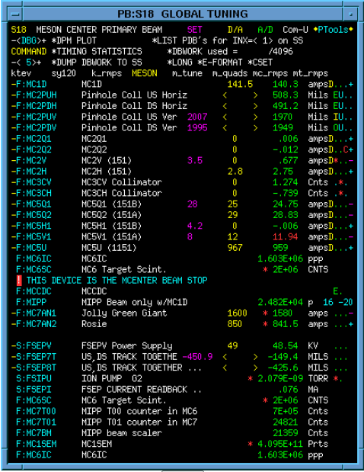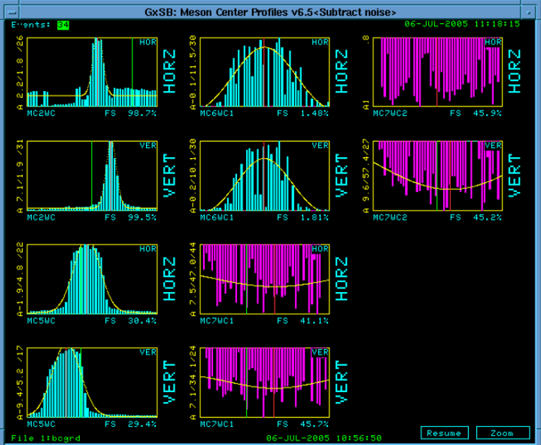

E-log entry from 11:43, 15 June 2005 below.
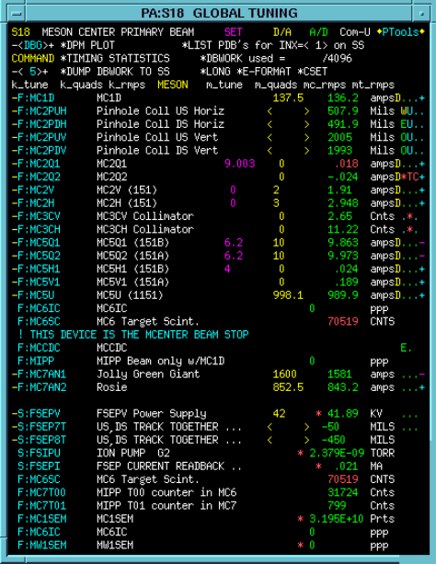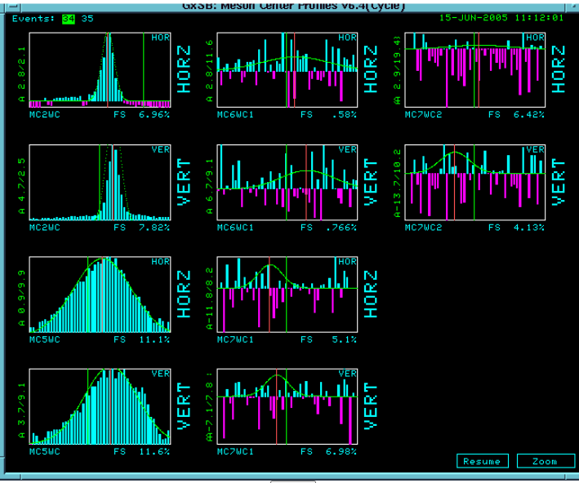
Comments by chuckb (Chuck Brown?) with these 2 figures above are below.
- chuckb
-- Wed Jun 15 11:15:58 comment by...chuckb -- Carol will now take these pictures and calculate what currents we need on MC5Q1 and MC5Q2 to get the beam through the collimator just downstream of MC6IC (and the new scintillation counter, MC6SC). Meanwhile I will go back and retune Enclosure-C to reduce the bad losses seen at H202 and V204 and improve the transmission to F1SEM which is currently only a few percent.

Note that this entry from 11:15:58 on 15 June 2005 is in a e-log content section titled “continue tuning 120 GeV to MIPP”, Note that MC5U = 939.9 Amps, MC6SC = 70519, MC1SEM = 3.19E10 (so MC6SC/MC1SEM = 2.2E-6) , the pinhole collimator positions are listed.

Gausian distribution (area):
