MC6D Power Tests Notes 6 Oct 2020
G. Koizumi
3 November 2020

MC6D dipole string had not been powered at the currents needed to transport 120 GeV beam to Meson Enclosure MC7 in a long time. Because of the changes in timing since then, changes were required in the ramp parameters and associated control module to allow MC6D dipoles and associated power supply to still operate at the 120 GeV current. Successful tests were conducted on 6 October 2020 to verify that with these changes the MC6D dipole string and power supply can be operated later this year to send 120 GeV beam to Enclosure MC7. It was also verified that there was no observed cooling line blockage to the MC6D magnets. Following are the details.
To accomplish this test, we started with the currents in the e-log from 13:01:15, 9 March 2020 which operated the MC6D dipoles at the nominal 64 GeV tune. The tests were done with the final current at twice the 64 GeV tune currents to provide some tuning margin above the 120 GeV current. Those doing the tests were G. Koizumi, M. Monningh and J. Lentz.
The basic power test steps were to run at the 64 GeV current and let the temperature of the magnets, cables and power supply stabilize. That was followed by running the MC6D power supply at currents twice, three times and 4 times the power of the 64 GeV power. Given the I squared power relationship, the twice the current of 64 GeV current meant the power would be 4 times the 64 GeV level to test the MC6D supply at twice the 64 GeV current. It was assumed for the purposes of this test that the resistance would remain unchanged. The appended plots summaries the tests. One deviation from the original plan was that we were not able to reach points during the tests where the supply and return LCW water temperatures leveled off at the test currents. This was due to the heat capacity of the system and the amount of time we had to do the tests. We checked with a heat sensor to make sure that the magnets, cables and the power supply did not excessively heat up to endanger them. One unexpected problem did arise, a new LCW leak on MC6D-2 dipole was found during the check after running the MC6D system at the 64 GeV current. The leak did not seem to spray on any components which aside from the leak itself would cause harm so the tests were continued after the leak. The leak has been reported and will have to be investigated and fixed if possible. This leak on MC6D-2 is faster, few drops per second, than the older known leak on MC6D-4.
The flat top of the ramped supply, even at the twice the 64 GeV current for MC6D, was very flat and reached the desired current level well before the time which we expect the beam to arrive.
The maximum temperatures detected following the running of the MC6D power supply at twice the 64 GeV current for approximately 1 hours, the final step in the step by step increase of the currents, were under 100 degrees F for the power supply, the cables and magnets. The only exception was the cable which went to a filter associated with the MC6D power supply which was found to be just above 100 degrees F. Aside from the leak issues, no problems were encountered in these tests. Hence the tests seemed to indicate we can still run MC6D at the 120 GeV currents assuming the LCW supply temperatures are not too high with other devices on at the same time to place additional heat load to the system. It should be noted that the fans associated with the MS2 LCW system never came on during these tests of 6 Oct. 2020.

Conclusion is that we can successfully operate the MC6D dipole string and associated cables, bus and power supply at the 120 GeV current when beam returns late 2020. The magnet current was ramped and was flat at the 120 GeV current well before the time of the expected arrival time of the MCenter beam.
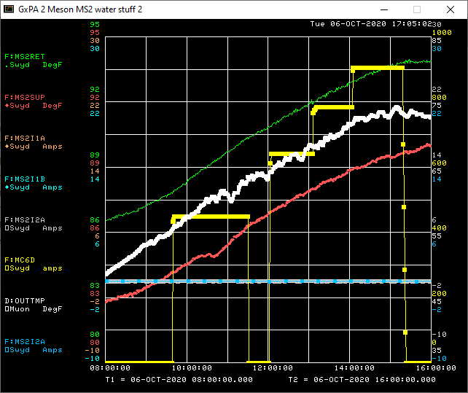
Figure 1. Steps taken on 6 Oct. 2020 to check that MC6D dipole system can run at twice the 64 GeV current. The highest step for F:MC6D shown (in yellow) was the current for twice the 64 GeV current. Twice 64 GeV current was selected so that it would allow for tuning of the MC6D dipoles when beam was sent to Enclosure MC7 at 120 GeV. The current used for the test were 435 Amps, 640 Amps, 785 Amps and 906 Amps.
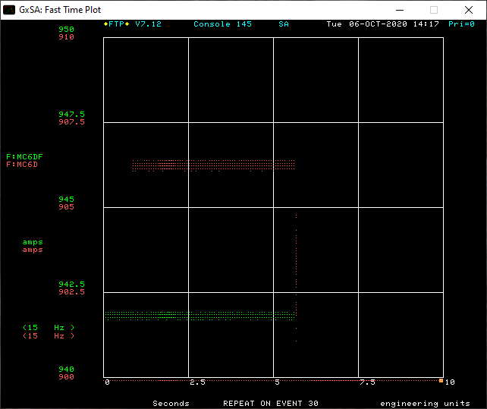
Figure 2. Fast time plot of F:MC6D (red dots) shows the current stability at the twice 64 GeV current, the highest current tests were conducted. Even at this current the MC6d is flat and reaches that current well before the time when the MCenter beam is expected to be sent.
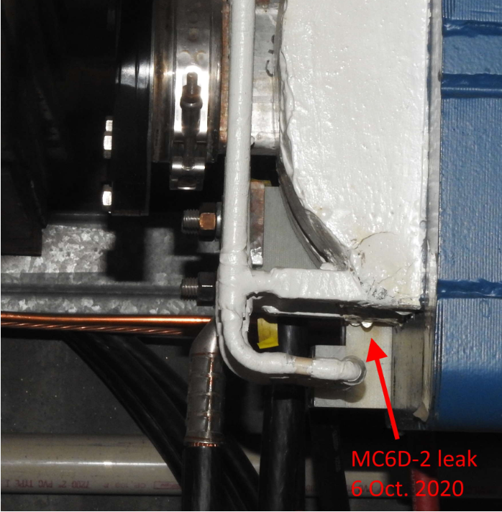
Figure 3. The one new problem we found during the tests of 6 Oct. 2020 was a small leak on the MC6D-2 dipole. This was a new leak not seen previously. The leak is slow and did not seem to be spraying on anything critical so the tests were continued. The leak was reported to the experts when the tests were completed. Experts have not been able to examine this leak to see if it is repairable due to demands for their time elsewhere but it is on their list of work that needs to be done. This leak seems to be similar to the previously known small leak on MC6D-4.

