Bergoz NPCT requirements

Specifications
These are the requirements and specifications for the NPCT. The NPCT will be installed in the Fermilab Booster with the following machine parameters:
Table 1: Booster parameters
Parameter | PIP | PIPII | Units
Injection current for tuning per pulse | 36 (~2 to 3 turns, 0.5 e12 protons) | 36 (~18 turns, 0.5 e12 protons) | mA
Maximum current at extraction per pulse | 700 (7e12 protons) | 800 (8e12 protons) | mA
Typical number of turns | 2 – 17 | 1 – 300
Ramp rate | 15 | 20 | Hz
Harmonic number | 84 | 84
Extraction notch size | 3 | 3 | Booster buckets
Injection frequency | 37.8 | 44.7 | MHz
Injection revolution frequency | 450.0 | 532.1 | kHz
Extraction frequency | 52.8 | 52.8 | MHz
Extraction revolution frequency | 628.6 | 628.6 | kHz
Injection kinetic energy | 400 | 800 | MeV
Extraction energy | 8 | 8 | GeV
Bunch structure | See section 2.2 | See section 2.2
Note: the instantaneous peak currents are a lot larger than the currents given above. See section 2.2.1.

NPCT electrical specifications
Table 2: Electrical specifications
Parameter | Value | Units | Comments
Output accuracy (see section 2.1) | 0.1 | % | Current ranges specified in Table 1.
Range control switching time | < 2 | ms | Switching between Booster events. To be discussed.
Amplifier settling time | 50 | μs | About 25 turns. Specified in NPCT spec sheet.
Bandwidth | 10 | kHz | Maximum as specified in NPCT spec sheet
Resolution (see section 2.1) | < 0.5 | $$μ\text{A}/\sqrt{\text{Hz}}$$ | High resolution model
Linearity error | < 0.1 | %

The typical currents in Booster after injection are between 70 mA to 800 mA depending on the mode of operations. However, the instantaneous peak currents can be > 2 A. See section 2.2.1. The compatible amplifier ranges for the range are $±200$ mA and $±2$ A as stated in the NPT specifications document. The specifications in Table 2 apply to both these ranges.

NPCT mechanical specifications
Table 3: Mechanical specifications
Parameter | Value | Units | Comments
Beam pipe outer diameter | 3.25 | inches | Round beam pipe
Maximum physical length | < 1 | m | Flange to flange
Vacuum | < 1e-7 | Torr
Connector type | – | – | To be discussed

- Rad hard sensor head (NPCT) and non-rad hard cables will be required at the installation location.
- Other parameters to be determined depending on the location of the installation.

Background
The requirements for the NPCT are stringent because the losses in the Booster have to be carefully controlled. The transfer efficiency from injection to extraction is expected to be in the 98% range during the PIPII era and so the beam current measurement accuracy will have to better than 0.1% for the entire Booster ramp. The following sections form the background material for the creating the specifications.

NPCT accuracy from Bergoz NPCT specifications
The expected accuracy of the Bergoz NPCT during the PIPII era is calculated here using published specifications.
We will assume that the NPCT is the “very high-resolution model” that has the following current noise spectral density
 | $$n_{σ}=0.5×{10}^{-6} [\text{A}/\sqrt{\text{Hz}}]$$ | (1)
The NPCT bandwidth of the electronics is $f_{\text{max}}=10$ kHz. Note that for PIPII, the revolution frequency is 532 kHz at injection. This means that an accurate value of the current is only available after
 | $$\text{\# of turns of averaging }=\frac{532 \text{kHz}}{10 \text{kHz}}=53 \text{turns}$$ | (2)
The noise power, $P_{n}$, given both the current noise spectral density, $n_{σ}$, and bandwidth, $f_{\text{max}}$, is
 | $$P_{n}=\int_{0}^{10×{10}^{3}}{{(n}_{σ})^{2}} df=2.5×{10}^{-9} [{\text{A}}^{2}]$$ | (3)
The rms noise current, $σ_{I}$, is thus
 | $$σ_{I}=\sqrt{P_{n}}=0.5×{10}^{-4} [\text{A}]$$ | (4)
In PIPII, the number of protons per injection is $I_{\text{inj}}=2$ mA, thus the fractional error is
 | $$ε_{I}=\frac{σ_{I}}{I_{\text{inj}}}=\frac{0.5×{10}^{-4}}{2×{10}^{-3}}=2.5\%$$ | (5)
which is outside the required 0.1% accuracy.
To achieve the required 0.1% accuracy, the current will have to increase. Let $N$ be the number of turns that in Booster that is required to achieve this accuracy, i.e.
 | $$0.1\%=\frac{σ_{I}}{{NI}_{\text{inj}}}⟹N=\frac{σ_{I}}{0.001I_{\text{inj}}}=\frac{0.5×{10}^{-4} }{0.001×\left(2×{10}^{-3}\right)}=25$$ | (6)

The typical number of turns in PIPII injection is about 260. This means that after 25 turns or 10% (25 turns/260 turns) of PIPII will not meet the accuracy specifications. However, from Eq.(2), due to the 10 kHz bandwidth, an accurate measurement of the beam current is only available after injecting 53 turns out of 260 turns, or after about 20% of the injections.

Booster bunch structure
In the current mode of Booster operation, PIP, the 400 MeV Linac beam with synchronized notches is injected up to about 17 turns with almost no RF voltage turned on. The beam is then adiabatically captured in about 250 μs. By the end of the capture of this multi-turn beam, a notch of about 3 Booster RF buckets is created. Booster is then left with an almost equally populated 81 bunches. Figure 1(a) depicts the measured bunch pattern for seven bunches at the end of capture for 5.7e12 protons.
During the PIPII era, the injected beam will not be adiabatic capture. Instead, the beam will be injected either on-energy or off-energy inside pre-opened Booster RF buckets with a peak voltage of ~0.2 MV and 81 consecutive bunches. Three buckets are left unfilled to form a notch. Each bunch profile will have a local minimum at the center of the bunch in its distribution. Its purpose is to minimize the longitudinal space charge effects at injection. Therefore, the expected bunch structure will be quite different from PIP operations. Figure 1(b) shows the predicted bunch pattern at the end of injection during the PIPII era.
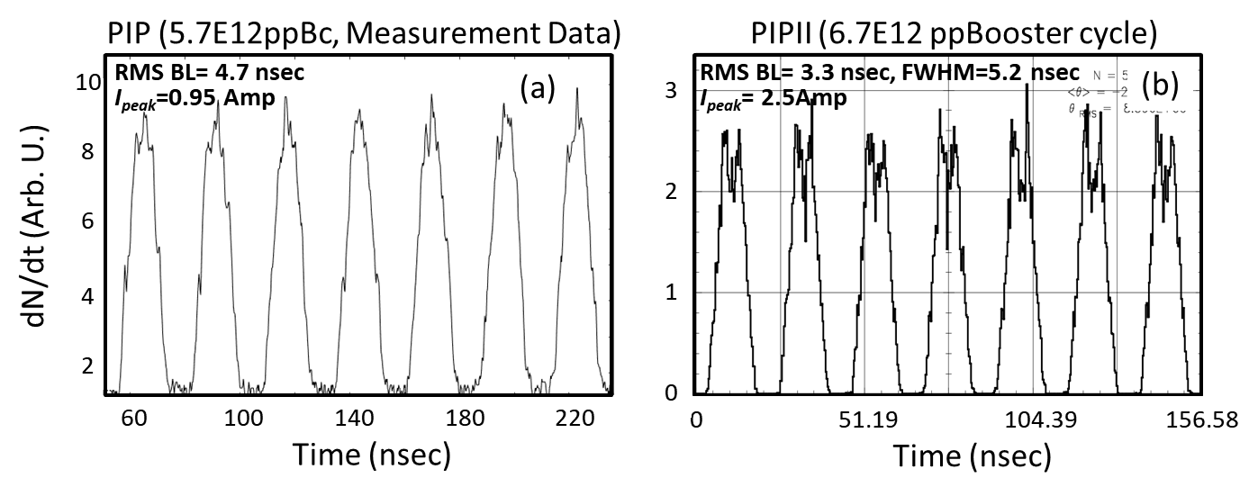
Figure 1: Booster bunch structures for PIP and PIPII at 400 MeV and 800 MeV respectively. In the case of PIP, the shown bunches are after beam capture and it is measured data. For PIPII, they are at the end of beam injection and it is ESME simulated data.

Beam currents
The peak current depends inversely on the bunch length. In the process of beam acceleration from injection energy to extraction energy of 8 GeV in the Booster, beam goes through transition at 5.16 GeV where the bunch length reaches its minimum just after this energy. Consequently, the peak current reaches its maximum here. Figure 2 shows the measured bunch structures while the bunch length is at its minimum. For bunches with a Gaussian profile, the peak current, $I_{\text{peak}}$ is given by,
 | $$I_{\text{p}\text{eak}}=\frac{eN_{b}}{\sqrt{2π}σ_{τ}} [A]$$ | (7)
where $σ_{τ}$is the RMS bunch length in seconds. Estimations of $I_{\text{peak}}$ are listed in Table 4 at injection and transition energies along with the measured and simulated parameters. Since the bunches at injection do not resemble Gaussian bunch profiles for the PIPII scenario, the following formula is used
 | $$I_{\text{peak}}=\frac{eN_{b}}{FWHM} [A]$$ | (8)

The simulations for PIPII shows that as the beam is accelerated, the bunch profiles change and can be approximated as a Gaussian near transition energy.
Table 4: Comparison between PIP and PIPII beam parameters
PIP: measured Booster cycle beam data for 5.7e12 protons
 | Revolution period (μs) | RMS bunch length (nsec) | Full bunch length (nsec) | Number of protons per bunch | $I_{\text{peak}}$  (A$)$
Injection (400 MeV) | 2.217 | 4.73 | 20.2 | 7e10 | 0.95
Transition (5.16 GeV) | 1.608 | 0.56 | 3.2 | 7e10 | 8
PIPII: simulated Booster beam data for 6.7e12 protons
Injection (800 MeV) | 1.879 | 3.3 | 16 | 8.27e10 | 2.5*
Transition (5.16 GeV) | 1.608 | 0.3-0.6 | 2.2-3.2 | 8.27e10 | 18.9
* Eq. (8) is used here.
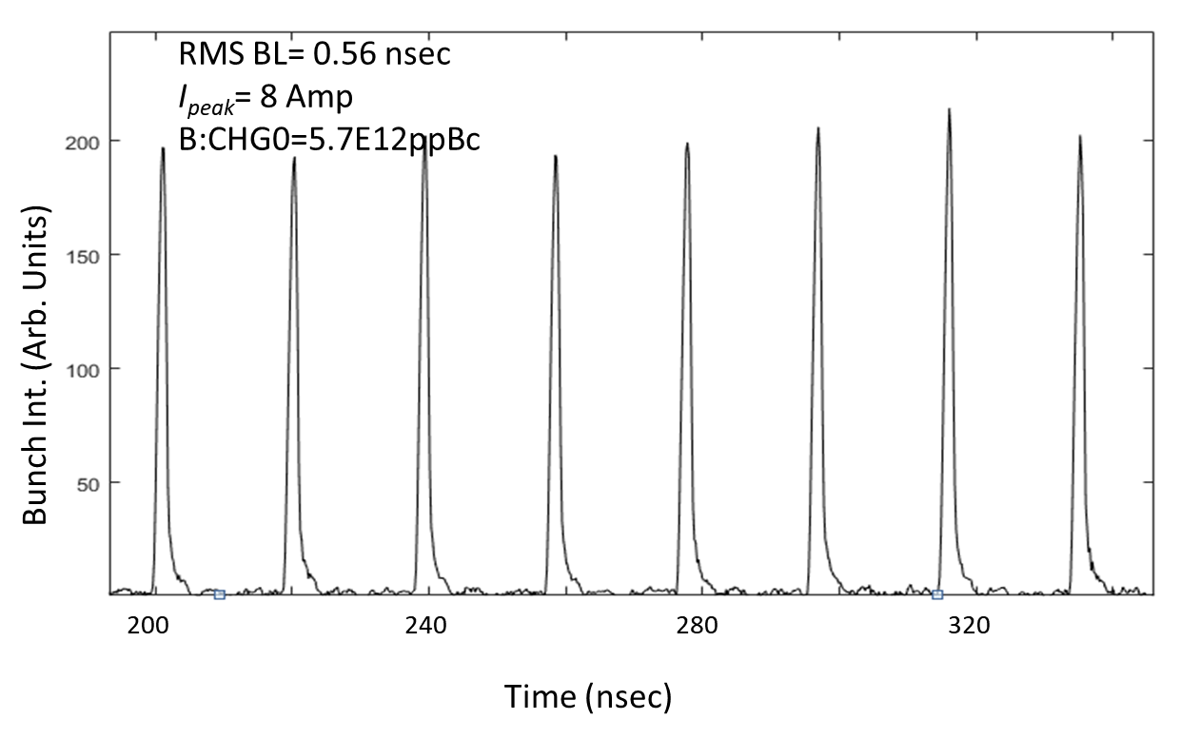
Figure 2: Booster bunch structures for PIP conditions from measurement data at about 5.16 GeV where the bunch length is minimum.

