FERMILAB-TM-2745-AD
Scenarios for an 8 GeV Linac “Booster Replacement”
David Neufferª
ªFermilab, PO Box 500, Batavia IL 60510 USA
Abstract. Increasing the Main Injector (MI) beam power above ~1.2 MW requires replacement of the 8 GeV Booster by a higher intensity alternative. In the Project X era, rapid-cycling synchrotron (RCS) and Linac solutions were considered for this purpose. In this paper, we consider the Linac version that produces 8 GeV H⁻ beam for injection into the Recycler Ring (RR) or Main Injector (MI). Starting from the Project X version, which has a 3 GeV cw segment followed by a 3-8 GeV pulsed linac, we consider alternative configurations. SRF improvements and changes in physics requirements may enable shorter linac configurations and different configurations of pulsed and cw components. Direct injection into the MI has advantages, but may conflict with MI-10 extraction for LBNF.
Keywords: muon, beams, PIP-II

introduction
The PIP-II project will provide a 800 MeV proton beam with cw capability, with beam power up to the MW level available for user experiments.[1] However, the amount of beam that can be transmitted to the Main Injector (MI) is limited by the 0.8—8.0 GeV Booster capacity. The next Fermilab upgrade should include a replacement for the Booster. The project-X design proposal included some options for that replacement, based on a continuation of the 800 MeV linac to 2—3 GeV followed by either a Rapid Cycling Synchrotron (RCS) or continuing the Linac to 8 GeV.[2] While an 8 GeV Linac would be expected to be very expensive, it may be made relatively affordably by using relatively inexpensive ILC-style cryomodules that use 1300 MHz SRF cavities, that have already been designed and mass-produced.
In this note we will focus on the 8 GeV Linac option. We begin with some discussion of the beam requirements and potential layouts for the Linac. Constraints on accelerating gradients and magnetic fields are discussed. The Project X 8 GeV design is used as an initial template.

Linac Scenarios
The initial design specification for the PIP-III upgrade is that it should enable at least ~2.4 MW from the MI. With a 120 GeV beam energy and a MI period of 1.2 s, this requires 1.5625*10¹⁵ p/cycle, or 25 ma-ms of injected beam. The 800 MeV beam PIP-II beam can provide 2 ma of cw beam, so 12.5 ms of injection, accelerated to 8 GeV, would be sufficient. This minimal requirement corresponds to 167 kW of 8 GeV beam. More beam would of course be desirable, and the 8 GeV Linac should enable at least another 160kW for other 8 GeV beam programs.
Scenarios for an 8 GeV Linac scenario were developed within the project X program.[3] Fig. 1 shows a possible scenario. The 800 MeV Linac is extended to ~1 GeV. The beam exiting that Linac is bent at a steep angle into a 13 GeV linac (~280 m long). In the Project X scenario that linac is a cw linac that uses the same 650 MHz cryomodules as the end of the PIP-II linac. The beam then goes through a bend of approximately 100° to be pointed toward injection into the Recycler. A ~390m 38 GeV pulsed linac, consisting of ILC 1300 MHz cryomodules takes the beam toward the MI. Parameters of the different linac components are shown in Table 1.
The curves away from the MI and back toward the MI are needed to fit the somewhat longer linac segments into the relatively short space between PIP-II and the MI. The current PIP-II is moved ~ 100 feet to the right from the position shown in Fig. 1. This places it slightly further from the MI injection point which can be used to fit a slightly larger curved linac (or the large angle into the initial linac could be reduced). A much longer linac design would not fit easily within this relatively confined space. The degree of curvature that could be added is limited by the fact that H⁻ ions must be accelerated and transported to the MI, and the bending fields must be low enough to avoid magnetic stripping.

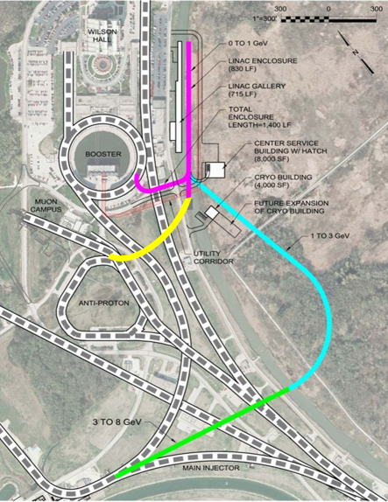
Figure 1. Layout on the 8 GeV Linac as envisioned in Project X (from ref. 3).

In the Project X design, the 3 GeV linac was designed to feed high-intensity Kaon physics experiments. In earlier versions the cw linac went only to 2 GeV, which was adequate for some experiments, but was inefficient in Kaon production. A high-intensity Kaon program may not be as important as in 2012, so this transition point could be reevaluated. The MI is intrinsically pulsed and needs the Linac for only 25 ma-ms per 1.2s. It is expected that 1300 MHz mass-produced pulsed ILC cryomodules would be much cheaper than alternatives, which would need additional development. Therefore the 38 GeV Linac was initiated as a pulsed Linac design.

The 8 GeV beam will also have some other functions. It could feed a continuation of the present short-baseline neutrino experiments, which currently use 8 GeV Booster beam. It could also be a primary beam source for a continuation of the g-2 experiment or other experiments. The pulsed linac could provide ~400 kW to such experiments. The Fermilab Project X also considered conversion of this linac to cw mode as a future upgrade, which could then provide up to ~8 MW for ultra high-intensity applications such as a “neutrino factory”.

The MI ring is partnered with a same circumference Recycler ring (RR). The recycler ring consists of permanent magnets, fixed to 8 GeV proton energy. In the present MI operation, protons are collected in the RR during the MI acceleration cycle, to be injected into the MI at the beginning of its accelerator cycle. The same mode of operation could be adopted in PIP-III, for both linac and RCS scenarios.

The aperture and acceptance of the RR is a bit smaller than the MI (24π versus ~30π, 95% , normalized), so use of it restricts MI intensity. Also the injection is fixed to 8 GeV. A higher energy injection would increase that acceptance, following a factor of βγ.

In the Linac scenario, beam could be injected directly into the MI in a single ~26 ma-ms injection pulse (13ms at 2ma); but, as discussed below, stripper foil heating is increased. For an RCS, multiple RCS pulses are required to feed the MI, which would then require an extended injection time, which would reduce the total intensity delivered by the MI. (Accumulation in the RR from the RCS avoids that extension.)

Table 1: Parameters of the Project X 8 GeV Linac
Section | Length | Maximum bending field | Total bending angle | Cav/mag  /CM | Cryomodule length
1GeV transport | 48 m | 0.277T | -60°
13 GeV Linac | 240m | 650 MHz | cw | 120/20/ 20 | 9.92m
3 GeV bend | 200m | 0.13T | 105°
38 GeV Linac | 390m | 1300 MHz | Pulsed, 10 Hz | 224 /28/28 | 12.5 m
8GeV injection |  | 0.055T

Table 2: SRF cavity parameters [16]
Parameter | 650 MHz from PIP II | 1300 MHz
Geometric β | 0.9 | 1.0
Cells/cavity | 5 | 9
Cavity length l | 1.04m | 1.038 m
R/Q | 638 | 1036 Ω
G=Q₀R_{s} | 255 | 270 Ω
Gradient E_{acc} | 18.8 | 25 MV/m
E_{max} | 35.2 | 50 MV/m
B_{max} | 64 | 106 mT
Q₀ | 1.5×10¹⁰ | 1.0×10¹⁰
Q_{L} | 3.4×10⁷ | 1.7×10⁷
Losses @2 K | 24W | 19 W
Cavity rf power | 23 kW | 32 kW
Cavities/ Cryo | 6 | 8
Cryomodule length | 9.9 m | 12.5 m

SRF constraints
The demonstrated and projected performance of SRF cavities and systems has significantly changed since project X. Two major discoveries at Fermilab have greatly improved SRF cavity performance. [4, 5, 6] First, nitrogen doping of SRF cavites has been shown to reduce the BCS surface resistance below previously perceived limits. Second, effective magnetic flux expulsion by fast, high thermal gradient, cooldown has achieved record low residual resistances. These innovations combined with continuing optimization of cavity treatments have greatly increased useable gradients, with increased Q values. Most recently, a 75/120 K modified low temperature bake improved Q by ~50%, and increased rf gradient to ~50 MV/m for 1300 MHz cavities.[7]

Table 2 shows 650 and 1300 MHz SRF cavity parameters and Table 3 shows some of the estimated present and future SRF improvements in fundamental cavity parameters, based on the Project X designs, the current PIP-II (650 MHz, cw), SLS-II (1300 MHz, cw) and ILC designs. The parameters approximate those presented recently by Checcin.[8, 9] The first row presents parameters used for Project X. This is followed by the current R&D, which has established clear improvements in cavity parameters, and near-term parameters which can be implemented in the next generation of designs, including PIP-III. Current technology includes the 650 MHz PIP II high-β cavities which include N-doping. The 1300 MHz ILC cavities do not have N-doping, but recent R&D shows clear advantages, which are included in the near-term improvement parameters. Long-term improvements include use of new cavity materials and coatings, and would be reserved for possible upgrades of the PIP-III complex.

Table 3: Past, present and future SRF cavity gradients and Q-factors.

 | 650 MHz –cw | 1300 MHz cw | 1300 MHz-pulsed
~Project X | 17 MV/m,  Q=1.5*10¹⁰ | 17 MV/m  Q=10¹⁰ | 22 MV/m  Q=10¹⁰
Current technology | 17 MV/m,  Q=3.0*10¹⁰ | 22 MV/m  Q=3.2 10¹⁰ | 30 MV/m  Q=0.8×10¹⁰
Near term improvement | 22 MV/m,  Q=4.0*10¹⁰ | 32 MV/m  Q=3.2 10¹⁰ | 37.5 MV/m  Q=1.6×10¹⁰
Long-term improvement | 40 MV/m  Q=3.2 10¹⁰ | 45 MV/m  Q=6.4 10¹⁰ | 80 MV/m  Q=3.2×10¹⁰

Linac scenarios

Cryomodule parameters
The building blocks for linac construction are the 650 MHz cryomodules, developed for PIP-II, and the 1300 MHz cryomodules, developed for the ILC (for pulsed operation) and the LCLS-II project at SLAC (for cw operation).[10] These designs are relatively advanced, and can be implemented for PIP-III with minimal modifications. Cross sections of a 650 MHz and a 1300 MHz cryomodule are shown in figs. 3 and 4.

The 650 MHz cryomodule contains 6 1.04 m long cavities within a total length of ~9.9 m. A gradient of E_{acc} = 16 MV/m, yields an acceleration of 100 MV per cryomodule, which approximates what was used for project X. Upgrading this to ~22 MV/m yields ~130 MV of acceleration, which could be available for PIP-III.

The 1300 MHz cryomodule contains 8 1.038m cavities, which are included in a ~12.5 m length. This would provide ~133 MV of acceleration at 16 MV/m and ~180 MV at 22 MV/m (Project X technology). An upgrade to ~30 MV/m (current ILC technology) would increase that to ~250 MV. Near-term improvements should increase that to more than 300 MV. (40 MV/m obtains 325 MV.) If a limit of 25 MV/m is set by beam neutralization or stability considerations, the cryo acceleration would be 200 MV.

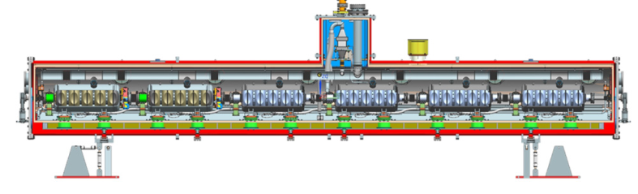
Figure 3: Cross section of a 650 MHz cryomodule, containing 6 5-cell rf cavities and a total length of ~9.9m.
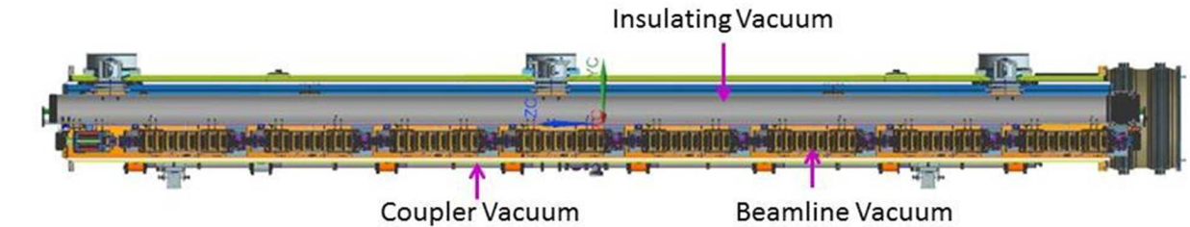
Figure 4: Cross section of a 1300 MHz cryomodule, containing 8 9-cell cavities, a focusing magnet, and a total length of ~12.5 m, from the LCLS-II design.[10]

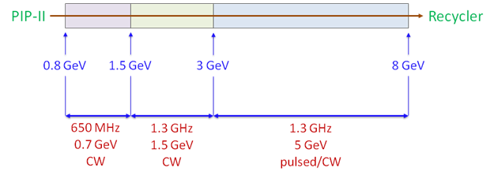
Figure 5. Conceptual view of components of an 8 GeV linac with cw and pulsed segments, following the Project X configuration.

Scenario cases
The Project X Scenario in Table 1 has the initial PIP-II Linac extended to 1 GeV extraction, by inserting 2 additional cryomodules in existing space at the end of the PIP-II linac. A 1GeV bend is followed by a 1—3 GeV linac using ~20 100 MV 650 MHz cryomodules, requiring ~200m, with matching optics that should fit within the ~280m slot in figure 1. A 3 GeV bend places the beam in a 3—8 GeV linac using 1300 MHz pulsed rf. This requires 28 180 MV 1300 MHz cryomodules (350 m), to fit within the ~390m slot of fig. 1.

An updated variant of this scenario is displayed in Figure 5, based on a presentation by Checchin.[8] Following recent progress in LCLS-II cw cryomodules, the cw linac is split into 650 MHz and 1300 MHz sections at 1.5 GeV. This can be obtained with ~6 650 MHz cryomodules and ~10 150 MV 1300 MHz cryomodules. The 1300 MHz rf is expected to be significantly less expensive than the 650 MHz, and provide higher gradient, with ~150 MV/cryomodule. This would shorten the required linac length by ~20m. The 3-8 GeV linac is the same as the Project X version.

As discussed by Checchin, the linacs could be shorter with the higher gradients. With the present ILC technology and 250 MV cryomodules, only 20 cryomodules are needed for the 3—8 GeV linac, which reduces the linac length by ~100m, and will significantly reduce costs. Another modification could be replacement of the entire 1—3 GeV with 1300 MHz cw rf. This would prevent a mid-linac mismatch in the focusing period, which could improve optics. With 150 MV cryos, this would require ~14 cryomodules (175 m) and reduce the required cw linac length.

Changes in Scenario Requirements
Physics requirements for other experiments have changed and the transition from cw to pulsed could be moved to lower energy. An advantage is that the bend at the end of the cw linac would be moved to lower energy which would allow a much shorter bend. The problem is that the beam must be transmitted as H⁻ and moderate magnetic fields will strip the H⁻ to H⁰. [11, 12]

Magnetic stripping constraints
The 8 GeV Linac beam must be transmitted as H⁻, for compatibility with H⁻ injection into the Recycler or Main Injector, and the bending fields in the 8 GeV PIP-III transports are limited to ~0.06T to avoid magnetic stripping to H⁰.[11] The 8 GeV Linac has three locations with significant amounts of bending magnets: the initial bend of ~60° following the PIP-II Linac where the beam is ~1 GeV, the bend of ~105° at the end of the 3 GeV cw linac, and smaller bends at 8 GeV associated with injection into the recycler/Main Injector.

The stripping length can be estimated using this formula of Schrek: [12]
meters,
where p = is the H⁻ momentum, B_{t} is the magnetic field and a and b are parameters fitted from data. Keating et al. [12] obtained a = 3.073 10⁻¹⁴ and b =44.14 from 800 MeV data. [13]

For 1 GeV protons the transport is a mirror image of the PIP-II transport to the Booster. For that transport, the PIP-II design set a limit of 0.277 T , at which τ=0.12s, and L=6.43×10⁷. Losses per meter would be 1.6×10⁻⁸ , which would be 0.032 W/m at 2MW beam power. The 60° requires ~21.4 m of bend, which must be included in an achromatic lattice. The total losses would be ~3.5×10⁻⁷, which is relatively small.

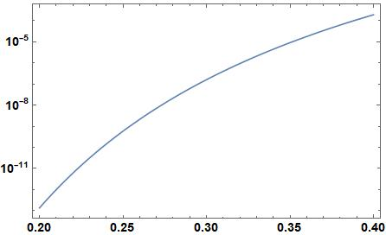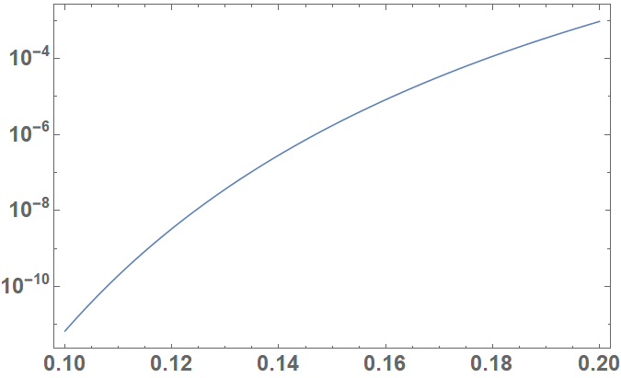
Figure 6: Magnetic stripping rate (m⁻¹) as a function of B(T) for 1 and 3 GeV H⁻ .

For E=2.0, 2.4, 3.0 GeV, we have calculated the allowed magnetic fields for similar stripping rates, along with the required lengths for a 105° bend. Results are presented in Table 4. The length of the mid-Linac bend could be greatly reduced at the smaller energies, which can then result in significant savings and an easier length match. Lengths for 1 and 8 GeV are considered. While the initial configuration with injection at MI-10 does not have much bending, the allowed bending radius is similar to that of the Main Injector, and H⁻ beam could be bent around to a different injection point. However, the next available straight sections for injection are fairly far away (MI 22 and MI 30) and would probably require a large post-linac transport.

Table 4: Magnetic fields and bending requirements for different proton energies.
Beam Energy (GeV) | P (GeV/c) | L_{strip}⁻¹(m⁻¹) | B(T) | L (105°)  (m) | Bending radius  Bρ/B (m)
1.0 | 1.696 | 1.56×10⁻⁸ | 0.277 | 37.5 | 20.5
2.0 | 2.785 | 1.69×10⁻⁸ | 0.172 | 99.1 | 54.1
2.4 | 3.204 | 1.625×10⁻⁸ | 0.150 | 130.7 | 71.3
3.0 | 3.825 | 1.67×10⁻⁸ | 0.1265 | 185 | 100.9
8.0 | 8.889 | 1.63×10⁻⁸ | 0.056 | 971 | 530

A related question is whether the H⁻ ions could be stripped by the acceleration cavity fields, and whether that sets a limit on the cavity maximum field that is lower than other gradient limits. The fields in the cavities include longitudinal electrical and azimuthal magnetic, similar to pillbox TM modes. While there are some differences, the fields may be approximated by pill box fields in first order. In this approximation:
,
where ω = 2π f (f=1300 MHz). The longitudinal electric field is the same in lab and beam frames. The peak electric field E₀ is a factor π/2 ≅ 1.57 greater than E_{acc}. In 1300 MHz elliptical cavities, the maximum electric field E_{max} is typically ~2.2 × E_{acc.} (This maximum field is on the iris of the cavity; the maximum field for the beam would be somewhat less.) The stripping rate for H⁻ as a function of electric field is shown in figure 3.
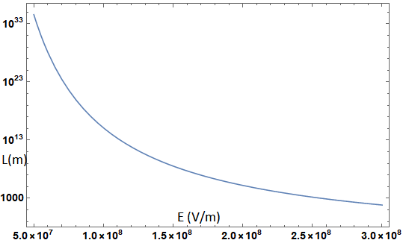
Figure 8: Stripping length as a function of electric field for 8 GeV protons. At 50 MV/m the mean stripping length is > 10³⁴ m. This is reduced to 3.5×10⁸ m at E = 150 MV/m.

In the beam frame the magnetic field transforms into an electric field with a magnitude of βγc B_{φ}. This magnifies E₀/c by a factor of βγ, and reduces it by J₁(ωr/c) ≅ (ωr/c)/2. The rms beam emittance is ~0.3 mm-mrad (normalized), which places the 8 GeV rms beam size at ~1 mm, at a large β⊥ = 30m., and 2c/ω = 73.45 mm at 1300 MHz. Beam particles would have to have amplitudes greater than ~1 cm to have transverse B-field limits that are less than the accelerating field limit.

The 0.056 T limit on transverse magnetic field used in the bending magnets transforms to a limit of 160 MV/m in longitudinal electric field, which would imply a limit of ~100 MV/m for E_{acc.} This is significantly above the presently discussed levels of 20—40 MV/m described in the present scenarios. The elliptical cavity field distribution is somewhat different from that of the pillbox approximation, and should be directly evaluated for more certainty. Provided that particle amplitudes can be confined within <~1 cm, magnetic and electric field stripping in the SRF cavities should not be a significant problem, particularly if E_{acc} is less than ~40 MV/m.

Other Scenario variants
Affordable variations can be constructed by varying the transition energies, gradients and other properties, as well as the injection time structure. While Project X had a 10 Hz period, PIP-II has a 20 Hz pulse structure and that could be continued into the future pulsed PIP III cw linac, and will be considered the baseline option below. The initial PIP-II spec is ~1.1 ma-ms beam per pulse, which must be increased to ~5 ma-ms for PIP III.

One variant that can be considered is to maintain a pulsed 1300 MHz linac throughout the system. With 250 MV cryomodules (current state of the art) this requires 28 (350m). This can be reduced to 24 (300 m) with 300 MV cryomodules, which is the near-term improvement goal.

Another variant would change the transition from cw to pulsed at a lower energy than that used for Project X. RCS scenarios consider using 2 GeV as the injection energy.[15, 17] The 1—2 GeV linac could be cw, requiring 10 100 MV cryos (~100m) for 650 MHz rf, which could be reduced to ~8 cryos (80 m) with modest gradient improvements.
1300 MHz rf would only require 4-5 cryos (50-62.5m). A 2 GeV bend would require only half the length of the 3 GeV bend (~100 m). The 2—8 GeV Linac would require 24 250 MV cryos or 20 300 MV cryos (250—300 m).

The Project X scenario had the linac beam injected into the Recycler. This allows a sequence of injections to accumulate while the Main Injector accelerates previously accumulated beam. If the linac injects directly into the Main Injector, the MI must be held at constant energy while multiple pulses are injected. With 6 pulses injected, the cycle time must be increased from ~1.2 s to ~1.45s. To maintain 2.5 MW with 120 GeV beam, the injected beam per cycle must be increased to ~1.9×10¹⁴, or an increased integrated pulse to 30 ma-ms from 25 ma-ms. This would increase foil heating by that amount. However, beam injected into the larger-aperture Main Injector could be injected into a larger emittance than the recycler. (The estimated potential increase could be 25π 40π mm-mrad for the “95%” emittance.) That larger emittance could be used to reduce the foil hit rate, and the foil heating would not be increased. Injection into a larger emittance also decreases space charge tune shifts, compensating for possible collective instabilities with the greater stored beam. The RR could then still be used as a storage ring for beam from other injection cycles, but would then require its own injection foil system. Alternatively, the other linac cycles could be injected into another, smaller-circumference 8 GeV storage ring, which could then be bunched into short bunches for pulsed applications or slow-extracted into cw-like applications.

Injection into MI-10, however, conflicts with the use of MI-10 as the extraction point for the long baseline neutrino experiment (LBNF), and that is the present preferred extraction point for this beam line.[18] It is unlikely that the straight section can accommodate both extraction and injection. (The use of MI-10 for extraction also makes injection into RR-10 more difficult. The recycler is located just above the MI and the use of extraction and injection kickers in the same region may be problematic. We have not determined whether the extraction and injection elements directly overlap, but the region will at least be congested with these elements in close proximity.) The problem could be ameliorated by moving LBNF extraction to MI-60, which was also considered, and was the original plan. It may be too late to change to that, however.

An important advantage of injection into the Main Injector is that it is not constrained to be at exactly 8 GeV energy, but could be at somewhat lower energy, if the linac has not achieved design gradients, or higher energy if the linac exceeds design gradients. Higher–energy injection would relax space charge related limitations in the MI, enabling higher intensity.

Another possible injection mode would be injection into a fixed energy 8 GeV storage ring, which could be some fraction of the MI in circumference (1/5 or 1/6), followed by boxcar stacking in the MI; this could be the same ring used to prepare beam for other experiments.

The intensity requirements of the 8 GeV linac are at least 5mA-ms per pulse, at 20 Hz. The peak current should be at least 2 ma, which would give 2.5ms for the active pulse width (5 ms could include rf rise and fall; this implies a 10% duty cycle) Total beam available would be 100 ma-ms/s or 0.1ma, or 0.8 MW. ~21 ma-ms/s (0.167MW) would be needed for the 120 GeV MI injector. A potential upgrade would be increasing the peak current to 4 or 5 ma to obtain a potential 1.6—2.0 MW at 8 GeV; this may be enough for a neutrino factory or muon collider after LBNF.

Table 5: Scenarios for 8 GeV Linac
 |  | 650 MHz  length | 1300 MHz cw Linac Length | Arc length | 1300 MHz pulsed Linac Length
Project X Linac |  | 200m |  | 200m | 350 m
Checchin scenario |  | 60m | 125m | 200m | 250 m
1-2-8 GeV scenario |  | 100m | (or 62.5m) | 100m | 250—300 m
All pulsed scenario |  | --- | ---- | < 40m | 300—350 m

Acknowledgments
This manuscript has been authored by Fermi Research Alliance, LLC under Contract No. DE-AC02-07CH11359 with the U.S. Department of Energy, Office of Science, Office of High Energy Physics.

References

1. M. Ball et al., The PIP-II Conceptual Design Report (2017).
2. Project X Accelerator Reference Design, Physics Opportunities, Broader Impacts, June 2013, Fermilab TM-2557.
3. S. Holmes, Proton Improvement Plan II, presentation to Fermilab Users meeting, June 11, 2014.
4. A Grassellino et al. “Nitrogen and argon doping of niobium for superconducting radio frequency cavities”, Superconductor Science and Technology, 26(10):102001, 2013.
5. A. Romanenkov et al. “Dependence of the residual surface resistance of superconducting radio frequency cavities on the cooling dynamics”. J. Appl. Phys., 115:188, 2014.
6. A. Grassellino et al. Unprecedented quality factors at accelerating gradients up to 45 MV/m in niobium superconducting resonators via low temperature nitrogen infusion. Superconducting Sci. Tech., 30:094004, 2017.
7. D. Bafia et al. Proc. 19th Int. Conf. on RF Superconductivity. Dresden, page 588, 2019.
8. M. Checchin, “PIP-III SRF Linac Costs”, unpublished seminar, April 2018.
9. M. Checchin, “R&D Directions for Future SRF-Based Accelerators”, unpublished seminar, March 2018.
10. LCLS-II Design Team, LCLS-II Final Design Report, LCLSII-1.1-DR-0251-R0
11. D. Johnson “Conceptual Design Report of 8 GeV H- Transport and Injection for the Fermilab Proton Driver”, Beams-doc 2597 (2007).
12. W. Chou et al., “8 GeV H− ions: transport and injection,” Proc. PAC 2005, Knoxville, TE, p. 1222 (2005).
13. L.R. Scherk, Canadian J. of Phys, 57, 558 (1979).
14. P.B. Keating et al., Phys. Rev. A 52, 4547 (1995).
15. J. Eldred, V. Lebedev, and A. Valishev, Rapid-Cycling Synchrotron for Multi-Megawatt Proton Facility at Fermilab”, arXiv:1903.12408v2, JINST 14 P07021 (2019).
16. N. Solyak, “Project-X CW Linac (ICD-2+) Lattice Design”, Project X presentation, March 16, 2010.
17. S. Nagaitsev and V. Lebedev, “A Cost-Effective Rapid-Cycling Synchrotron”, Reviews of Accelerator Science and Technology, pp. 245-266 (2019).
18. “Long-Baseline Neutrino Experiment (LBNE) Project Conceptual Design Report Volume 2: The Beamline at the Near Site”, October 2012.

