IPM Application bugs and requests

December 18, 2017

Last save: 12/18/2017 4:49 PM

# General comments

Denton came over while we were going through and was concerned that there are two different groups going through bugs/improvements for the same interface. Due to the differences in the systems (and expected differences in how they will be used) it may be worth having two separate applications for the different machines (MI/RR and Booster). Currently it seems that there are just different ACNET pages that link to a single application. There was concern over how requested changes from one machine group may impact the other. This will need some discussion, possibly with the machine groups.

# Booster

1. Todd would like to be able to save data as a file name that has meaning to him. Currently the date and time format makes it hard to recall a specific test days later, especially if multiple people are using the application and saving data. This could include having a copy of the normal data saved with the requested name, since changing the current format would throw a wrench in Dave’s file organization scheme. This may need some discussion. This is something that Slimmer will have to support
2. The voltage setting won’t correctly save when changed. I saw this
3. We would like to combine both horizontal and vertical pages into one, and plot both at the same time (either in separate windows or one the same plot with two colors, if possible). Especially when recalling data, it is cumbersome to change pages, call up the appropriate file name, etc. Noted. This will happen eventually. A good reason to support different code basis for Booster and for MI/RR.
4. When replotting saved data with a different analysis the raw data plot seems to have issues. We changed the analysis start turn to 500, and analysis to 1000 turns, which resulted in plotting the entire (or entire minus the initial 500) 20000 turns scaled to 1000 turns.
5. What is the appropriate way to start a multiturn analysis at a specific turn? Is this the “turns delay” field?
6. For the Booster system, can the “Skip turns” field be removed? Yes
7. Todd mentioned that the naming of the specs, along with the listing of these specs, leads to a bit of redundancy. For example, spec 4 is listed as “Spec #04: 04-BOOSTER EVENT $1D” in the Measurement Specs window, and “04 04-BOOSTER EVENT $1D” in the pulldown menu. Going along with this, Todd found it confusing that he could not change the spec name before the hyphen. I understand that this is part of Dave’s naming convention, but if there is a way to indicate that you cannot write over this that would be preferred. This is something that Slimmer will have to support; I have changed the colors (yellow to white (barely visible)) to help convey this for now.
8. F.E. IPM Status and F.E. Active Spec indicators are not working.
9. When using the “Save this spec to no.” option, after the spec is saved the Measurement Specs windows displays a mashup of the two specs. For example, after saving spec 4 to spec 7, we saw it display “Spec #04 – 07 BOOSTER EVENT $1D”. It would be ideal to have the window display the spec we are saving to. Hmm. This is a bug I need to fix.
10. Some fields stay red when editing (Trigger field), some highlight (Num turns acqd), and some turn yellow after clicking (the spec name field). It would be good to have consistency between these. In addition, if we could change the display color of the name change acknowledgment to yellow that would be good. We all originally mistook that message to mean that the spec had been saved after the name changed, not that the spec *needed* to be saved still.
11. When using the data plots window for the Booster System, the title still displays “MI/RR IPM Data Plots”

# MI/Recycler

I also uncovered an additional new bug to add to the list I sent you earlier this week.  When changing data acquisition turn delay numbers it affects the plotting in a manner that makes one believe the IPM data turn delay is delaying the actual injection of the beam, which is obviously not the case.   Maybe I have no good understanding of what Turns Delay does or what is actually displayed in the plots.

Denton

First image:  Recycler 104 HIPM was said to be timed in and working.  I am not sure that's the case.  I tired many different patterns on the standard $2A/$E3 spec with no real success.

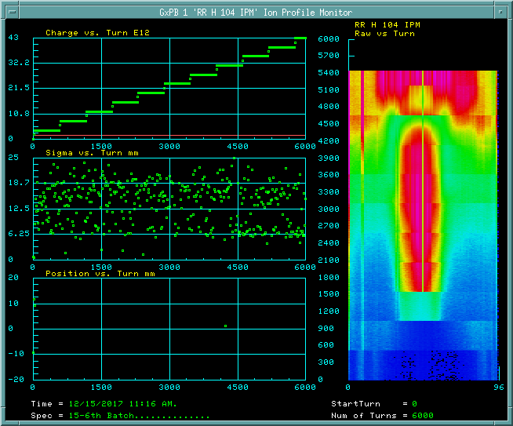

Jim timed in spec 10 through 15. But there is still work to do with this timing.

Second image:  MI H104 IPM with Turn Delay = 0.  Note that it appears beam is injected slightly after turn 400.

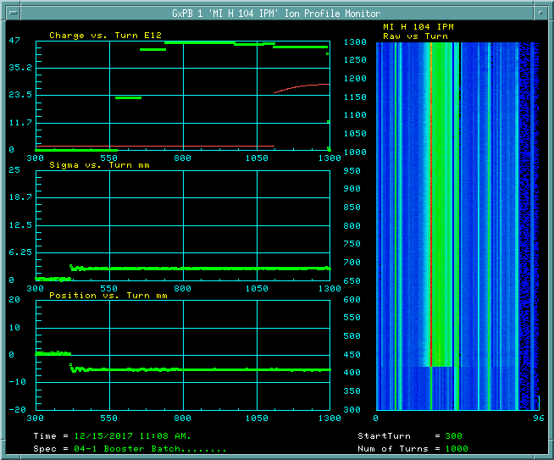

Third image:  Turn Delay = 100.  Injection appears to happen slightly after turn 450.

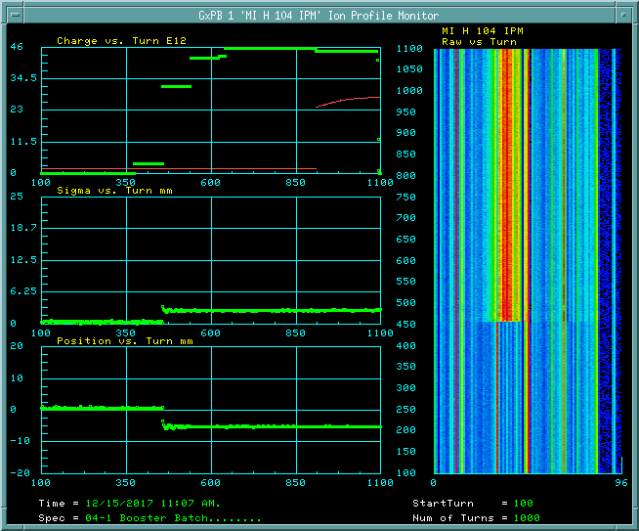

Image four:  Turn Delay = 300.  Injection appears to be delayed to almost turn 500.  And what is the red fit to the Charge vs. Turn plot supposed to represent?

The red trace is the energy. The data I receive from Slimmer has this step in it:

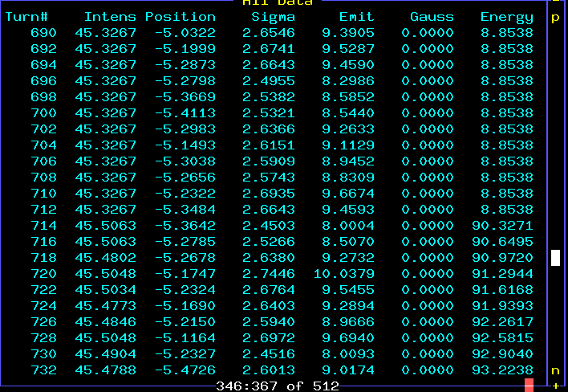

The front end ends at about turn 700. Dave will see if there is a reason for the truncation.

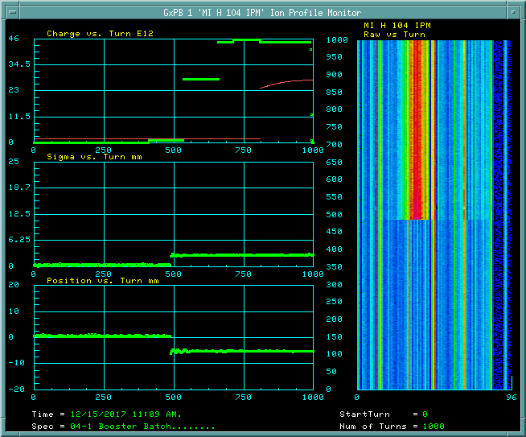

--

Saving to a new spec – the screen goes all goofy – it should show the new one completely.

The MCP voltage cannot be saved properly

Skip turns makes no sense in booster.

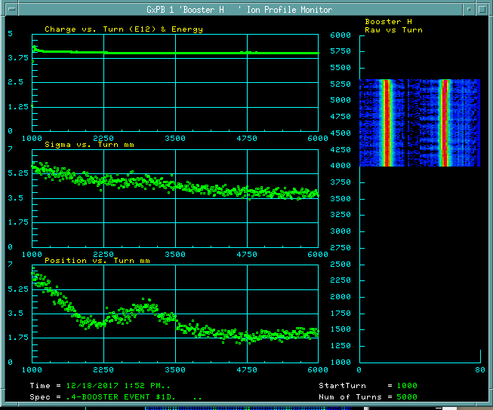

MI/RR header on lower portion.

One and only one booster. Sigma and booster charts, too.