Applications for Linac BPMs
Elliott McCrory
Created: January 29, 2013
Last saved: 7/22/2013 1:51:00 PM
Several Java applications have been released for the new, 2013 Linac BPM electronics modules. This document provides a basic outline of each application so that someone in Operations can launch these apps and roughly understand what it is supposed to do. For this document, it is more important to be brief than to be complete.
The applications are launched in the normal way for Java applications: Visit http://www-bd.fnal.gov/appix/ and search for the application name, as indicated in the section below. These are all on the “L” index page. Then click on the launch button, which looks like this:
Say “Yes” or “RUN” to all the popups. Note that you must have a valid Kerberos ticket available in order to run any of these applications (or be on a console computer). These applications are compiled for Java 6.
Each of these applications should be terminated through the “Exit” menu choice from the “File” menu. Otherwise, DAQ processes on the server may not be stopped properly.
As of this writing, all of the programs are in development—it is likely that you are going to find problems with them at some level. Please report the problems you find back to the author.
Contents
Overview 2
Application Summary 2
General Notes 2
Application Descriptions 3
Linac BPM 3
Linac BPM Data 3
Linac BPM Expert 3
Linac BPM Expert Overview 4
Linac BPM Multiplex Waveform Control 5
Linac BPM Sync DAQ 6
Linac BPM All Readings 6

Overview

Application Summary
The following Java applications are available in the Linac BPM system.
Application | Summary | Comments
Linac BPM Simple Display | Show summary data from the BPMs | Prototype Java operations application.
Linac BPM Data | Show variations in the BPMs | Written by Bob Florian, as specified by Fernanda Garcia.
Linac BPM Expert | Display and control of the registers, flash and calibration of the BPMs, one BPM at a time | An Expert application. Flash panel is read-only at this time; Calibration simply gives control over the “Cal Tone”
Linac BPM Expert Overview | Shows the value of one register for each BPM in the entire system | An Expert application. Linac and Booster
Linac BPM Multiplex WF Control | Control the setup of the multiplexed waveforms and show these waveforms | An Operations application.
Linac BPM Sync DAQ | Control and display of the Synchronous DAQ Waveforms throughout the system | An operations application.
Linac BPM All Readings
Each of these applications is written by the author, except as noted.

General Notes
In many places within these applications, there will be a button that looks like this:
This button launches a time chart of the data from that scalar parameter. Clicking it again will cause the chart to be hidden (as will clicking on the “close” button normally found on the upper-right corner of the window).
The charts in this application are implemented through the CERN JDataViewer package. For the reader who is not yet familiar with this package, here are some key features:
- Zoom in by dragging a rectangle within the chart.
- Zoom out by right-clicking within the chart.
- Use the “Views” drop-down menu to select another set of data to display. For example, some of the charts that are displayed by clicking the “#” button, above, have a time plot and a histogram—select the histogram from the Views menu.
- A spreadsheet of the numbers in a chart can be seen by first selecting the chart and then clicking on the “More” pull-down menu and then selecting “Table.”

Application Descriptions

Linac BPM
This program provides a simple display of the BPM data. It is a prototype for a future Java application and is not ready for full operations. However, comments are welcome. The initial screen looks like this:
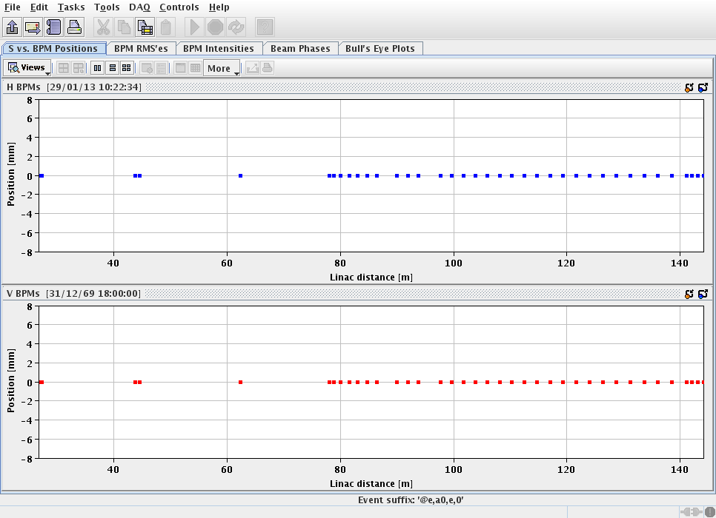

Linac BPM Data
This application, written by Bob Florian, is used by Linac experts to understand the variations in the Linac BPM readings.

Linac BPM Expert
This program gives you access to all of the internal workings of each BPM module. The screen will look like this when it starts:
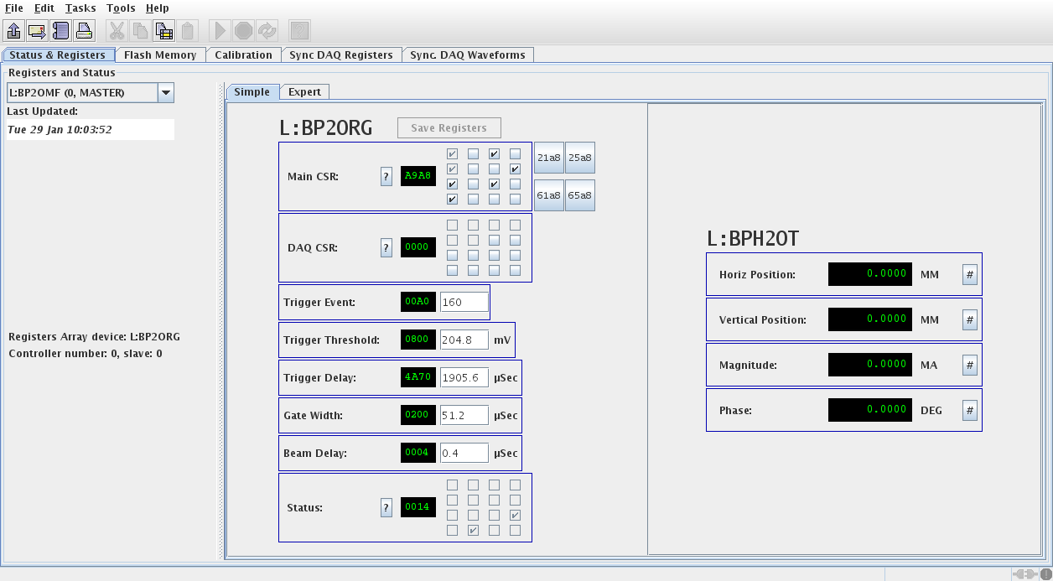
This view allows you to change the most important (in the judgment of the author) registers in each module. Click on the “All registers” tab to see, and to be able to change, all the registers. Click on the pull-down menu on the left (under the words “Registers and Status”) to select another module.
The other main tabs give you the following functionalities:
- Flash Memory – See the contents of the flash memory on the module
- Calibration – Allow you to turn on the “cal tone” in order to debug the DAQ within the module.

Linac BPM Expert Overview
This application provides much of the same information as “Linac BPM Expert”, but it shows the same information for all of the modules at the same time.
The initial screen looks like this:
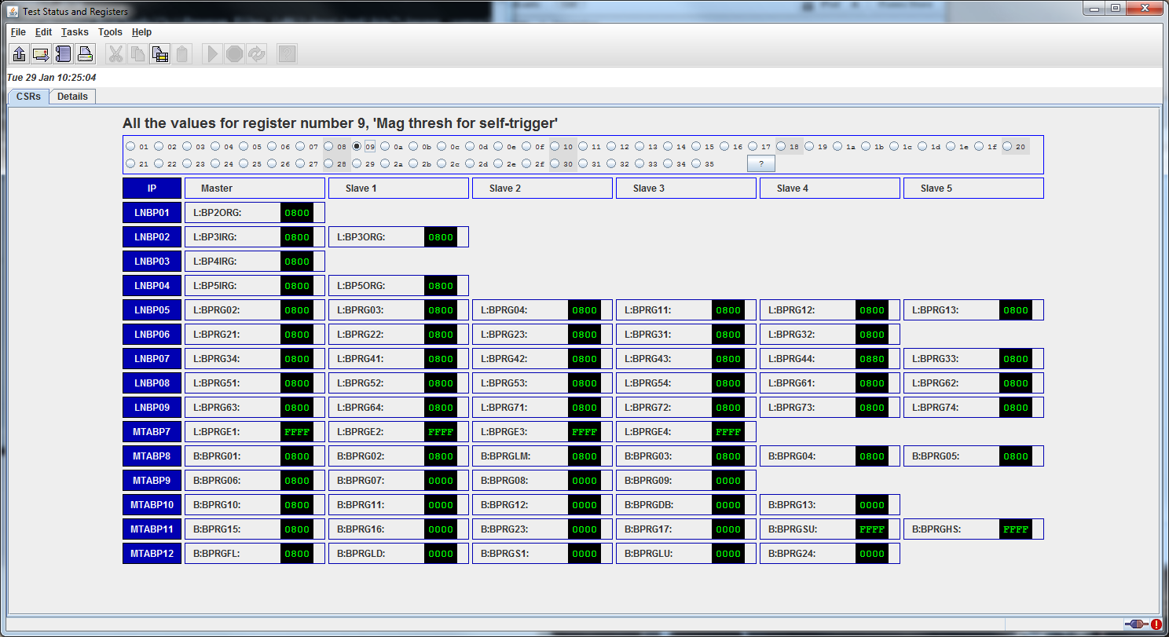
This screen shows the value of all of the registers, in this case, the first register (the Control Status Register, or CSR), for all of the modules. Other registers can be chosen through the radio buttons across the top. Click on the “?” button to see a list of the registers.
Usually, a value of “FFFF” indicates that this module is not responding to the data request.
Some of the registers have well-defined limits to the values. If the reading exceeds the limits set internally in the program, the readback will be red.

Linac BPM Multiplex Waveform Control
This program allows for the control and display of the multiplexed waveforms that are available through the Linac BPM OAC.
The OAC looks at eight channels, L:BPMXCn, to determine which BPMs to read for the array data (waveforms) that are presented in the eight matching waveform channels, L:BPMWFn. The 32-bit code is not particularly readable—it represents the node address of the module that contains this waveform, and the memory location within that module.
The initial screen of this application looks like this:
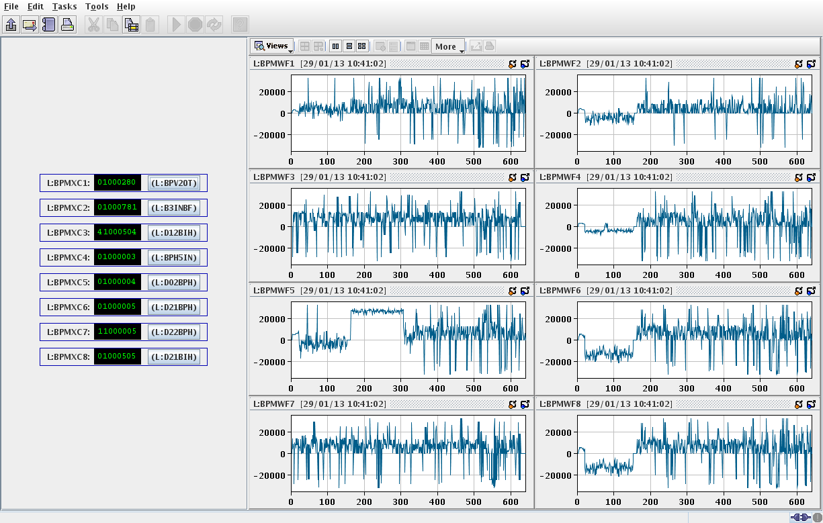
The display of the waveform is included for completeness. It is assumed that the real display will come from another application, like D27.
Click on the button on the left side of the display, just to the right of the green-on-black hex number field. A pull-down menu will pop up and allow you to select the BPM for which you want to display. You can display the X, Y, Magnitude (“I”) or Phase (“F”) of any BPM.
These multiplexed devices all begin with “L:” although the Booster 400 MeV-line BPMs are available for these devices, too.

Linac BPM Sync DAQ
This application exercises the new functionality in the BPM control modules called “Synchronous DAQ Waveforms.” The initial screen looks like this:

Linac BPM All Readings
Show all the BPM readings on one (scrolling) panel. Also can show the calculate RMS values of these readings.

